VALVE LIFTER CUP FOR NISSAN ( TIIDA )
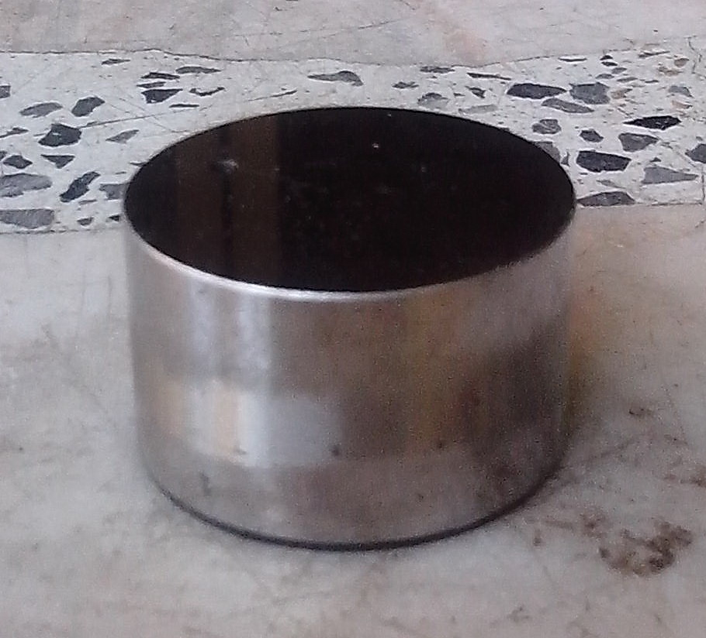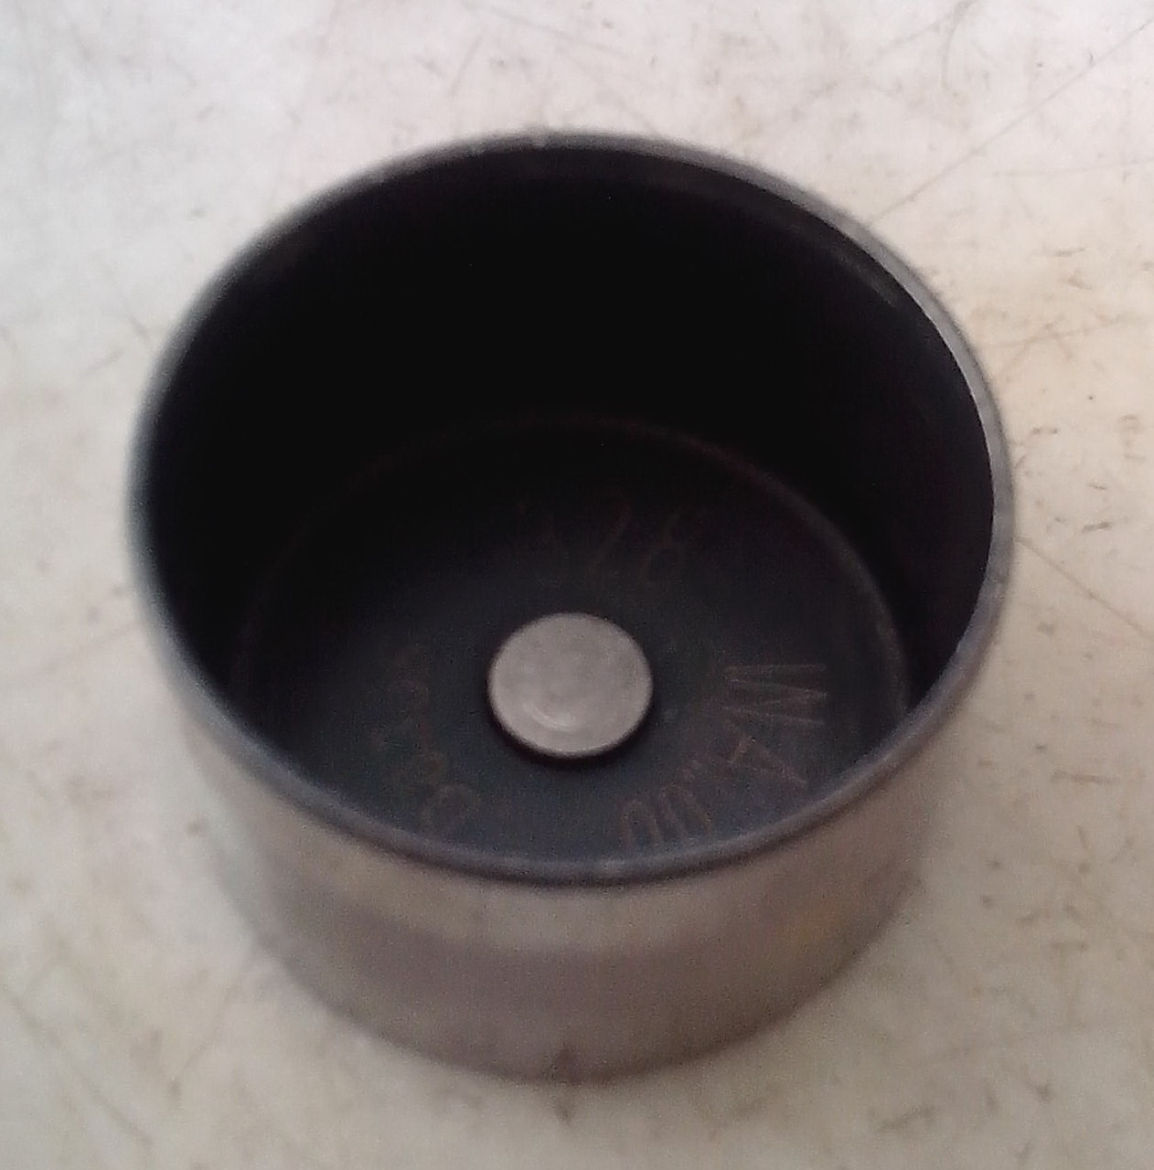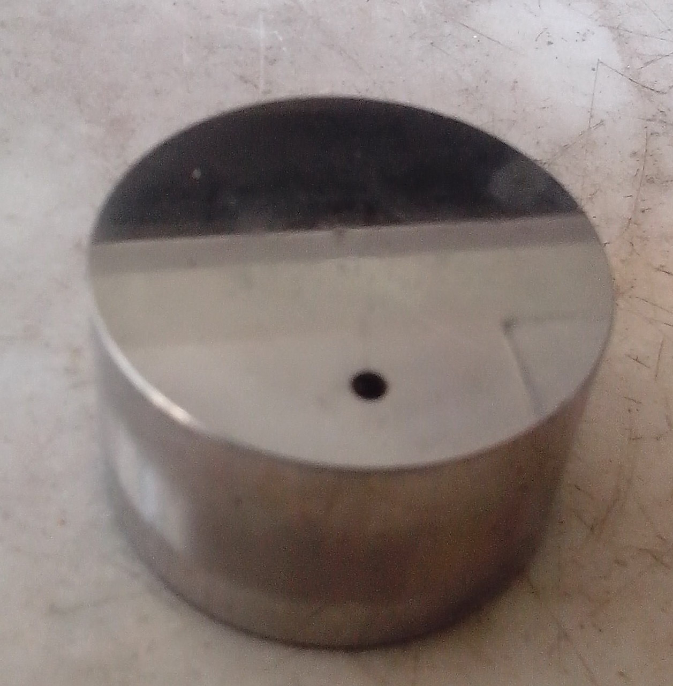
Inside picture of valve lifter cup
Out side picture of valve lifter cup
25 mm.
25 mm.
Lift height 5 mm.
25 mm.
25 mm.

