REVISIONS
REV | DESCRIPTION |  |  | CHANGED BY |  | DATE |  |  | APPROVED BY |  | DATE
NC | Production Release |  |  | Tam N |  | 2-11-08 |  |  | Keith V |  | 2-14-08
Material: Nitrite
Shelf life: 10 years
APPROVED |  | DATE | PROJECT NO  AK-451 |  | AMERI-KING CORPORATION  17881 SAMPSON LANE  HUNTINGTON BEACH CA 92648
PREPARER  TAM NGUYEN |  | 2-11-08
CHECKER |  |  | R.F.Q. NO
PROJECT ENGINEER  KEITH VAN |  | 2-14-08 | CONTRACT NO |  | TITLE  Gasket
Q.C. MANAGER |  |  | CUSTOMER
RELIABILITY
PROGRAM |  |  |  |  | SIZE  A |  | CODE IDENT NO  15099 |  |  | DRAWING No.  451002-1 |  | REV  NC
RELEASE APPROVAL |  |  |  |  | SCALE |  |  | WEIGHT |  | SHEET  1 of 3 |  | REV  NC

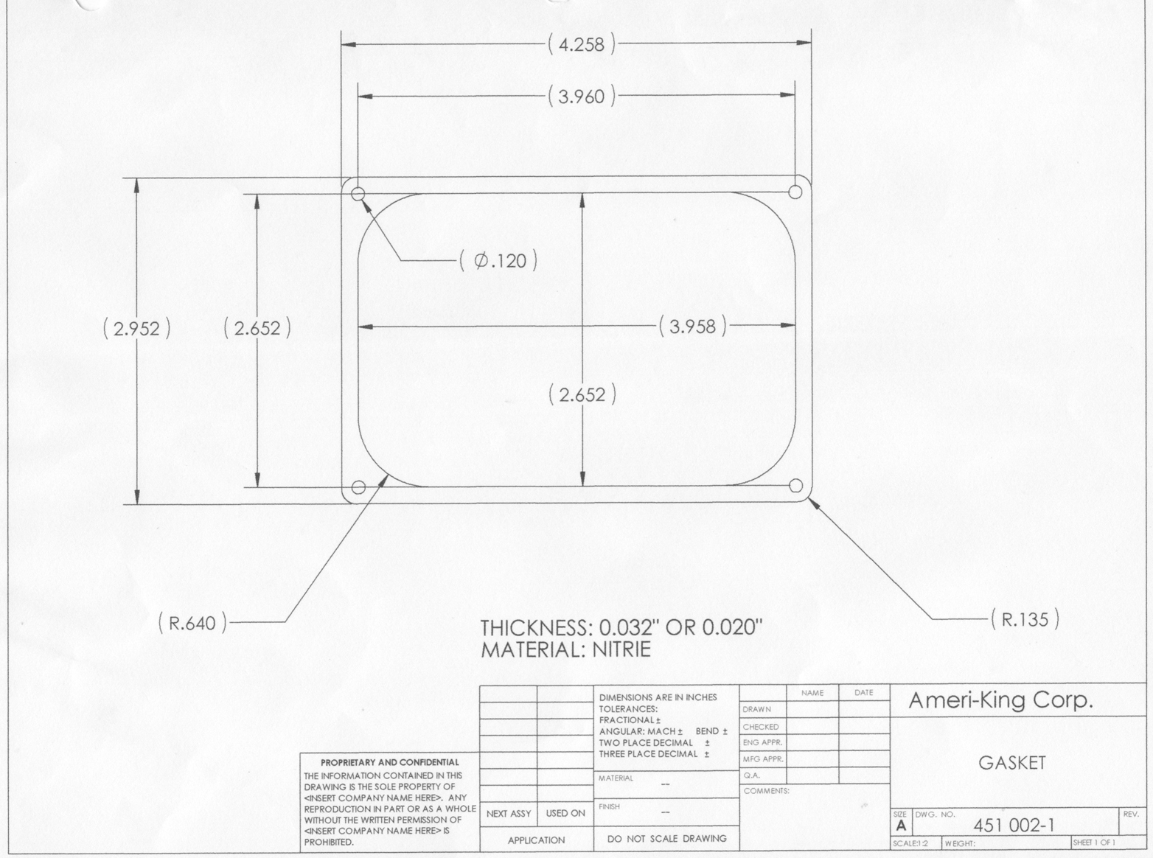

Sheet 2 of 3
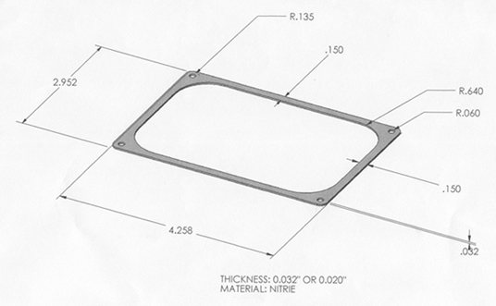

Sheet 3 of 3

