

Price($) | QTY | OEM NO | PRITURE | DESCRIPTIOM | NO
 | 100 | 9438200261 | 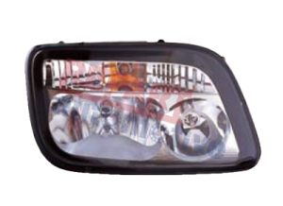 | Head lamp  (R)  Mp2 | 1
 | 75 | 9438200361 | 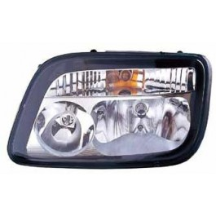 | Head lamp  (L)  Mp2 | 2
 | 25 |  | 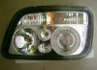 | Head lamp  (R)  Mp2 | 3
 | 25 |  |  | Head lamp  (L)  Mp2 | 4
 | 20 | 9438201661 | 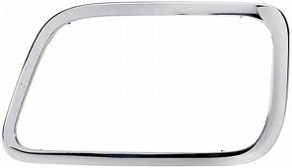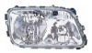 | Head lamp  (L)  Mp3 | 5
 | 20 | 9438201761 | 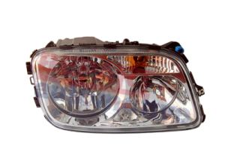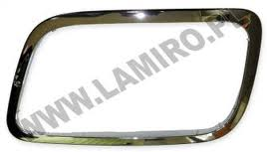 | Head lamp  (R)  Mp3 | 6
 | 100 | 9438200056 | 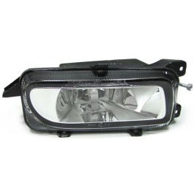 | FOG LAMP  (L)  MP2 | 7
 | 100 | 9438200156 | 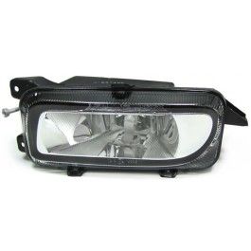 | FOG LAMP  (R)  MP2 | 8
 | 50 | 6418200861 | 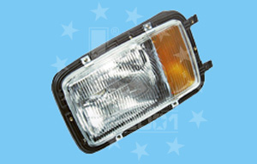 | Head lamp  (L)  LB | 9
 | 50 | 6418200961 | 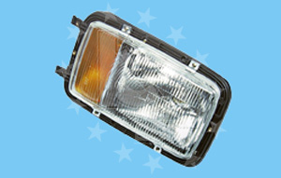 | Head lamp  (R)  LB | 10
 | 75 | 9418205361 | 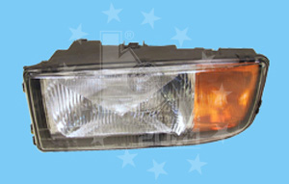 | Head lamp  (L)  MP1 MAGA | 11
 | 100 | 9418205461 | 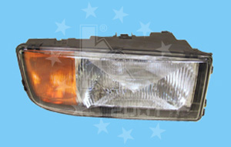 | Head lamp  (R)  MP1 MAGA | 12
 | 75 | 9418205761 | 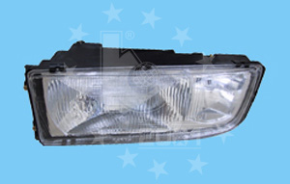 | Head lamp  (L)  MP1 MAGA Space | 13
 | 100 | 9418205861 | 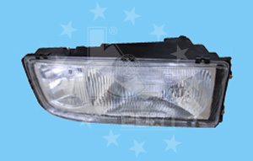 | Head lamp  (R)  MP1 MAGA Space | 14
 | 200 | 0018207501 | 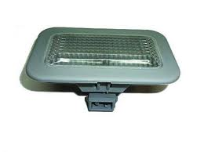 | STEP LAMP | 15
 | 100 |  | 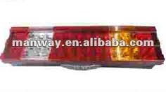 | LED TAIL LAMP SOCKET&CABLE | 16
 | 100 |  | 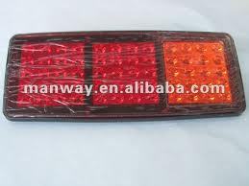 | LED TAIL LAMP | 17
 | 100 | 0015406270 | 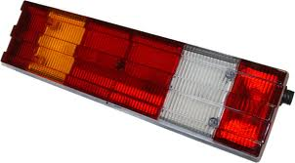 | TAIL LAMP SOCKET  (L) | 18
 | 100 | 0015406370 |  | TAIL LAMP SOCKET  (R) | 19
 | 100 |  | 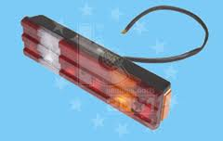 | TAIL LAMP  CABLE | 20
 | 200 | 9418200521 | 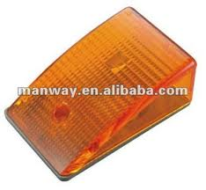 | CORNER LAMP  SOCKET  Two lines | 21
 | 100 | 9418200721 | 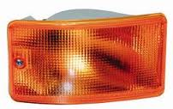 | CORNER LAMP | 22
 | 100 | 0028208756 | 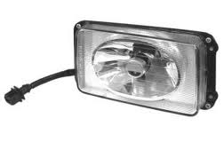 | FOG LAMP  R+L | 23
 | 100 | 0028205856 | 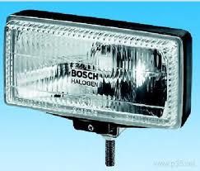 | FOG LAMP  R+L | 24
 | 50 | 0301709009 | 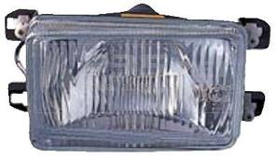 | FOG LAMP  (L) | 25
 | 50 | 0301709010 |  | FOG LAMP  (R) | 26
 | 100 | 0008261759 L  0008262259R | 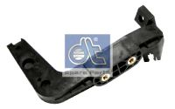 | FOG LAMP  Bracket  R&L | 30
 | 50 | 9438800214  9438800314 | 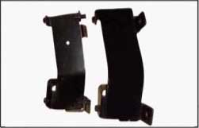 | Head lamp  Bracket  R&L | 31
 | 1000 |  | 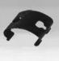 | Head lamp  Bracket | 32
 | 50 | 9438200046 | 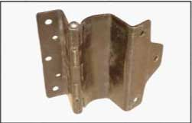 | Head lamp  Bracket | 33
 | 50 |  | 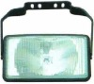 | FOG LAMP | 34
 | 100 |  |  | Glass Head lamp  MP2  R | 35
 | 50 |  |  | Glass Head lamp  MP2  L | 36
 | 100 |  |  | Glass Head lamp  MP1  R | 37
 | 50 |  |  | Glass Head lamp  MP1  L | 38
 | 200 |  |  | Glass TAIL LAMP | 39
 | 25 |  |  | mp3  FOG LAMP  R | 40
 | 25 |  |  | mp3  FOG LAMP  L | 41
 | 100 |  | 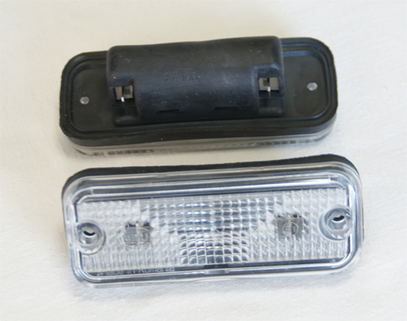 | SUN VISOR LAMP  LED | 42

