PART FOR REACH TRUCK BT
- Model: RR B2
- Serial No: 936633/2006

No | Description | Q’ty | Unit | Remark
1 | Load wheel ( front)  - Diameter: D 300 mm  - Material: Polyurethane | 20 | PCS | 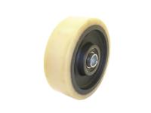
2 | Traction wheel ( rear)  - Bolt holes: 7  - Material: Polyurethane | 20 | PCS | 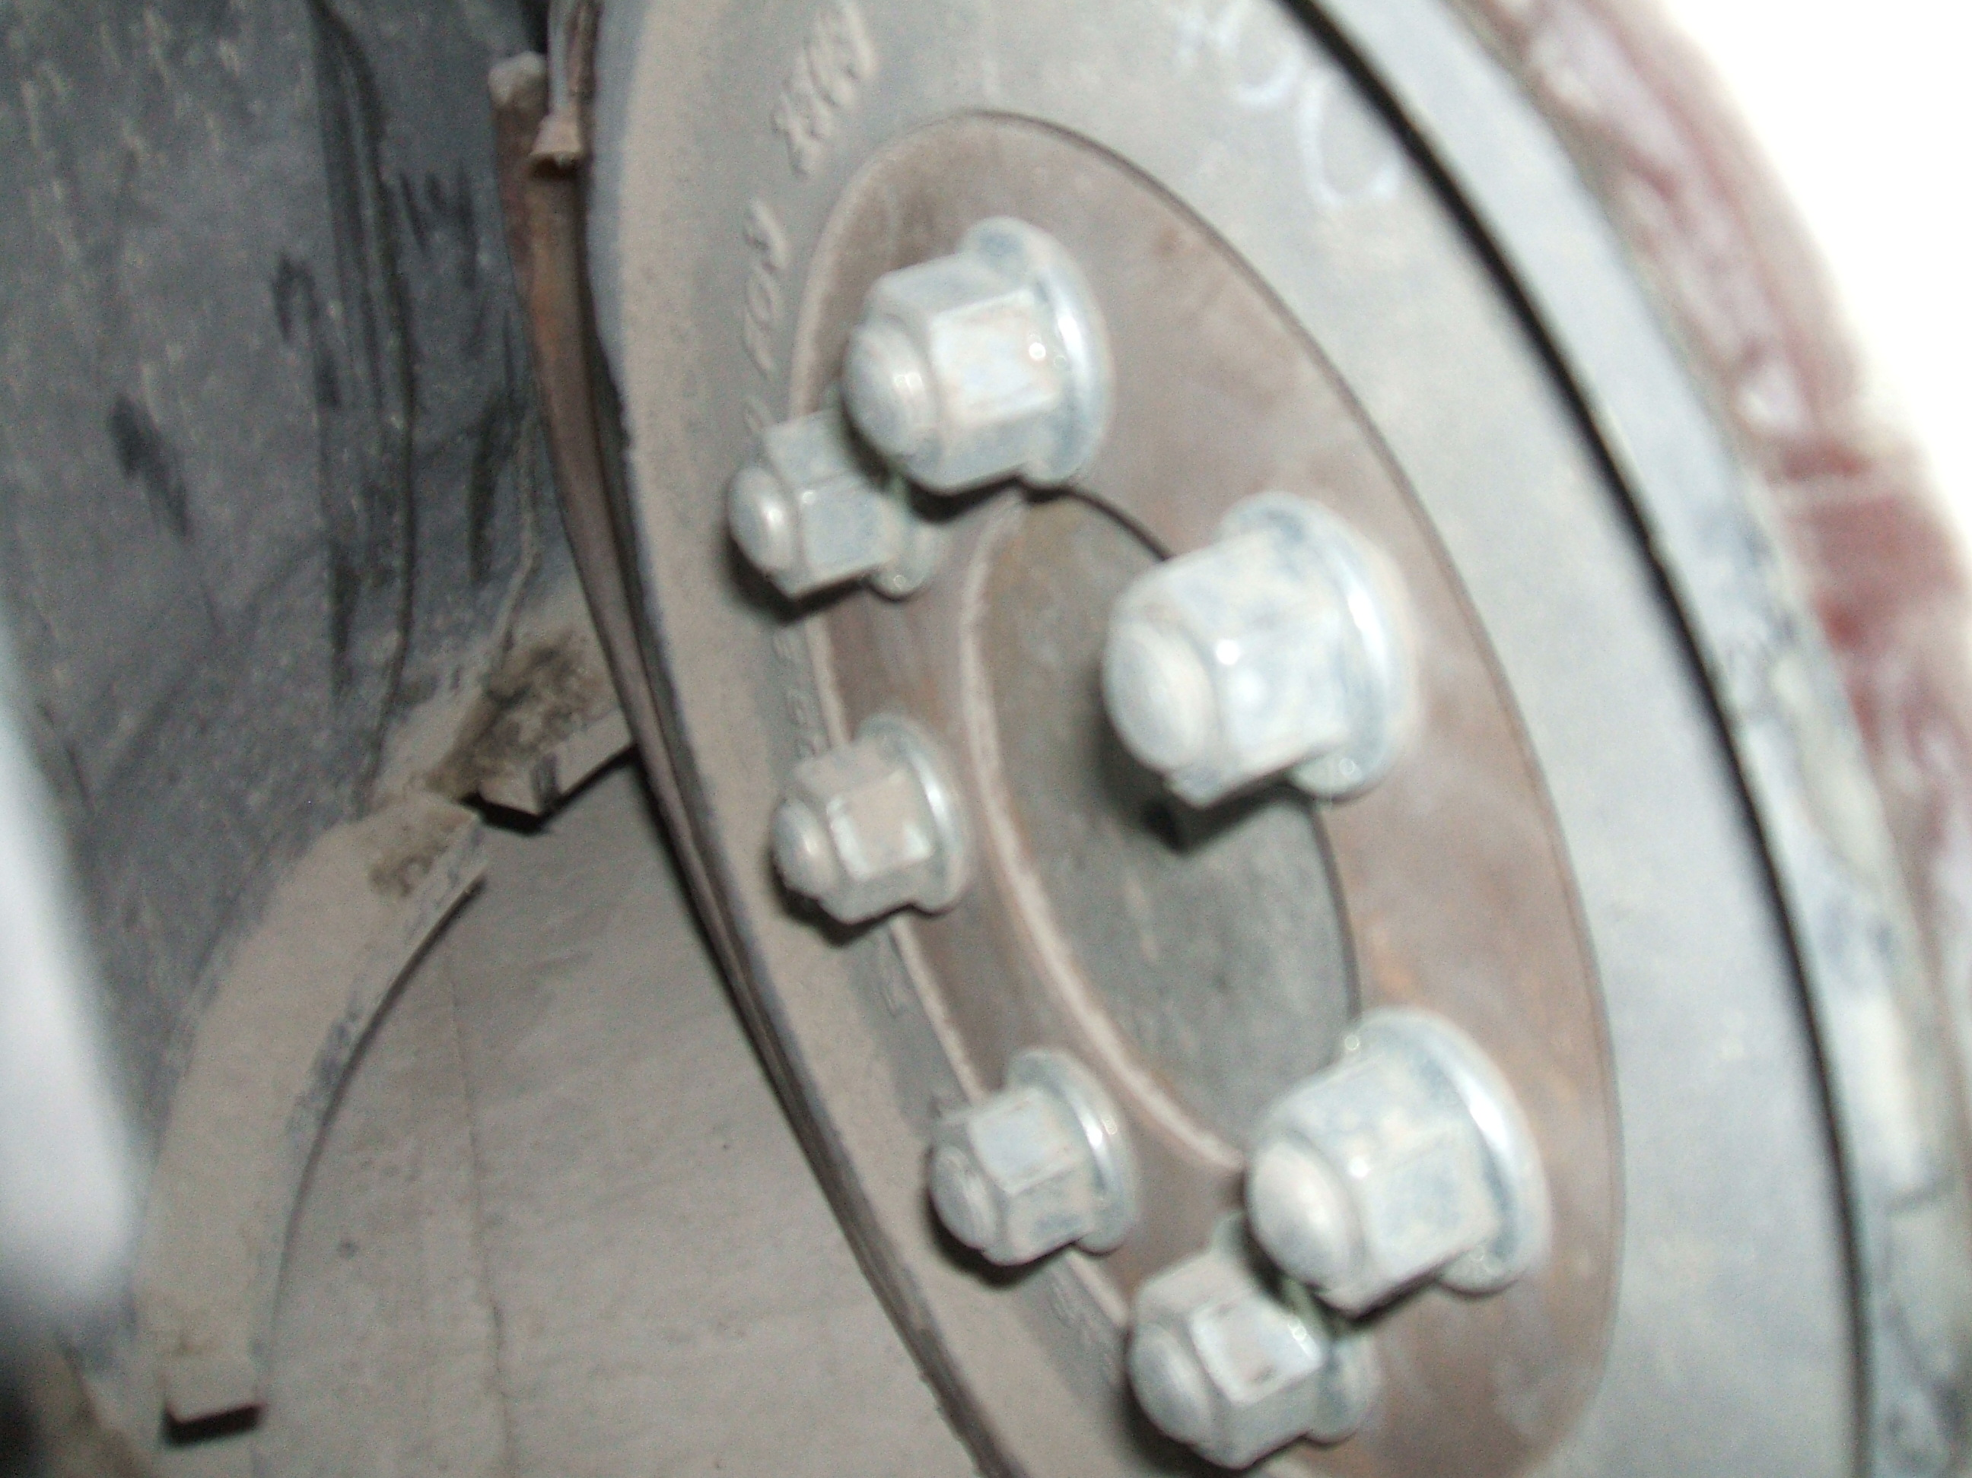 OLD WHEEL
 |  |  |  | 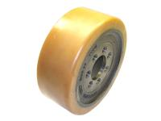 NEW WHEEL

