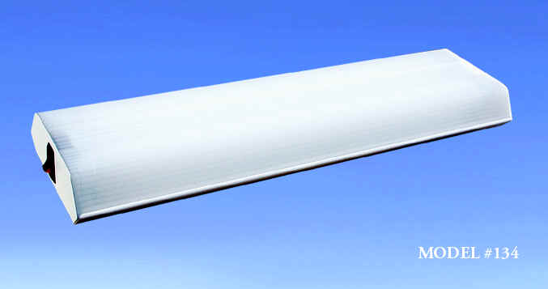 | MODEL 134
  Watts: 30
  Lamp: Two F15T8/CW
  Voltage: 12 VDC
  Amps: 2.2
  Lumens: 1650
  Dimensions: 18" x 5.375" x 1.75"
  Dimensions (mm): 457.2 X 136.6 X 44.5
  Weight (kg): 1.62 lb (0.735 kg)

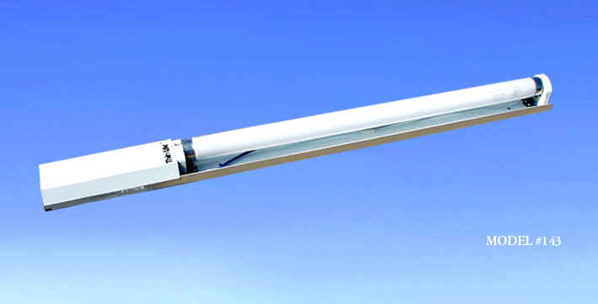 | MODEL 143
  Watts: 15
  Lamp: One F15T8/CW
  Voltage: 12 VDC
  Amps: 1.3
  Lumens: 825
  Dimensions: 23.437" x 2.15" x 1.625"
  Dimensions (mm): 595.3 x 54.6 x 41.3
  Weight (kg): 0.90 lb (0.408 kg)

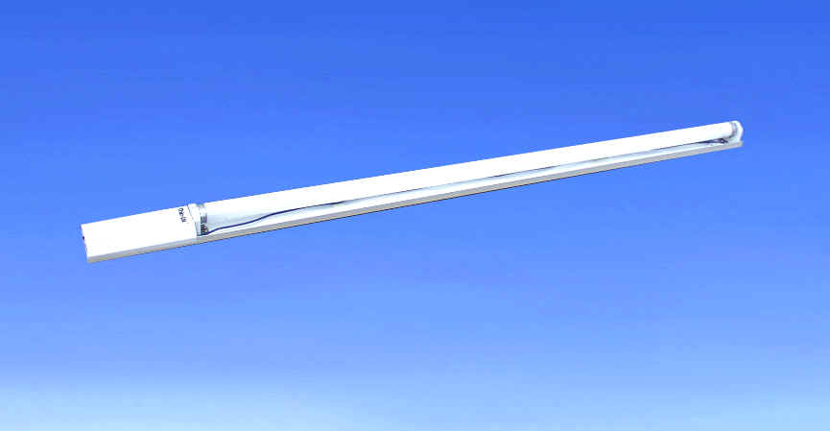 | MODEL 147
  Watts: 30
  Lamp: One F30T8/CW
  Voltage: 12 VDC
  Amps: 2.1
  Lumens: 2175
  Dimensions: 41.437" x 2.15" x 1.625"
  Dimensions (mm): 1052.5 x 54.6 x 41.3
  Weight (kg): 1.50 lb (0.681 kg)

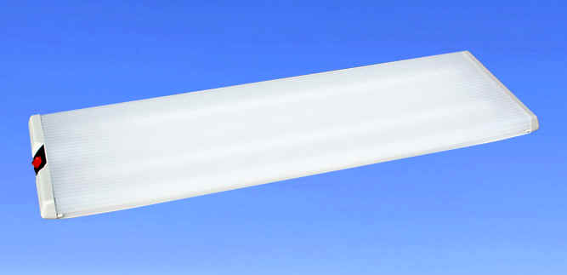 | MODEL 746
  Watts: 30
  Lamp: Two F15T8/CW
  Voltage: 12 VDC
  Amps: 2.2
  Lumens: 1650
  Lens: Extruded Acrylic
  Endcap: Injection Molded
  Housing: White Stamped Sheet Aluminum
  Dimensions: 19.125" X 6.125" X 1.75"
  Mounting Opening:18.125" X 4.75" X 1.00"
  Weight (kg): 1.58 lb (0.717 kg)

