Heater & cooler Blower Motor

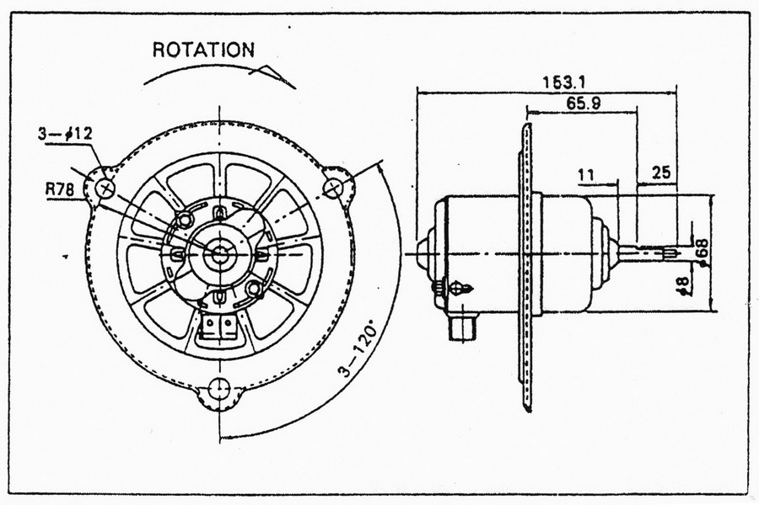

Specification

|  |  |  |  |  |  |  |  |  |  |
| --- | --- | --- | --- | --- | --- | --- | --- | --- | --- |
| **Voltage** | | **No Load** | | **Maximum Efficiency** | | | | | **Stall** |
| Rated (V) | Operating(V) | Speed(r.p.m) | Current(A) | Speed(r.p.m) | Current(A) | Torque(kg.cm) | Output(w) | Eff(%) | Torque(kg.cm) |
| 12V | 9-14 | 3600 | 1.5 | 2900 | 9 | 2.5 | 75 | 67 | 14 |