QUOTATION PICTURE DRAWING PACK

BLOCK CASTING

PART NUMBER LP4985

This drawing pack is issued for cost estimating purposes.
It is expected that costs estimated will be within 5%
Dimension shown are approx. for costing purpose only.

October 2011
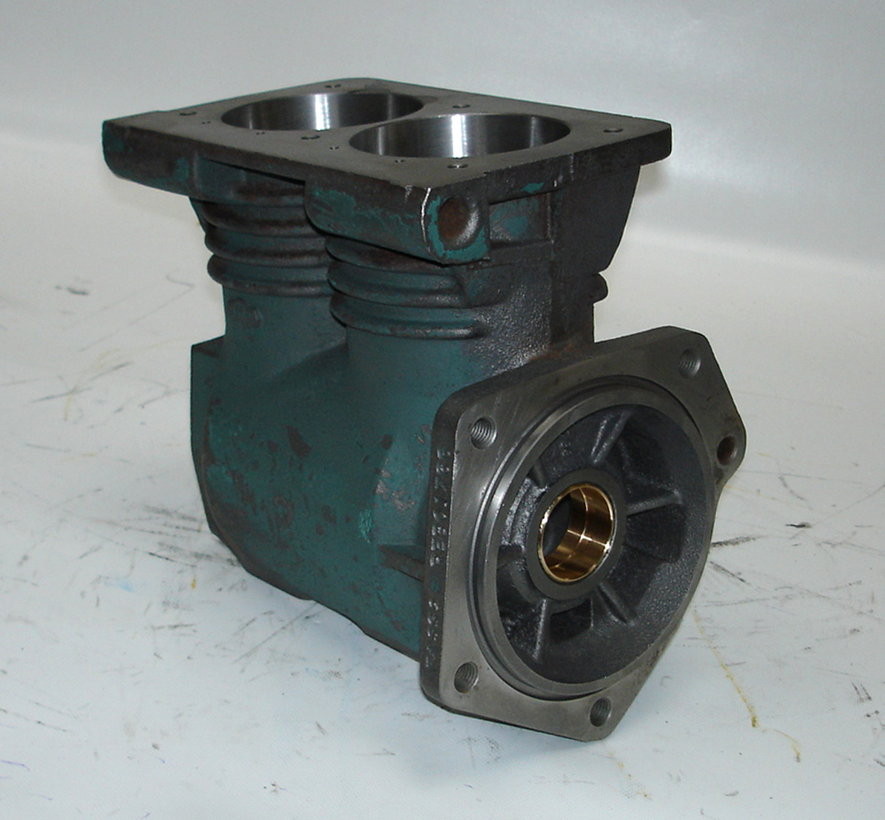
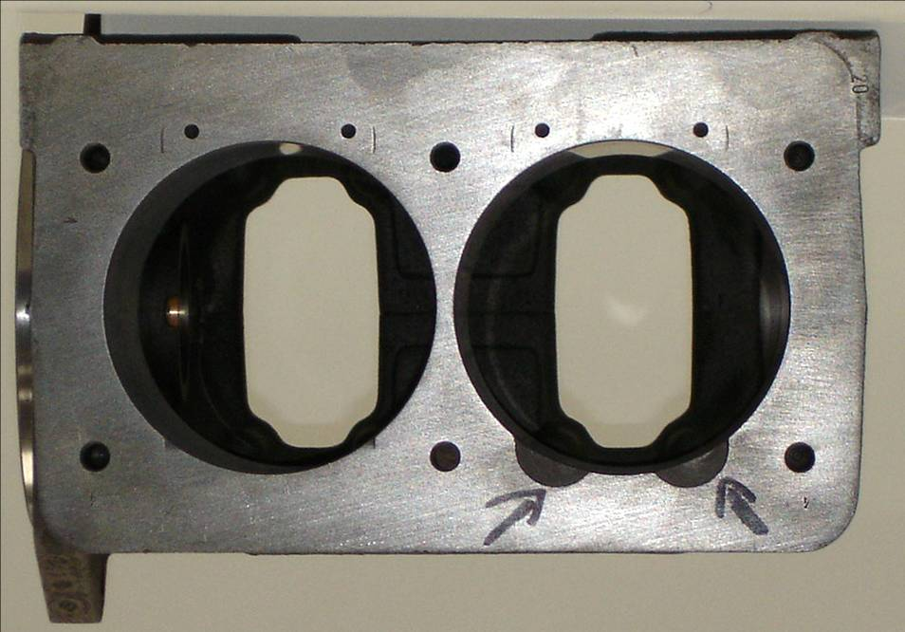

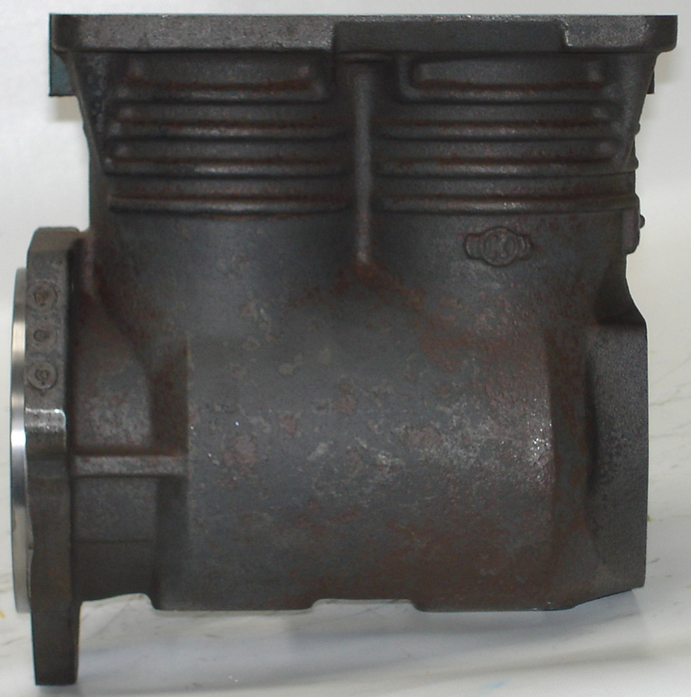
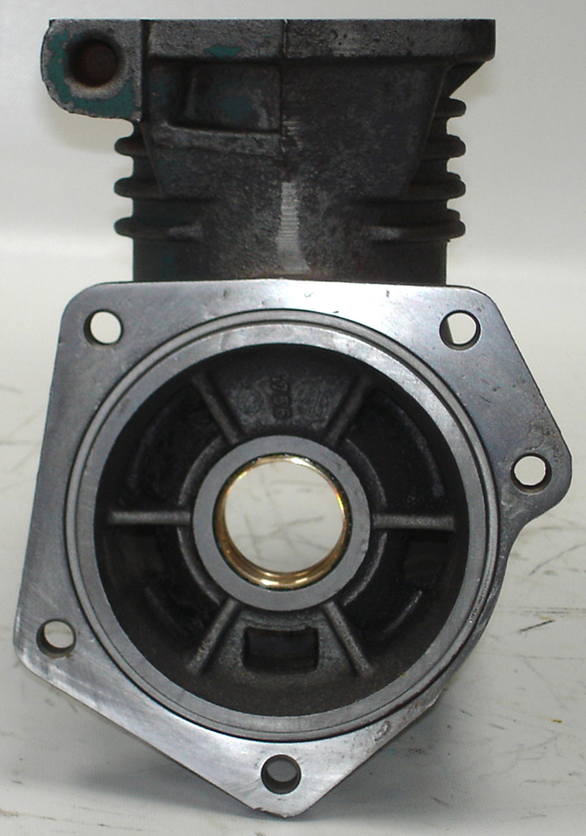
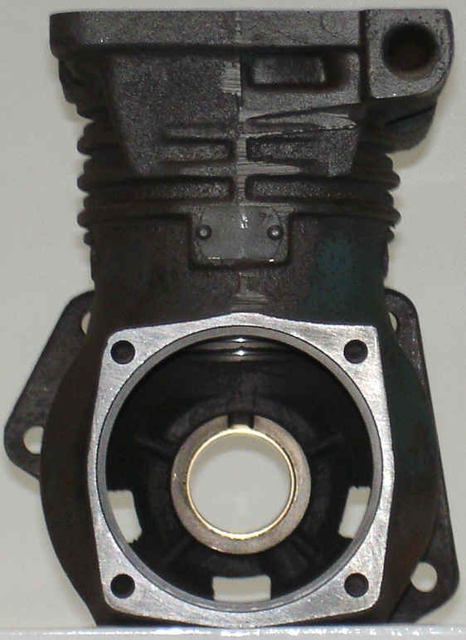

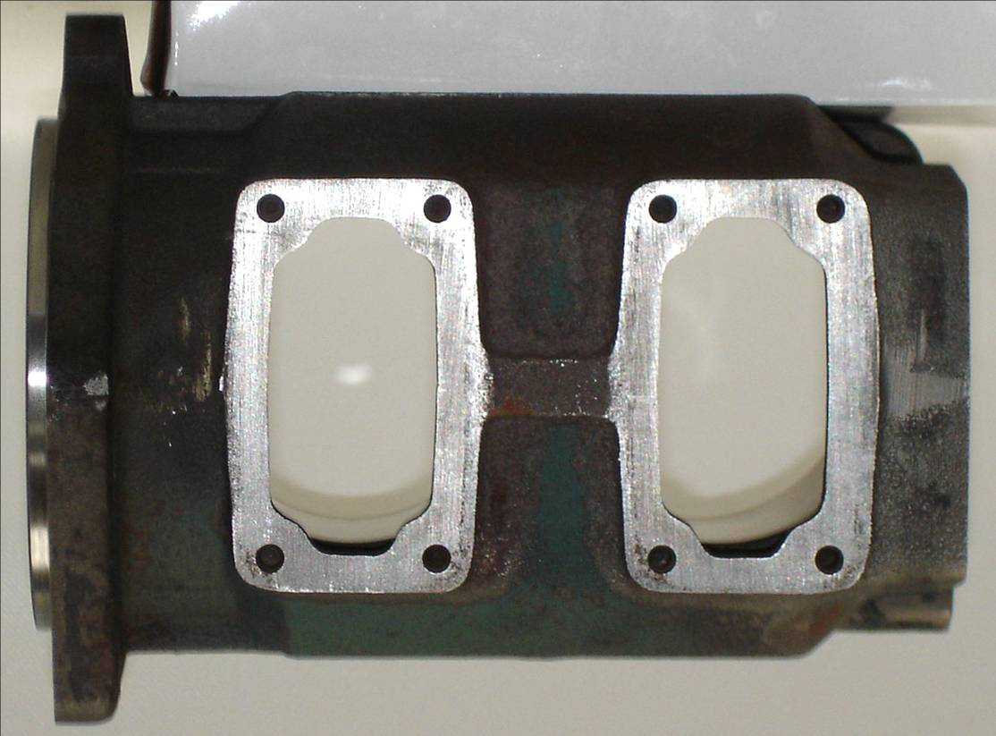

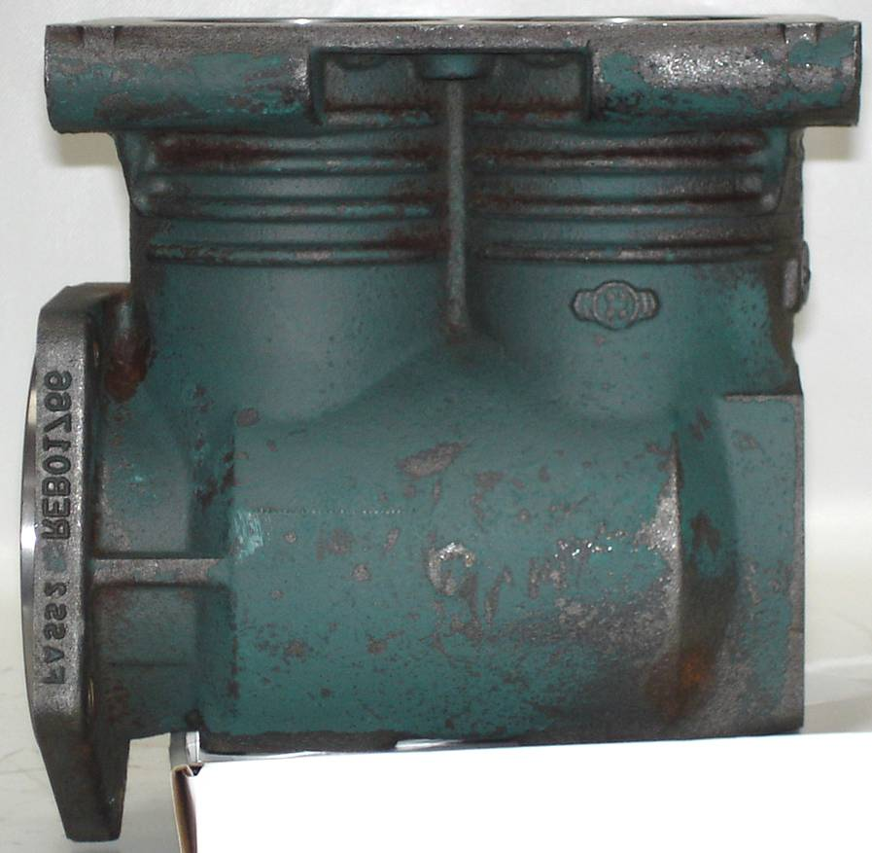

= Machined

GENERAL NOTES :-

Material of casting Grade 220 cast iron

General Wall Thickness 7 – 10 mm

Weight Of Casting 10.960 kg

General Machining Finish N7

23230 mm

23250 mm

23210 mm

23170 mm

23230 mm

23230 mm

4 x 3.5mm hole
5mm depth

23135 mm

23~88 mm

23220 mm

6 x 8x1.25
30mm depth

145mm

Blank 14mm diameter hole
34mm depth

215mm

= Machined

92mm
4 x 8x1.25 thread
22mm depth

= Machined

55mm

100mm

32mm
65mm

155mm

8 x 6x1 thread
16mm depth

180mm

5 x 12x1.5 thread

43mm

180mm

Bush not required

75mm
80mm

