MAKE | MODEL | OEM NO | CORE SIZE | AT/MT | QTY  /PCS |  |  |  | QTY
DAEWOO Radiator | Chevrolet AVEO | 96443475 | 480*418*16 | MT | 50 |  |  |  | 200
DAEWOO Radiator | Chevrolet AVEO | P96536526 | 600*418*16 | AT | 50 |  |  |  | 50
Chevrolet Radiator | OPTRA  04-07 | 96553243/  96553244/  P96553243 | 372x702x18 | MT | 50
Chevrolet Radiator | OPTRA  04-07 |  |  | AT | 50
DAEWOO Radiator | LANOS | 96182261 | 635*382*16 | MT | 600 |  |  |  | 200
DAEWOO Radiator | NUBIRA Saloon (KLAJ) 1.6 16V | 96351103/96273594 | 655*382*16 | AT | 100 |  |  |  | 50
HYUNDAI Radiator | ACCENT  99~ | 25310-25150 | 337x638x16 | MT | 200 |  |  |  | 50
HYUNDAI Radiator | ACCENT  99～ | 25310-25050 | 335X308X16 | MT | 200 |  |  |  | 50
HYUNDAI Radiator | EXCEL  92-96 | 25310-22005/22020/22025 | 335X602X16 | MT | 100 |  |  |  | 50
MITSUBISHI Radiator | LANCER | MR968857  MR464612 | 375*688*16 | MT&AT | 200 |  |  |  | 50+50
OPEL Radiator | VECTRA A | 1300133 | 620*363*32 | MT | 100 100 |  |  |  | 50
OPEL Radiator | VECTRA A | 90264491 | 525*326*32 | MT | 100 100 |  |  |  | 50
OPEL Radiator | VECTRA A | 1300122 | 535*382*32 | AT/MT | 100 100 |  |  |  | 50
TOYOTA Radiator | HIACE(DIESEL)  99～05 | 16400-5B740/  5B741/  5B750/  5B751 | 500X402X40 | MT | 100 150 |  |  |  | 50
TOYOTA Radiator | HIACE(DIESEL)  90-99 | 16400-5B740/  5B741 | 490X398X40 | MT | 300 200
TOYOTA Radiator | HIACE(DIESEL)  84-89 | 16400-54280 | 400X529X40 | MT | 5050 50
CHERY | A5  1600CC | A21-13-1110 | 675*325*30 | MT | 600 |  |  |  | 200
Chery  RADIATOR | Chery B11  2000CC | B11-12-1110 | 375*688*16 | AT | 150
Chery  RADIATOR | TIGGO |  |  |  | 50
Chery  RADIATOR | QQ3 S11 |  |  |  | 50
TOYOTA RADIATOR | COROLLA  1300 CC  03-04 | 164000D230 | 600*348*16 | MT | 100 |  |  |  | 100
TOYOTA RADIATOR | COROLLA  1300 CC  03-04 | 164000D240 | 600*348*26 | AT | 300
HYUNDAI Radiator | ELANTRA  1600 CC 04> | 25310-29700 | 378*668*16 | MT | 100 |  |  |  | 100
HYUNDAI Radiator | ELANTRA  1600 CC 04> | 25310-2D010 | 377*668*18 | AT | 300 |  |  |  | 100
HYUNDAI Radiator | VERNA  1300CC | 25310-25050 | 336*326*16 | MT | 200 |  |  |  | 100
HYUNDAI Radiator | MATRIX  1600CC | 25310-17100 | 360*614*26 | AT | 50
HYUNDAI Radiator | MATRIX  1600CC | 25310-17000 | 378*668*16 | MT | 50
HYUNDAI Radiator | Hyundai Accent 2007 NEW  07~ | 25310-0M000/1E001 | 370x628x16 | MT | 200
ISUZU  D  Radiator | D-MAX  DA-IS-353  2. 4L  DEISEL | 897387 | 475 x588 x16 | M | 150
ISUZU  D  Radiator | D-MAX  DA-IS-353  2. 4L  DEISEL | 8973333522 | 475x 588 x26 | M | 100
MITSUBISHI Radiator | LANCER  02～05 | MB968858  MR187964/MR299618 | 375X688X26 | AT | 100
MITSUBISHI Radiator | LANCER02～05  02～05 | MR464612 | 375X688X16 | MT | 150
KIA Radiator | PRIDE | 16400-75470 | 138x 158 x26 | MT | 50
KIA Radiator | PRIDE 93~ | KK139-15-200A | 320x378x26 | MT | 50
KIA Radiator | SEPHIA/MENTOR/CARENS 98/96/02 | OK2A2-15200-B | 345x668x26 | AT | 50
KIA Radiator | SEPHIA/MENTOR/CARENS 98/96/02 | OK2A1-15200-B | 345x668x26 | MT | 50
TOYOTA  Radiator | COROLLA  1300CC | 16400-15500 | 638*350*16 | AT | 150
MERCEDES  Radiator | W123 | 123 501 5601  123 501 04 01 | 420*488*32 | AT | 250
MERCEDES  Radiator | W123 | 1235005903/1235010201  123 500 56 03 | 420*488*32 | MT | 50
MERCEDES  Radiator | E-CLASS W124-200/200E/230E  奔驰 W124-230 AT  84-93 | 201 500 38 03/48 03 | 488X488X32 | AT | 50
NISSAN  Radiator | SUNNY N16  00～02 | 21460-6M200  21460-6M000  2146066Y00 | 360X688X16 | AT/ MT | 200 \
HYUNDAI Radiator | ACCENT  99~ | 25310-25150 | 337x638x16 | MT | 100
PEUGEOT | 307 S 5 DOOR HATCHBACK 1587CC  307 1.6i  06/01- | 133082/  133069/  1330A1/  1330H3  133082/G3 | 378X541X20 | MT | 150
MITSUBISHI Radiator | LANCER (96-) | MR187961 | 376X658X18 | MT | 100
OCTAVIA |  | 1K0121251E/F/  P/Q/R/H/J/L/DL  /CE1K0121253AC  /P/R/N/BQ | 650X414.5X24 |  | 50
Grand Cherokee Radiator - | 2005-2010 |  | 23.25 x 20.25 x 0.93  1.5 in. inlet size, 1.75 in. outlet |  | 50
Grand Cherokee Limited 6 Cyl 4.0L | 2004 Jeep |  | 23.5 x 21.56 x 1. |  | 50
Cherokee LIBERTY Radiator | 6 Cyl 3.7L; |  | 19.94 x 20 x 1 |  | 50
  Jeep 2002-2006
Chevrolet Condenser | OPTRA |  |  | AT | 50
DAEWOO Condenser | LANOS | 96182261 | 635*382*16 | MT | 200 |  |  | 20
DAEWOO Condenser | NUBIRA | 96273596 | 655*382*16 | AT | 100
TOYOTA Condenser | COROLLA  1300CC & 1600CC | 88460-02320 | 626*380*16 | AT | 50 |  |  | 20
HYUNDAI Condenser | ELANTRA | 976062D000 | 613*360*18 | AT | 50 |  |  | 20
Chevrolet Aveo Condenser | 2006 AVEO 4cyl; 1.6L; 98c.i.  2004-2007 | 96539634/ 96539632 | 580X435X18 |  | 50 |  |  | 20
CHERY A5 Condenser | A5  1600 CC | A21-13-1110 | 675*325*30 | MT | 500
MITSUBISHI Condenser | LANCER  1600CC | MR500441 | 705*335*16 | AT | 100
MERCEDES  Condenser | W123  200  DA-ME-343 | 123 501 5601  123 501 04 01 | 420*488*32 | AT | 100 100
MERCEDES  Condenser | E-CLASS W124-200/200E/230E  奔驰 W124-230 AT  84-93 | 201 500 38 03/48 03 | 488X488X32 | AT | 100  100 |  |  | E-CLASS W124-200/200E/230E  奔驰 W124-230 AT  84-93
NISSAN Condenser | SUNNY  1600CC |  | 730*304*16 | AT | 50
  92110-3S401
Chery Condenser | Chery B11  2000CC | B11-12-1110 | 375*688*16 | AT | 50
Jeep  Grand Cherokee Condenser | 2005-2010 Jeep | P2839 |  | AT | 20
Cherokee LIBERTY Condenser - | 6 Cyl 3.7L; | P2481 |  | AT | 20
  Jeep 2002-2006
Grand Cherokee Limited 6 Cyl 4.0L  Condenser | 2004 Jeep |  |  | AT | 20
 |  |  |  |  |  | 7710

CHERRY A5 APP
373×698×16

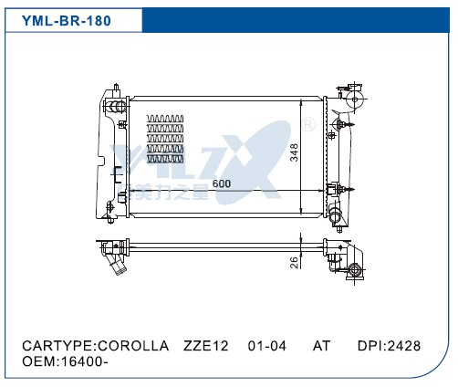

2005-2010 Jeep Grand Cherokee Radiator - Replacement - OE replacement Part #: P2839
Mfr #: P2839
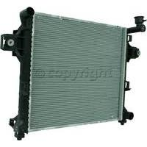


UN06-045
RADIATOR
QQ3 S11
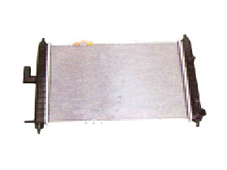
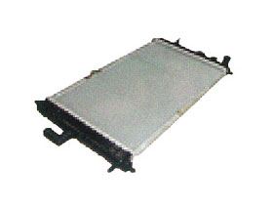
UN06-046
RADIATOR FOR 372 ENGINE
QQ3 S11

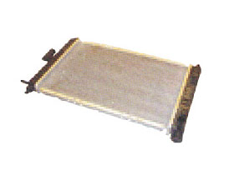
UN06-049
RADIATOR FOR 465 ENGINE
QQ3 S11

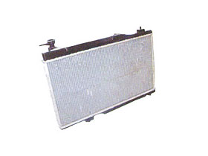
UN06-093
RADIATOR
QQ3 S21
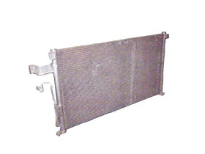
UN06-160
condenser
A5
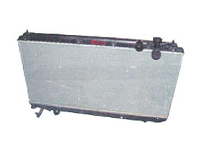
UN06-275
RADIATOR
TIGGO

