EXHAUST FLEXIBLE PIPE 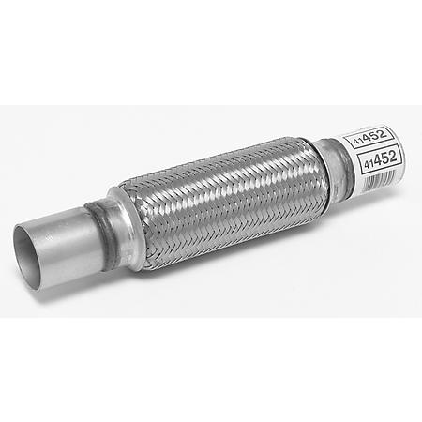
SIZE | WEIGHT  (KG) | QTY  (PCS)
2"x8" (51x203mm) with tube end | 0.982 | 8500
1.75"x4"(45x100mm) with tube end | 0.435 | 1500
2.5"x6"(61x152mm) with tube end | 0.883 | 1000
1.75"x8"(45x203mm) with tube end | 0.773 | 2000
2"x8" (51x203mm) ) without tube end | 0.75 | 1000
2"x4"(51x100mm) without tube end | 0.289 | 500
1.75"x4"(45x100mm) without tube end | 0.233 | 1000
1.75"x10"(45x254mm) without tube end | 0.866 | 500
2"x10"(51x254mm) without tube end | 0.917 | 500
Specification of Products:
All the products above are with inner and outer braid(double braid).
1) The main body is made of Stainless Steel Plate 202
2) The major body has middle double layers bellow (0.3x2=0.6mm)
3) The braid is knitted by Stainless Steel 202 wires
4 )The collars are Aluminized trumpet mouth
5) The braid is composed with 12 unit wires
6) The extension necks are the Aluminum pipe, each one is 51mm.

