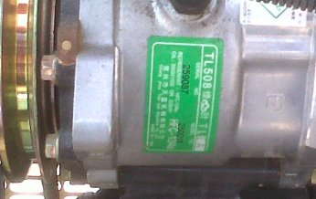
Refrigerant
Reference: TL508
Serial Number : 259087
Model Number: 250018
Refrigerant Gas: HFC-134A

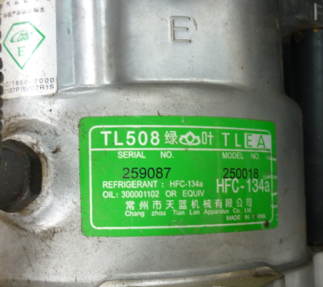
Refrigerant
Reference: TL508
Serial Number: 259087
Model number: 250018
Refrigerant gas: HFC-134A

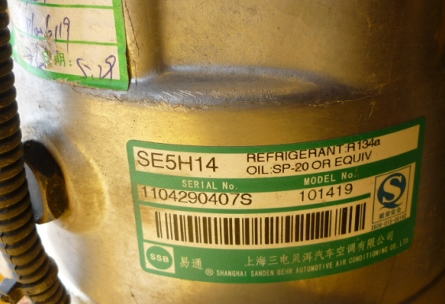
Refrigerant
SE5H14
Serial number : 1104290407S
Model number: 101419
Refrigerant gas: R 134

