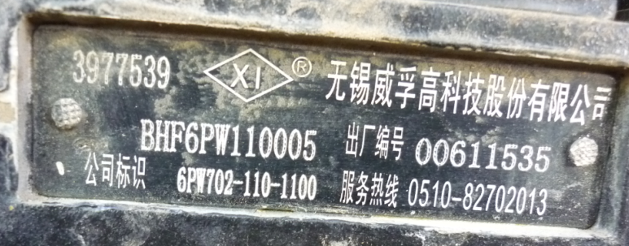
Fuel Pump
3977539
BHF6PW110005

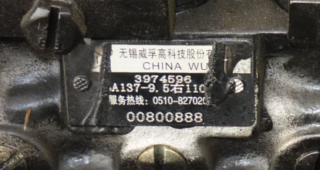
Fuel Pump
3974596

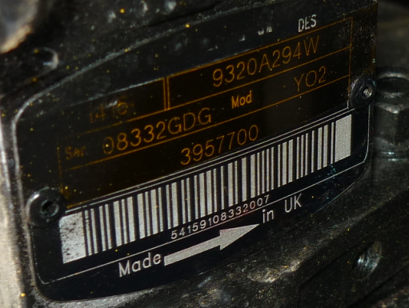
Fuel pump
Part number 9320A294W
Serial: 08332GDG

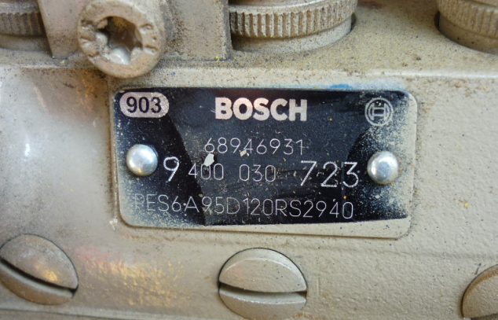
Fuel Pump
Bosch
68946931

