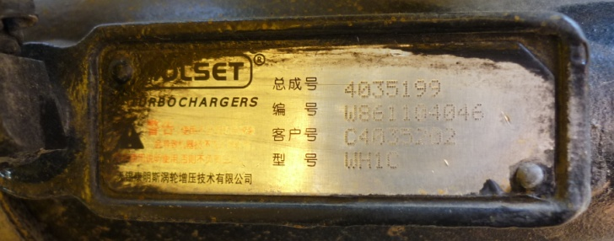
Turbocharge
Assy: 4035199
Serial: W861104046
Cust: C4035202
Model: WH1C

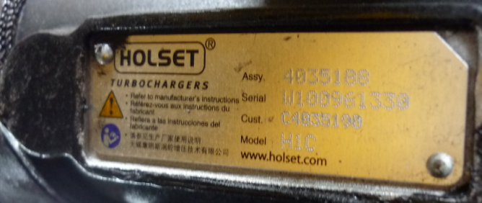
Turbocharger
Assy: 4035188
Serial: W100961330
Cust: C4035190
Model: H1C

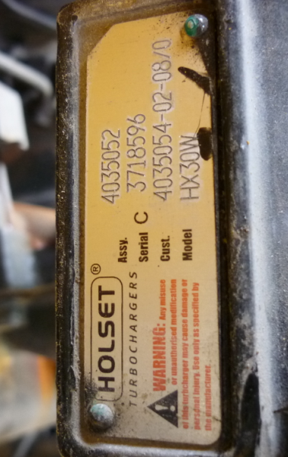
Turbocharges
Assy: 4035052
Serial: 3718596
Cust: 4035054-02-08/0
Model: HX30W

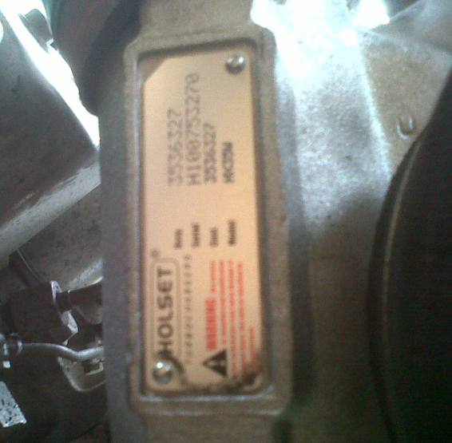
Turbocharger
Assy: 3536327
Serial: H100753270
Cust: 3536327
Model: HX35W

