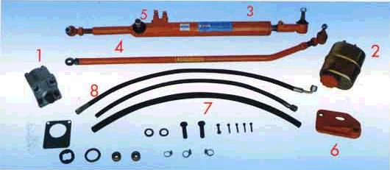
Tractor Power Steering Conversion Kit for
Fiat 480, 540, 640, 750, 780, 54C

TYPE | WORKING VOLUME  cm³ | RATED PRESSURE  bar | MAX PRESSURE  bar | MIN SPEED  MIN-1 | MAX SPEED  MIN-1 | ROTATION
A 25 | 11,3 | 175 | 200 | 650 | 3500 | Anti Clockwise

