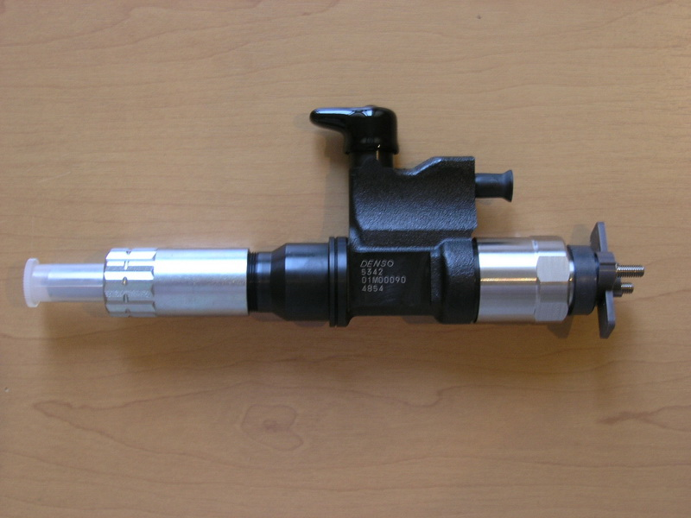

Injector assm, engine E-3, 4HK1-T, V-5,2, Denso 095000-5342, Isuzu 8976024854

