Tripod Joint/Universal Joint- Trizeta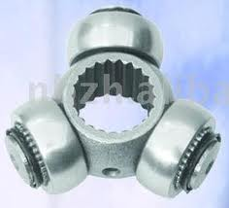
OEM | DESCRIPTION/YEAR/MODEL
7701638463 | CLIO 1.0 16V
7701056850 | CLIO 1.0 16V
7701056151 | Scenic (00) 2.0 8V
7700113959 | Scenic (00) 2.0 8V
7701056850 | Scenic (00) 2.0 8V
7701638463 | Scenic (00) 2.0 8V
7700113959 | Scenic (00) 2.0 8V
7701056850 | Scenic (00) 2.0 8V

