Control Arm /Braço Oscilante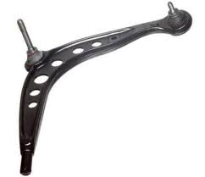
OEM | DESCRIPTION/YEAR/MODEL
8E0407694AG | PASSAT (99) 1.8 20V
8E0407693AG | PASSAT (99) 1.8 20V
8E0407506A | PASSAT (99) 1.8 20V
8E0407505A | PASSAT (99) 1.8 20V

