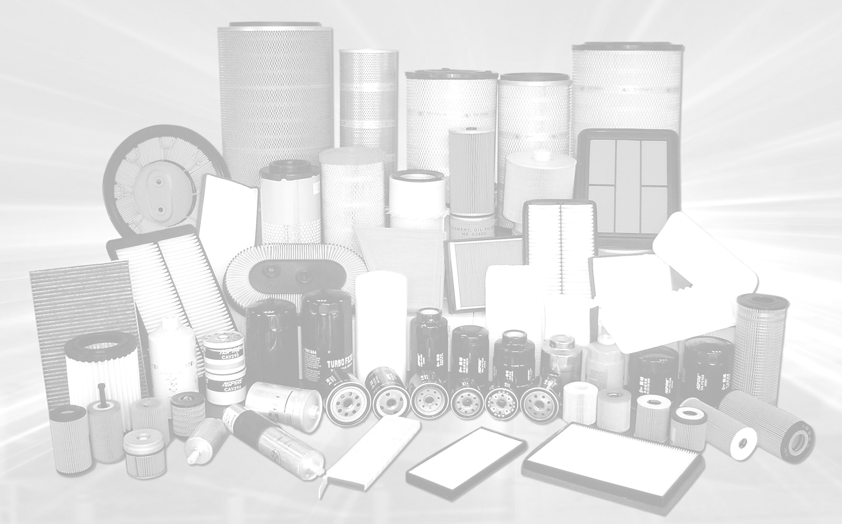
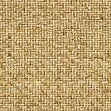
S/N | Description | Part No | FOB price USD | Quantity |  Remarks
1 | AIR FILTER | 17801-10030 |  | 2000pcs | Grey PP, White non-woven fabric
2 | AIR FILTER | 17801-11090 |  | 3500pcs | Grey PP, White non-woven fabric
3 | AIR FILTER | 17801-15070 |  | 2500pcs | Grey PP, White non-woven fabric
4 | AIR FILTER | 17801-35020 |  | 3500pcs | Grey PP, White non-woven fabric
5 | AIR FILTER | 17801-11050 |  | 1500pcs | Grey PP, White non-woven fabric
6 | AIR FILTER | 17801-74020 |  | 2300pcs | Grey PP, White non-woven fabric
7 | AIR FILTER | 17801-74060 |  | 500pcs | Grey PP, White non-woven fabric
8 | AIR FILTER | 17801-22020 |  | 5000pcs | White non-woven fabric
9 | AIR FILTER | 17801-21030 |  | 3000pcs | White non-woven fabric
10 | AIR FILTER | 17801-B1010 |  | 500pcs | White non-woven fabric
11 | AIR FILTER | 17801-21050 |  | 3000pcs | White non-woven fabric
12 | AIR FILTER | 17801-20040 |  | 500pcs | White non-woven fabric
13 | AIR FILTER | 17801-28010 |  | 500pcs | White non-woven fabric
14 | AIR FILTER | 17801-BZ050 |  | 500pcs | White non-woven fabric
15 | AIR FILTER | 17801-31120 |  | 500pcs | White non-woven fabric
16 | AIR FILTER | 17801-70010 |  | 500pcs | Grey PP, White non-woven fabric
17 | AIR FILTER | 17801-16020 |  | 500pcs | Grey PP, White non-woven fabric
18 | AIR FILTER | 17801-16010 |  | 2500pcs | Grey PP, White non-woven fabric
19 | AIR FILTER | 17801-13050 |  | 1500pcs | Grey PP, White non-woven fabric
20 | AIR FILTER | 17801-63010 |  | 500pcs | Grey PP, White non-woven fabric
21 | AIR FILTER | 17801-0C010 |  | 500pcs | Brown paper, black PU
22 | AIR FILTER | 17801-70050 |  | 1000pcs | White non-woven fabric
23 | AIR FILTER | 17801-50040 |  | 500pcs | Grey PP, White non-woven fabric
24 | AIR FILTER | 17801-54100 |  | 500pcs | Yellow paper
25 | AIR FILTER | 1500A190 |  | 500pcs | Grey PP, Yellow non-woven fabric
26 | AIR FILTER | MR266849 |  | 500pcs | Grey PP, Yellow non-woven fabric
27 | AIR FILTER | MD620584 |  | 500pcs | Grey PP, Yellow non-woven fabric
28 | AIR FILTER | MR188657 |  | 500pcs | Grey PP, Yellow non-woven fabric
29 | AIR FILTER | MR404847 |  | 500pcs | Grey PP, Yellow non-woven fabric
30 | AIR FILTER | MD620721 |  | 500pcs | Grey PP, Black non-woven fabric
31 | AIR FILTER | 16546-77A10 |  | 500pcs | Grey PP, Pink paper
32 | AIR FILTER | 16546-V0100 |  | 500pcs | Black PU, pink paper
33 | AIR FILTER | 13780-77A00 |  | 500pcs | Grey PP, White non-woven fabric
34 | AIR FILTER | 16546-2S601 |  | 500pcs | Yellow paper
35 | AIR FILTER | 16546-ED000 |  | 500pcs | White non-woven fabric
36 | AIR FILTER | 17220-PNB-Y01 |  | 500pcs | Yellow non-woven fabric
37 | AIR FILTER | 17220-P2N-A01 |  | 500pcs | Yellow paper
38 | A/C FILTER | 88568-52010 |  | 1000pcs | DIMENSION (17×196×216)
39 | A/C FILTER | 88508-20120 |  | 1000pcs | DIMENSION (17×215×216)

