Photo | Description | Price USD
INTERN CODE: MPD 297  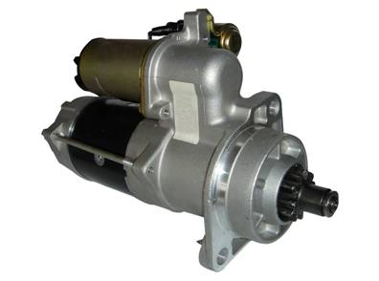 | STARTER 29MT 24V CW 11 TOOTH No OEM 8200297 (REPLACE DR 8200138/ EV BOSCH 0 001 231 033) APPLICATION FOR MERCEDES-BENZ OM 904/OM 906/ATEGO
INTERN CODE: MPB 002  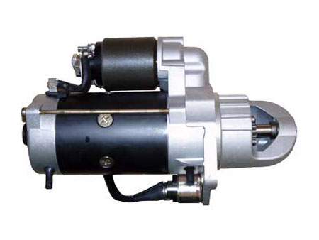 | STARTER BOSCH 0 001 231 002 SÉRIES PLGR 4.0 KW /24V CW 9 TOOTH (LESTER 18364) 2-2770-BO
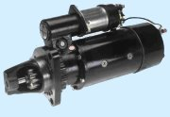  INT.CODE: MP 41MT | 41 MT STARTER 24V CW 12 TOOTH DR 10479292/DR 10479310. APPLICATION FOR MERCEDES-BENZ 1938L/1944L/2638LK/0400
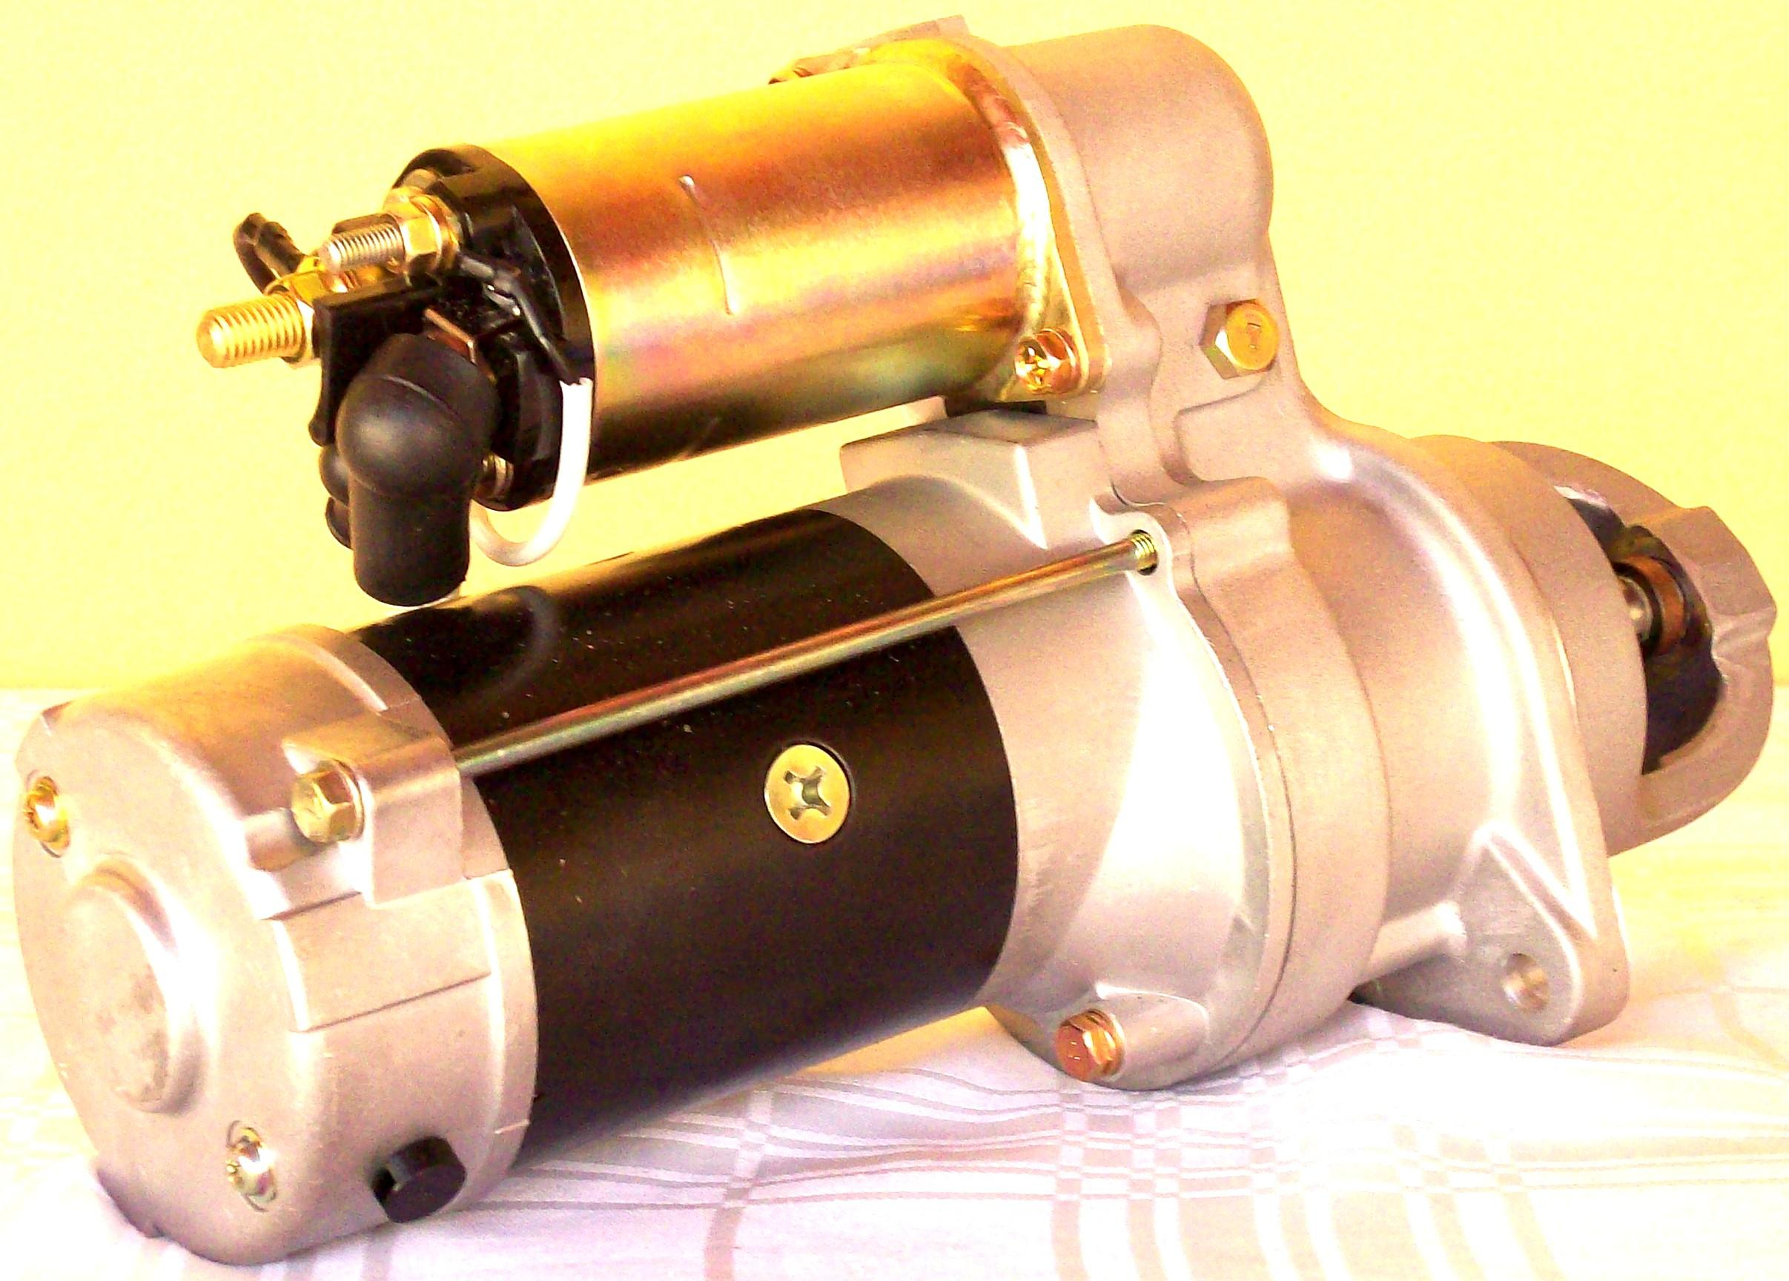  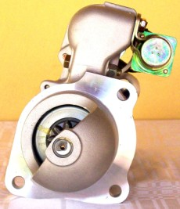  INT.CODE: MPD 650 | 28MT STARTER 24V CW 9 TOOTH DR 10479626/DR 10479650
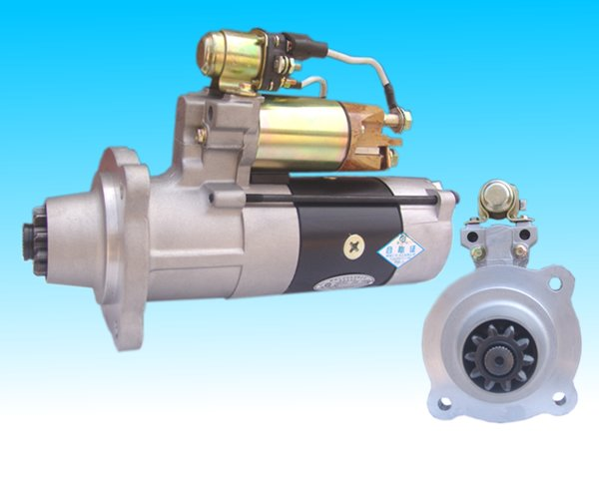  INT.CODE: MPM 61171 | MITSUBISHI STARTER M009T61171(VOLVO OEM 20430564) 24V

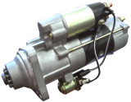

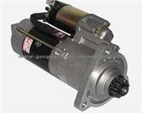  INT.CODE:MPM80472 | MITSUBISHI STARTER M009T80472 24V (MERCEDES-BENZ A 006 151 1501)
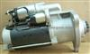  INT.CODE:MP001/S4 | STARTER BOSCH 0 001 241 001 24V) APPLICATION SCANIA S4
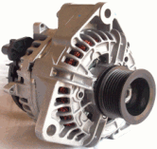  INT.CODE:AB015 | ALTERNATOR BOSCH O.124.555.015/007 28V/80A MAIN APPLICATION MERCEDES-BENZ (VW) (OTHERS)IND
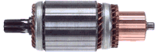  INT.CODE:MP117 | ARMATURE DR 10457117(WAI 61-8401) 28MT 24V(USED FOR STARTER 10479626/10479650/10479652)
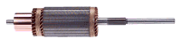  INT.CODE:IND41MT24 | ARMATURE DR 10472559 41MT 24V
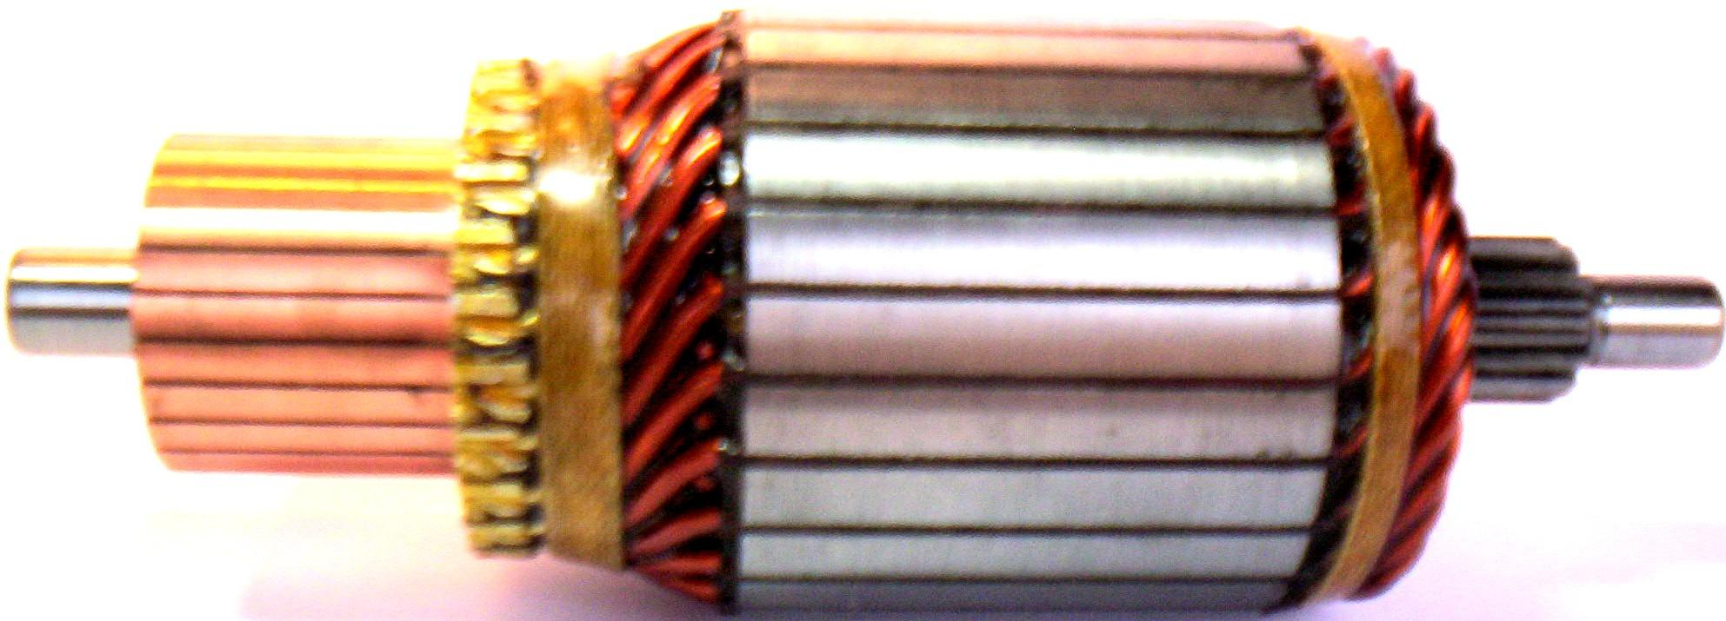  INT.CODE:IND29MT24 | ARMATURE FOR STARTER DR 8200297 29MT 24V

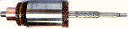  INT.CODE:IND.JF24V | ARMATURE FOR STARTER BOSCH 9 000 083 065/064/079 (OTHERS)24V (No 9 001 083 498)
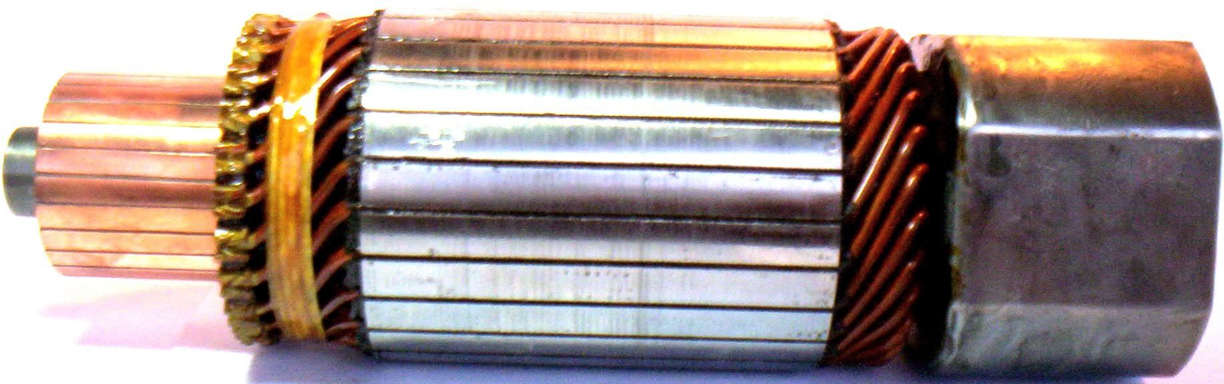  INT.CODE:IND.KB24V | ARMATURE FOR STARTER BOSCH 9 000 084 012/013/018/024(OTHERS) 24V (No 2 004 005 151)
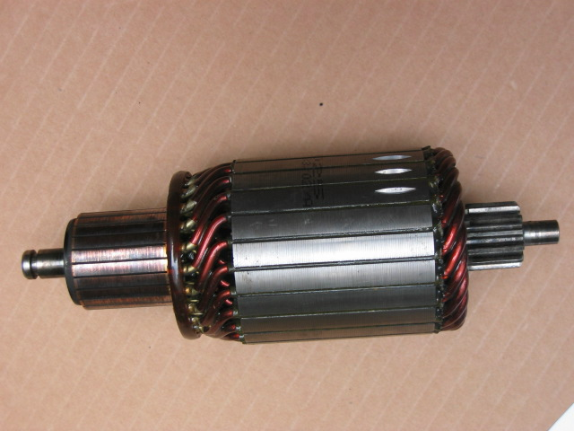  INT.CODE:IND.BS4 | ARMATURE FOR STSRTER BOSCH 0 001 241 001 24V (No 6033AD5025)
INT.CODE:IND.M171 | ARMATURE FOR STARTER MITSUBISHI M009T61171 24V (VOLVO 20430564)
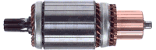  INT.CODE:INDM472 | ARMATURE FOR STARTER MITSUBISHI M009T80472 24V(MERCEDES-BENZ A 006 151 1501)
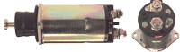  INT.CODE:AUT.810 | SOLENOID FOR SARTER DR 10479652 24V(OTHERS) No DR 10483810

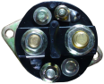  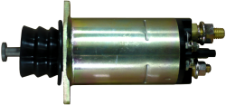  INT.CODE: AUT 815 | SOLENOID FOR STARTER DR 10479626/10479650 24V (NUMBER DR 10457368) 24V
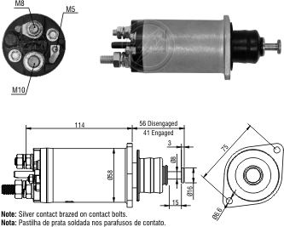  INT.CODE: A29MT24 | SOLENOID FOR STARTER 29MT 24 V DR (8200004/54/64/65/296) No DR10515840 24V (ZM 1-818)
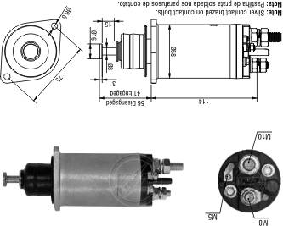  INT.CODE:A782/29D | SOLENOID FOR STARTER ( DR 8200183/8200297) No 10518782 (24V) (ZM 2- 818)
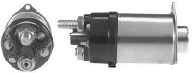  INT.CODE:A37M621 | SOLENOID FOR STARTER 37MT DR 10479196 (No DR1115621) 24V
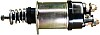  INT.CODE:ADR677 | SOLENOIDE SEMI SOLID LINK FOR (STARTER DR 10479196) 24V (No 1115677)
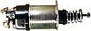  INT.CODE:ASL637 | SOLENOID SEMI SOLID LINK FOR (STARTER 41MT DR 10479292/10479310) 24V – No DR 10512637
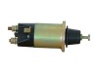  INT.CODE:AM171 | SOLENOID FOR STARTER MITSUBISHI M009T61171(VOLVO 20430564) 24V

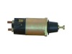  INT.CODE:AM472 | SOLENOID FOR STARTER MITSUBISHI M009T80472 (MB A006 151 1501) 24V
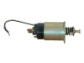  INT.CODE: 39MT409 | SOLENOID DR 10511409 39MT 24V
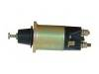  INT.CODE:ADR094 | SOLENOID DR 10512094 38MT 24V(8200053/072)( VW TITAN TRACTOR/CONSTELLATION/CARGO ELETRONIC)
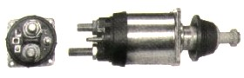  INT.CODE:AJE006 | SOLENOID BOSCH 2 339 403 006(JE) USED FOR STARTER BOSCH(0 001 371 006/9 000 453 068) 24V
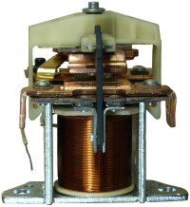  INT.CODE:AKB006 | SOLENOID BOSCH 0 331 101 006 24V (WAI 66-9110) (ZM 902)
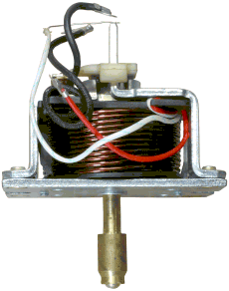  INT.CODE:AKB001 | SOLENOID BOSCH 0 331 450 001 24V (WAI 66-9118) (ZM 902)
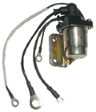  INT.CODE:RA366 | AUXILIARY RELAY DR 10457366 24V (USED FOR STARTERS 10479626/10479650)
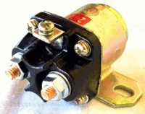  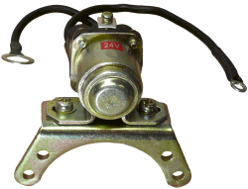  INT.CODE:RA5659 | AUXILIARY RELAY DR 10483616 24V (USED FOR STARTER 10479196)

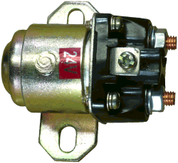  INT.CODE:RA29MT | AUXILIARY RELAY 29MT 24V DR 10518784
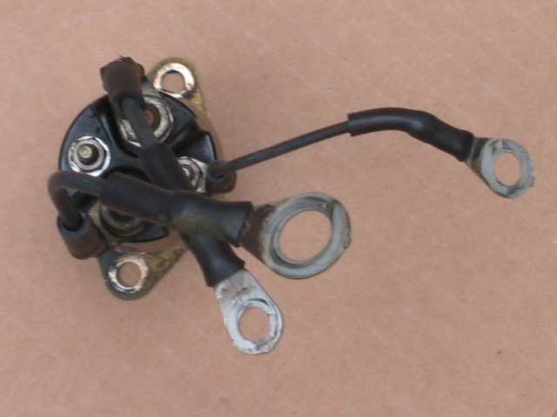  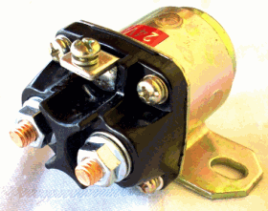  INT.CODE:RA5659 | AUXILIARY RELAY DR 1115659 (FOR STARTER 10479652) 24V
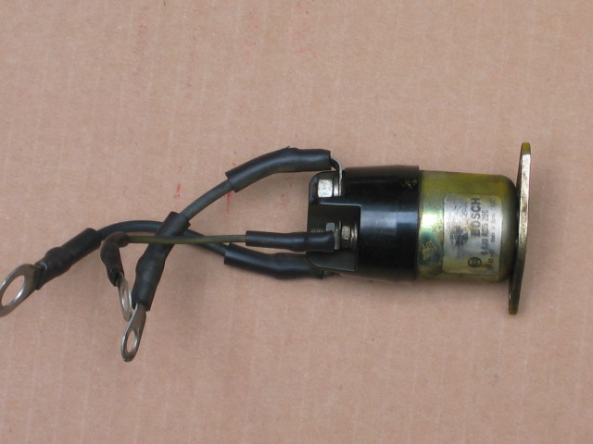  INT.CODE:RAS4 | AUXILIARY RELAY FOR STARTER BOSCH 0 001 241 001 24V
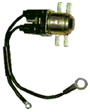  INT.CODE.RAM472 | AUXILIARY RELAY FOR STARTER MITSUBISHI M009T80472 24V
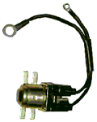  INT.CODE:RAM171 | AUXILIARY RELAY FOR STARTER MITSUBISHI M009T61191
INT.CODE:RAB002 | AUXILIARY RELAY FOR STARTER BOSCH 0 001 231 002 / 24V

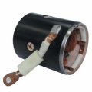  INT.CODE:CP28/24V | FIELD COIL COMPLETE DR 10457118 (24V) (FOR STARTER 28MT 24V DR 10479626/10479650/10479652/OTHERS)
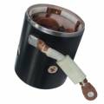  INT.CODE:CP29/24V | FIELD COIL COMPLETE FOR STARTER DELCOREMY 8200297 29MT/ 24V
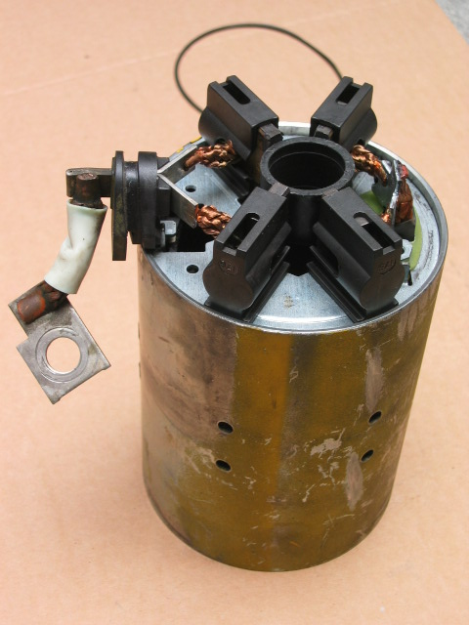  INT.CODE:CP1171 | FIELD COIL COMPLETE FOR STARTER MITSUBISHI M009T61171(VOLVO 20430564) 24V
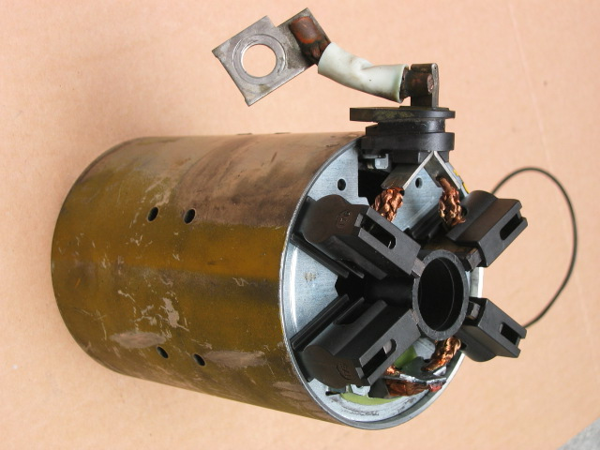  INT.CODE:CPMIT472 | FIELD COIL COMPLETE FOR STARTER MITSUBISHI M009T80472(MB A006 151 1501) 24V
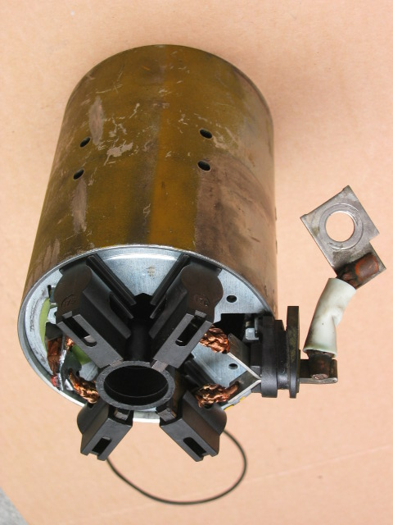  INT.CODE:CPB001 | FIELD COIL COMPLETE FOR STARTER BOSCH 0 001 241 001
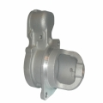  INT.CODE:MD1722 | HOUSING DR 10457359 (FOR STARTER DR 10479626/DR10479650)
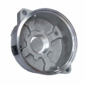  INT.CODE:TT1722 | LID CLOSURE DR 10500290 ( FOR STARTER 10479626 / 10479650)

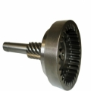  INT.CODE:PLAN1722 | SHAFTY PLANETARY DR 10457357 (FOR STARTER 10479626 / 10479650)
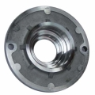  INT.CODE:FLA28MT | FLANGE AXLE IMPELLER DR 10456470 (STARTERS 28MR MODELS VARIOUS)
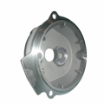  INT.CODE:MI363 | INTERMEDIATE HOUSING DR 10457363 (FOR STARTER 10479626 / 10479650)
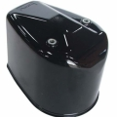  INT.CODE: TFECH/KB | LID CLOSURE BOSCH No 9 001 084 160 / 0 331 101 005)
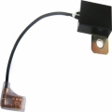  INT.CODE:COND250V | CONDENSER 2,2 uf 250V
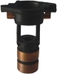 | SLIP RING FOR ROTOR ALTERNATOR (BOSCH 0 124 555 002 / 007 /015/ 022 OTHERS)
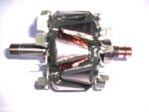  INT.CODE: ROT 1722 | ROTOR BOSCH F 00M 131 616 (FOR ALTERNATOR 0 124 555 002 / 0 124 555 015 / 0 124 555 022) 28V 80A

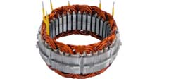  INT.CODE:EST1722 | STATOR BOSCH No F 00M 130 112 (FOR ALTERNATOR 0 124 555 002/ 0 124 555 007/ 0 124 555 016, OTHERS) 28V 80A
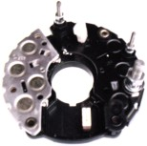  INT.CODE:CR753 | RECTIFICIER BOSCH 1 127 320 753 (FOR ALTERNATOR BOSCH 6 033 GB3 022 (OTHERS) 28V / 80A
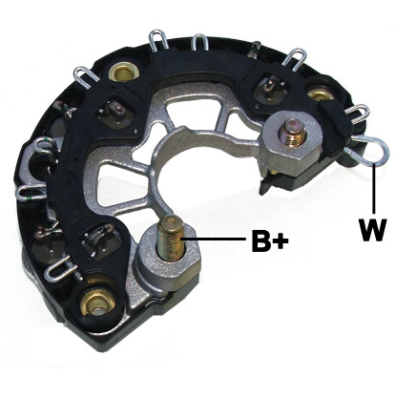  INT.CODE:R3224 | RECTIFICIER BOSCH F 00M 133 224 (FOR ALTERNATOR BOSCH 0 124 555 002/013/015/022 OTHERS)
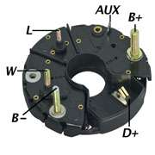  INT.CODE:RET/EDC | RECTIFICIER BOSCH 1 127 320 995 28V 55A (1 127 320 928/969/989)
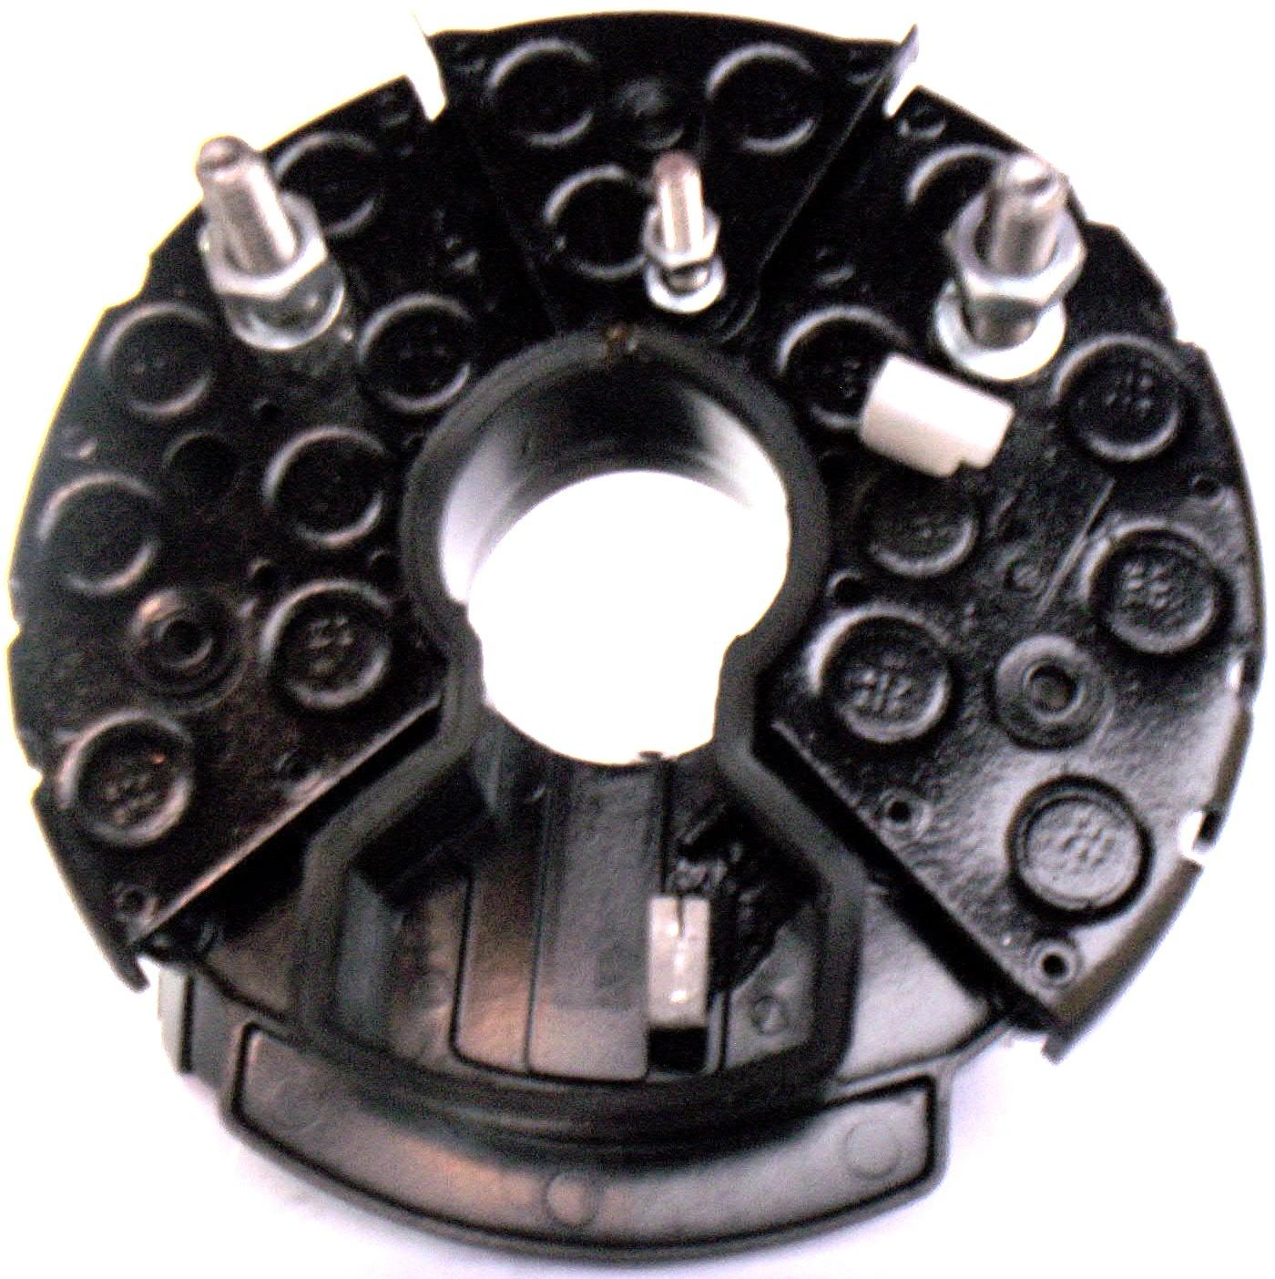  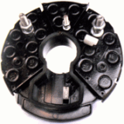  INT.CODE: RET547 | RECTIFICIER BOSCH 1.127.320.547/ 973 (28V 75-140A) IR/IF
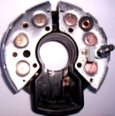  INT.CODE: RET541 | RECTIFICIER BOSCH 1.127.320.541 (12/28V 35-100A)

