722-011 – shackle
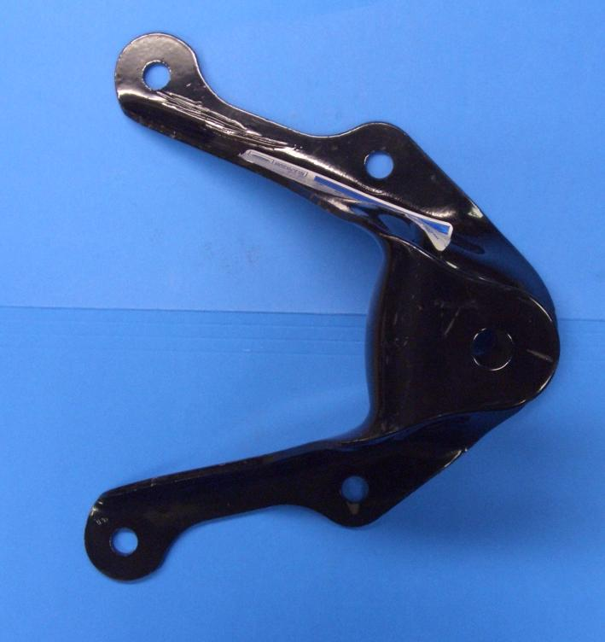
Part No. | Quantity | Part No. | Description
1 | 1 | 722-011-BOX | Box
2 | 1 | 722-011-LBL | Label
3 | 1 – FAI PO only |  | 5 x 7 Customer Card  (*see required text below )
4 | 1 | 722-011-1 | Shackle
5 | 4 | 722-003-3 | M10X1.5 Bracket Prevailing Torque Nut
6 | 4 | 722-003-4 | M10X1.5 Bracket Bolt

*Customer Card Required Text:

We appreciate your opinions regarding this product!

Please call our technical assistant with any challenges or suggestions regarding the installation or operation of this product

