28 | 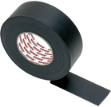 | PVC Insulation Tape  19mm 10 Yards

