26 | 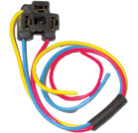 | Holder For H4 Lamps P43t-38, P45t-41  Nylon
27 | 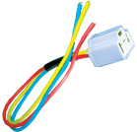 | Holder For H4 Lamps P43t-38, P45t-41  Ceramic

