25 | 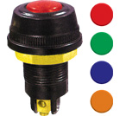 | Dash Board Light  Tata, Diesel Tempo, Hind. Tractors  Red, Green, Blue, Yellow | RED/GREEN

