22 | 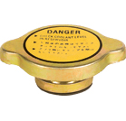 | Radiator Cap  Round Medium
23 | 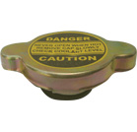 | Radiator Cap  Round Small
24 | 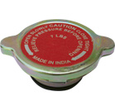 | Radiator Cap  Korek chłodnicy  Ursus C-360

