19 | 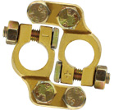 | Battery Terminal (Forged) - 100% BRASS  Angle Bosch Type  Pair (Negative & Positive) | (+,-)

