16 | 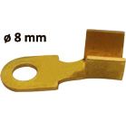 | Battery Cable Lug - Machine Made  Cable Lug (Brass)  Ø 8mm; 2.00 mm | Barss, BRONZE Color
17 | 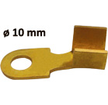 | Battery Cable Lug - Machine Made  Cable Lug (Brass)  Ø 10mm; 2.00 mm | Barss, BRONZE Color
18 | 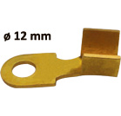 | Battery Cable Lug - Machine Made  Cable Lug (Brass)  Ø 12mm; 2.00 mm | Barss, BRONZE Color

