13 | 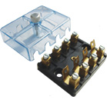 | Fuse Box for Continental Fuse  with Transparent Cover; 4 Poles  Universal / Swaraj
14 | 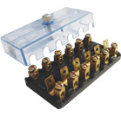 | Fuse Box for Continental Fuse  with Transparent Cover; 6 Poles  Ford Tractors, Nova, Jeep
15 | 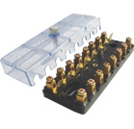 | Fuse Box for Continental Fuse  with Transparent Cover; 8 Poles  Matador / Deutz Tractors

