10 | 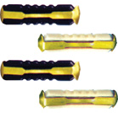 | Fuse (Porcelain Type) Continental  8, 16, 25 Amp.  Pack of 100 Pcs.
11 | 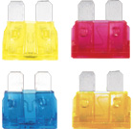 | Fuse Blade  5,7½,10,15, 20, 25, 30, 35, 40 Amp.  Pack of 100 Pcs. | 20A,25A,30A,35A,40A
12 | 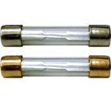 | Fuse (Glass) Cylindrical Tata  10, 35 Amp.  Pack of 100 Pcs.

