9 | 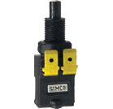 | Brake Lamp Switch  Jeep Peugeot | black color

