5 | 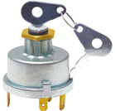 | Heater Starter Switch 6 Terminals  Massey Ferguson, Inter N/M D.I., Tafe  Case/IH, David Brown

