2 | 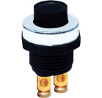 | Push Horn Button  Metallic Cap  Fix Hole: Ø 20.50mm
3 | 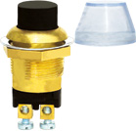 | Push Button (Starter / Horn)  Brass Body, Fix Hole: Ø 19mm, with Water Protective Cap  Inter / Universal

