Skoda Octavia A5 Front Bumper
( Model Number : skoda octavia A5 )
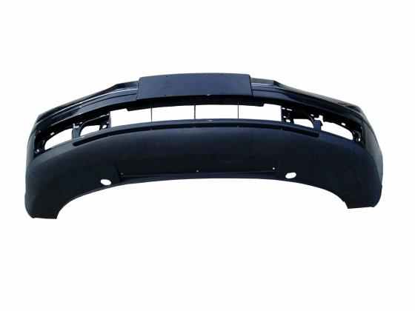
Model Number | skoda octavia A5

front bumper for SKODA Octavia A5 model.
OEM NO.: 1ZD 807 221
very good quality

