RH FT CONTROL ARM :: A21-2909020 QTY = 200

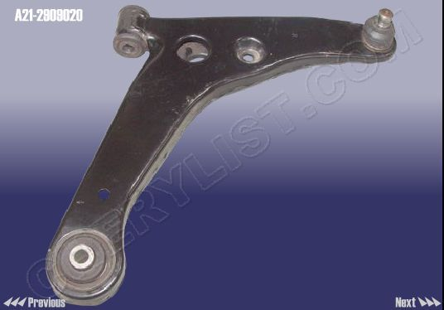

CONTROL ARM ASSY-LH :: A21-2909010 QTY = 200
