AIL LAMP ASSY-RR RH :: A21-3773020

QTY = 200

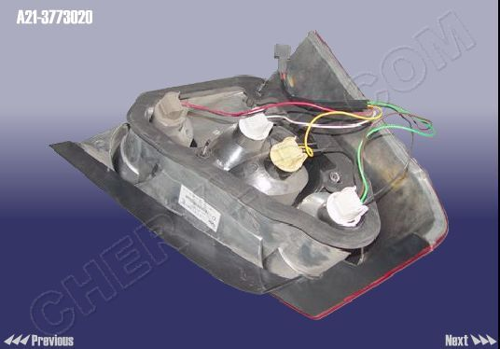

HEAD LAMP ASSY-FR RH :: A21-3772020

QTY = 200

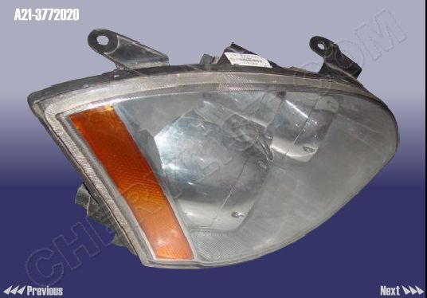

QTY = 200
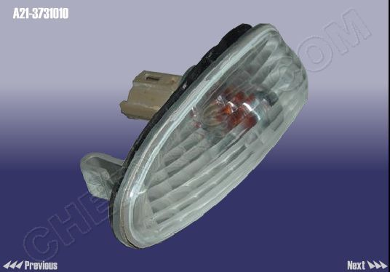

HEAD LAMP ASSY-FR RH :: A21-3772020AB

QTY = 200

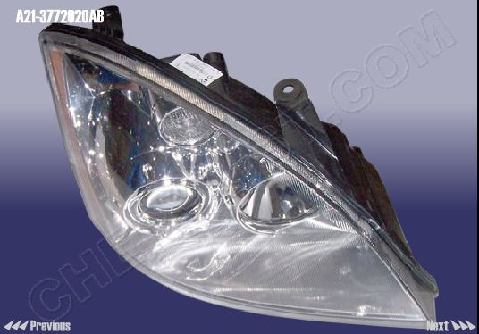

FOG LAMP ASSY-FR RH :: A21-3732020

QTY = 200

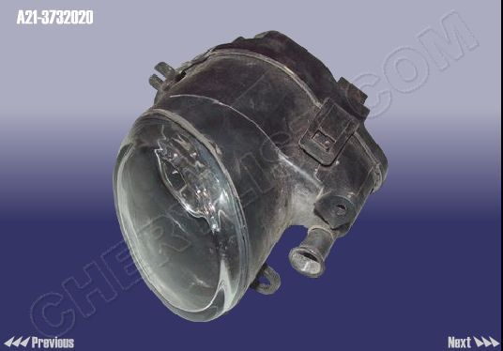

TAIL LAMP ASSY-RR LH :: A21-3773010

QTY = 200

