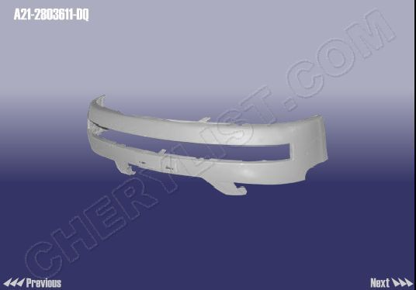

BODY-FRONT BUMPER :: A21-2803611-DQ
QTY = 500

ABSORBOR MEMBER-FRONT BUMPER :: A21-2803700
QTY = 100

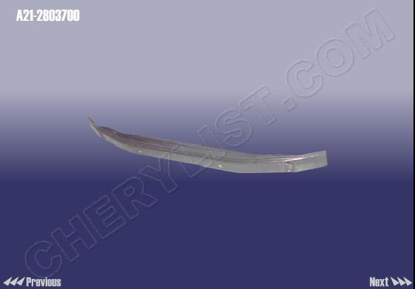

BUMPER BODY-RR(BASE PAINT) A21-2804601-DQ ,

QTY = 200

