CHERY FORA A21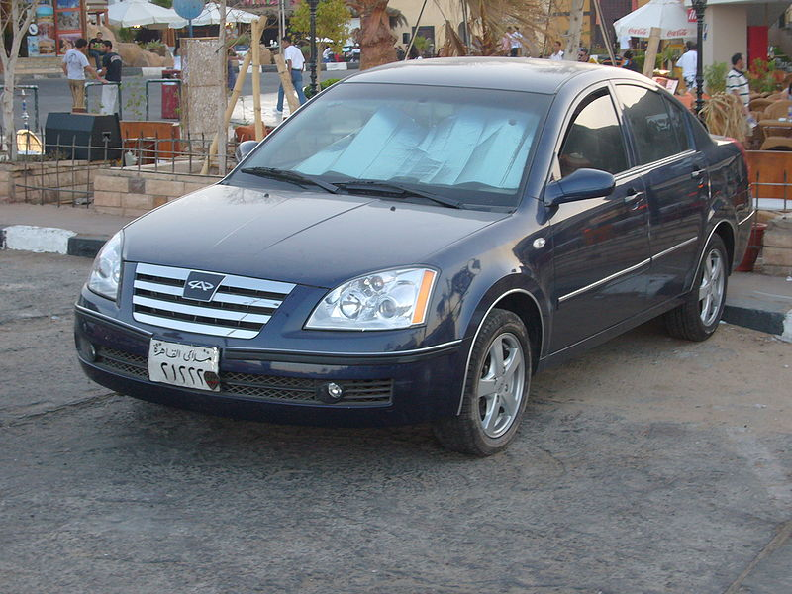

CHERY A5

EXHAUST SYSTEM
AUTO PART Aftermarket quantity A
THE DETAILS

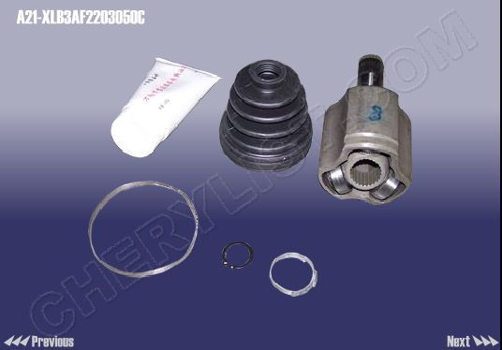QTY = 10

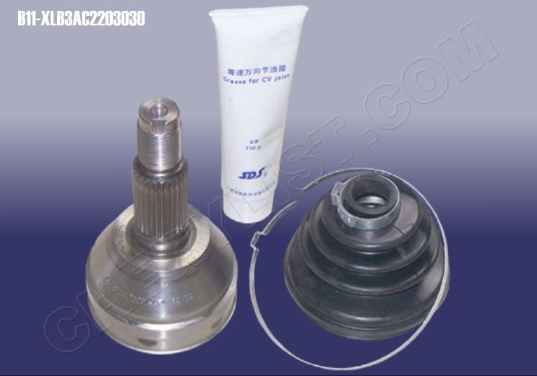
QTY = 20

QTY = 10

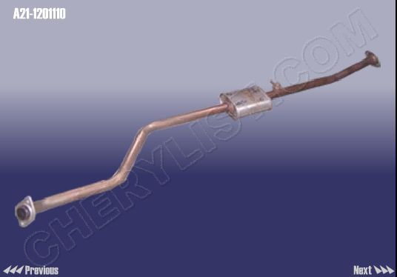

SILENCER - RR :: A21-1201210 QTY = 10

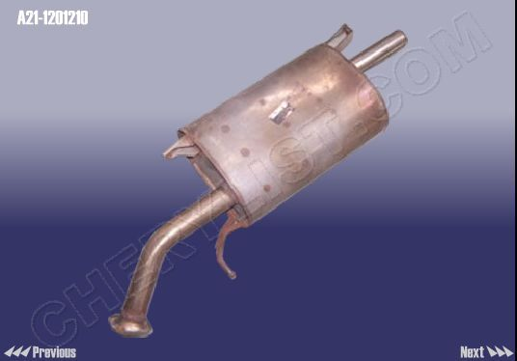
BL

OCK :: A21-1200017 QTY = 200

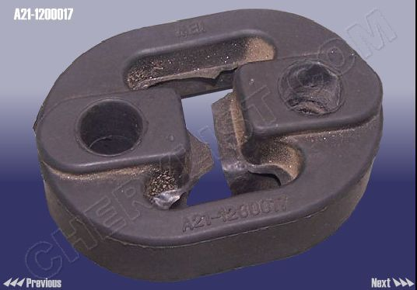

QTY = 10

OXYGEN SENSOR вЄ :: A11-1205310

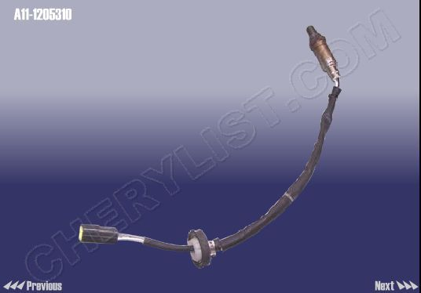
SENS

OR - OXYGEN вё :: A11-1205110DA

QTY = 10

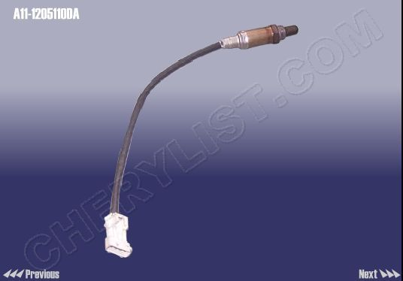

QTY = 20

HANGER II :: A21-1200018

ELECTRIC FUEL PUMP ASSY :: A21-1106610
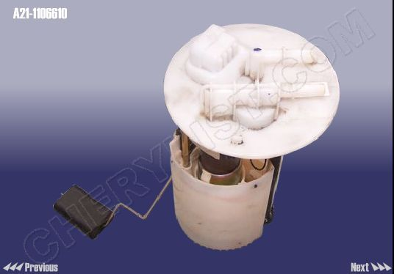

QTY = 10

FUEL INLET TEE-PIPE ASSY. :: A21-1104220

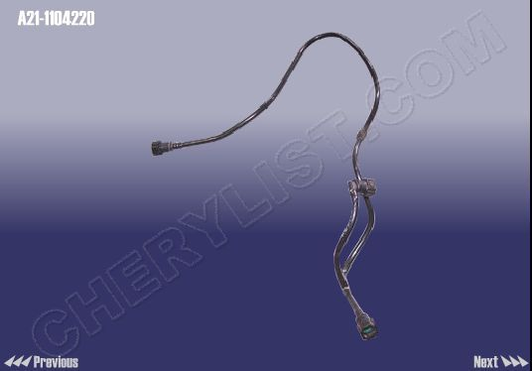

QTY = 2

ACTIVE CARBON CANISTER ASSY :: A21-1208110
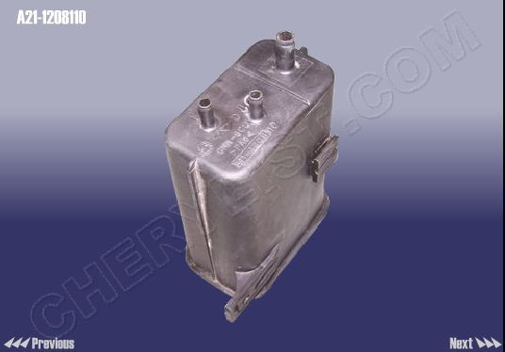

PIPE-ENGINE TO EXPANSION TANK :: A21-1303701

QTY = 20

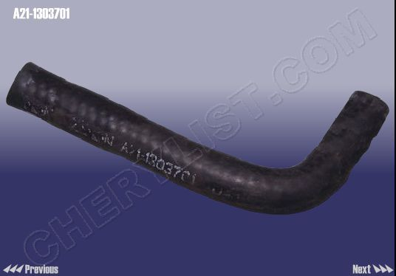 QTY = 100

QTY = 200
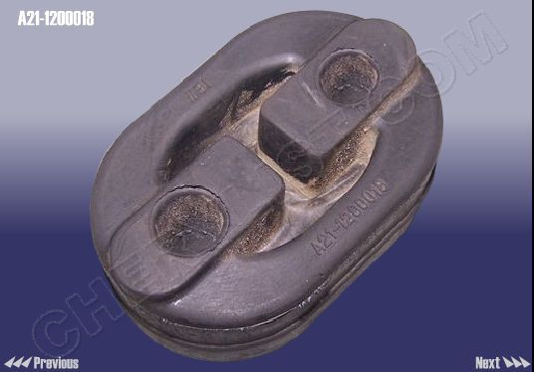

QTY = 20

CAP ASSY - FUEL TANK :: S11-1103010

INFLATION BOX :: A21-1311110
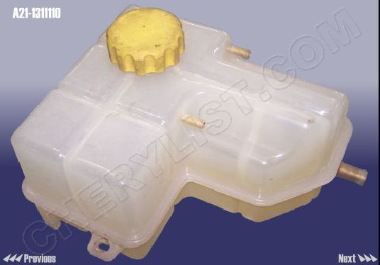

PIPE-ENGINE TO EXPANSION TANK 2 :: A21-1303703
QTY = 100

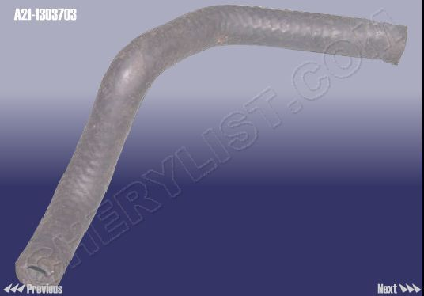

PIPE-EXPANSION TANK TO WATER PUMP :: A21-1303801
QTY = 100

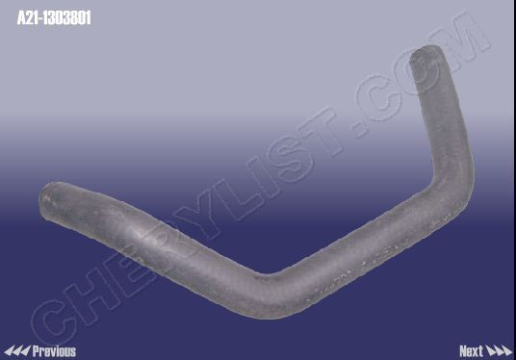

ENGINE PIPE - DISCHARGE :: A21-1303201
QTY = 100

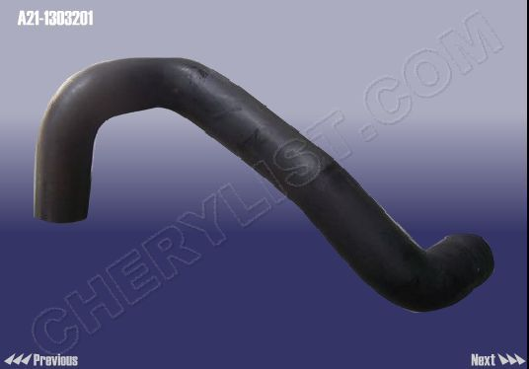

WATER OUTLET HOSE-OIL COOLER :: A21-1303621
QTY = 100

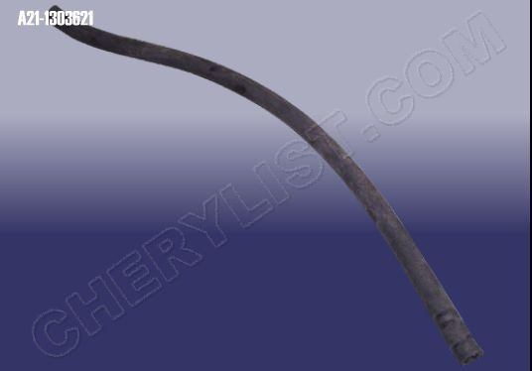

RADIATOR ASSY :: A21-1301110
QTY = 100

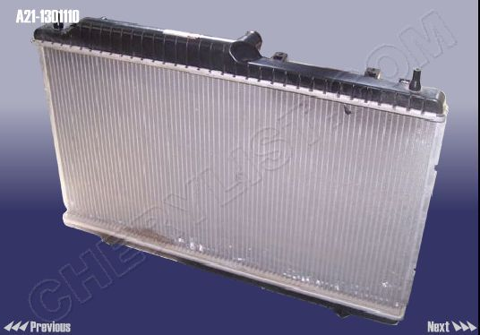

RADIATOR FAN :: A21-1308010
QTY = 10

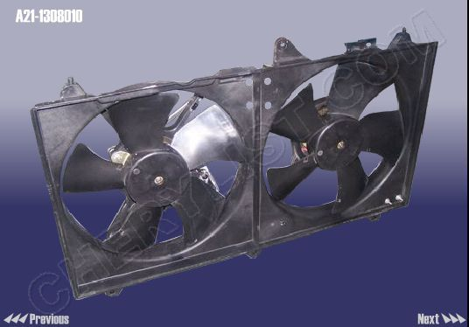

HOSE - OUTLET гиTHROTTLE :: A21-1303821
QTY = 10

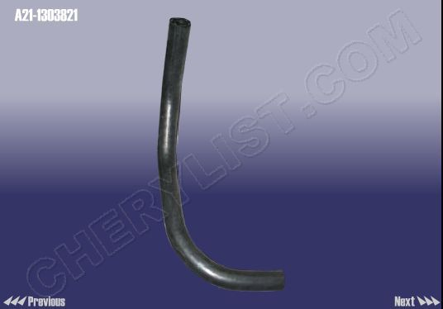

ENERGY ABSORBER :: A21-2803531
QTY = 100

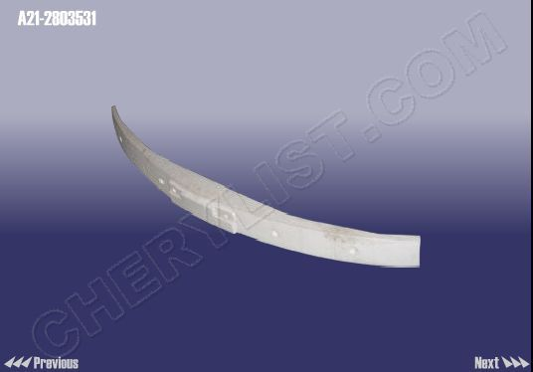

GRILLA-AIR INTAKE FR :: A21-2803651GRILLA-AIR INTGRILLE BODY :: A21-8401111
QTY = 200

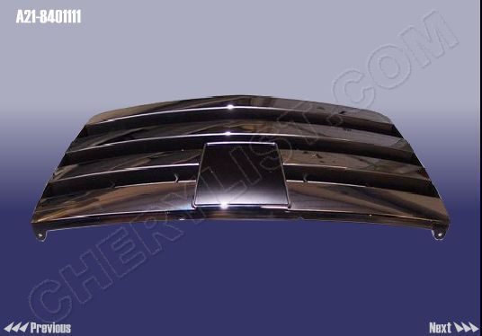

SIDE HANDLE :: A21-6105210-DQ
QTY = 10

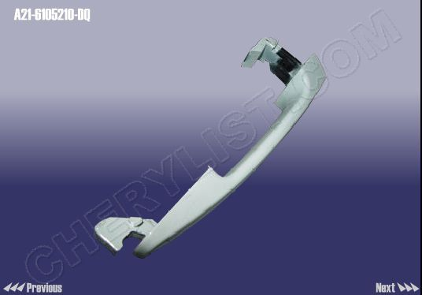

FRAME - INNER HANDLE LH :: T11-6105131
QTY = 100

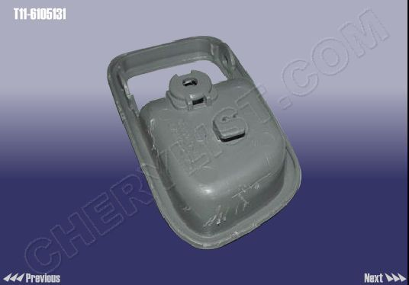

BUSH :: T11-6105225
QTY = 100

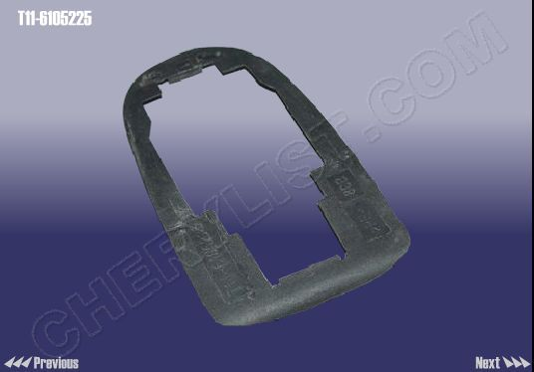

HANDLE SEAT ASSY - RR DOOR RH :: A21-6205240
QTY = 100

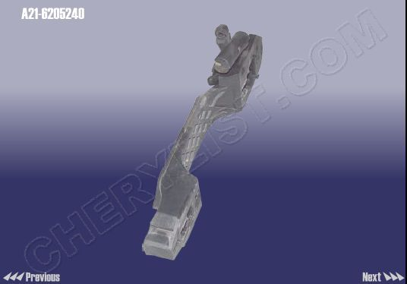

LOCK ASSY-RR DOOR RH :: A21-6205020
QTY = 10

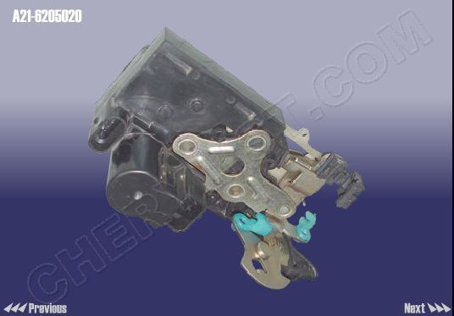

ROD ASSY - INNER LOCK RH :: A21-6105120
QTY = 100

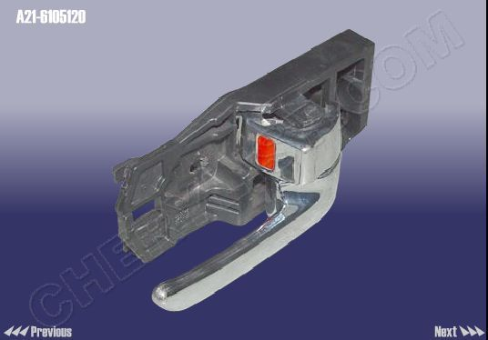

REAR DOOR CHECK :: A21-6209110
QTY = 10

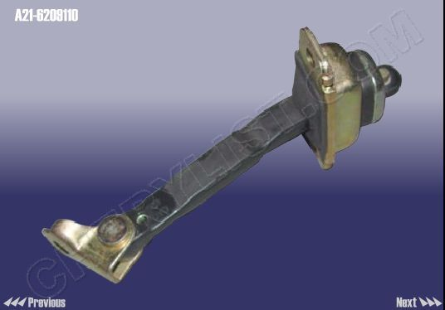

FRAME - INNER HANDLE RH :: T11-6105132
QTY = 100

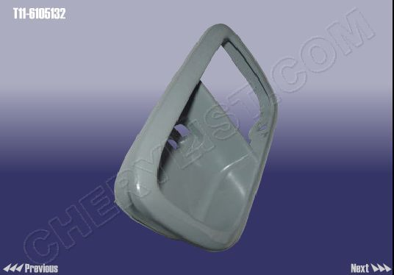

ROD ASSY - INNER LOCK LH :: A21-6105130
QTY = 100

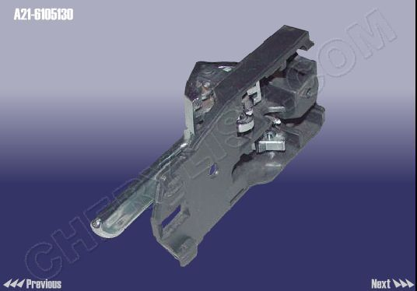

SWITCH ASSY-FR DOOR WINDOW RAGULATOR LH :: A21-6104110

QTY = 10 OF EACH DOOR

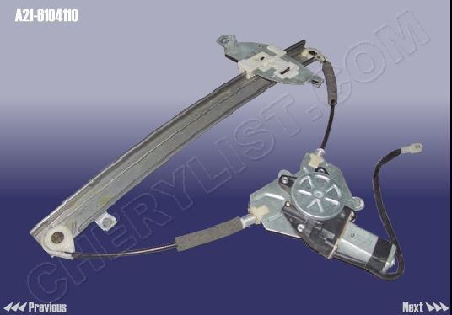

IGNITION SWITCH HOUSING :: A21-3704013
THE OEM FOR EGYPT QTY = 100

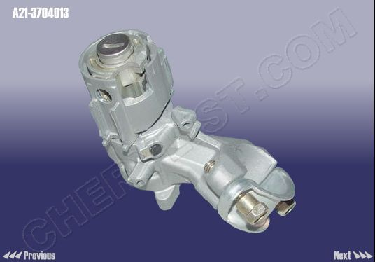

QTY = 40 1-1: CONTROLLE electronic Chip :: A21-7900011 -
: QTY = 40 CONTROLLE body and blank key :: A21-8CB6105330SP

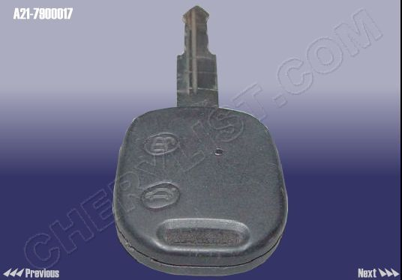

QTY = 50 WINDOW REGULATOR and SWITCH ASSY :: A21-3746050
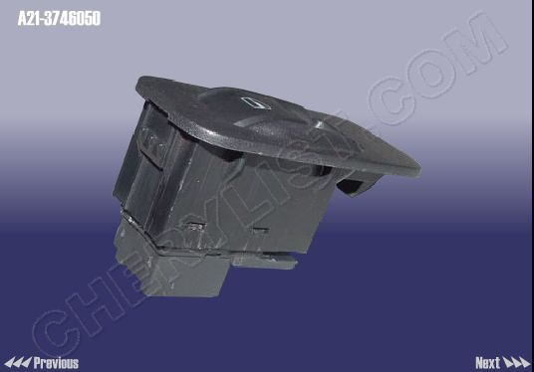

BUFFER CROSSBEAM BRAKET-RR BUMPER :: A21-2804703

QTY = 50

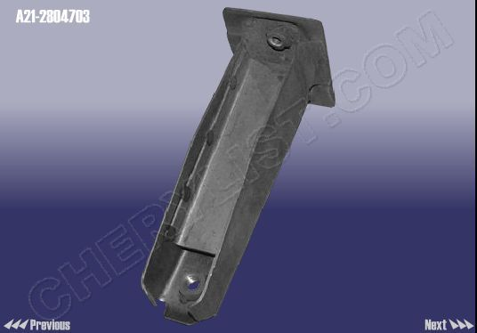

REINFORCEMENT PANEL-RR BUMPER LH UPR :: A21-2804605

QTY = 50

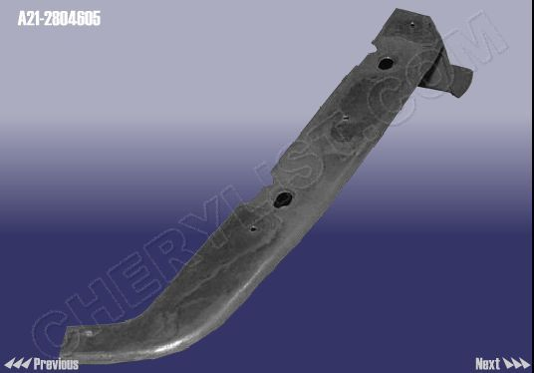

FENDER ASSY-FR RH :: A21-8403760-DY

QTY = 100

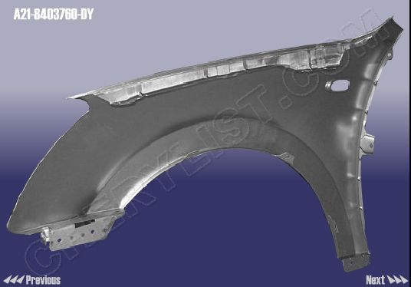

SIDE PANEL ASSY-LH (ELECTROPHORESIS) :: A21-5400010-DY

QTY = 10

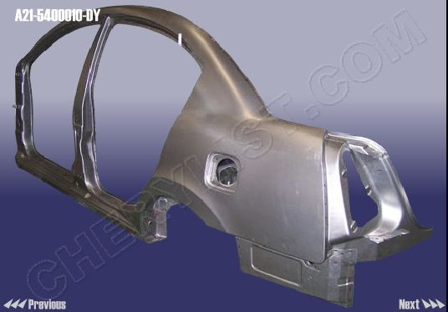

APRON ASSY - RH (ELECTROPHORESIS) :: A21-5400020-DY

QTY = 10

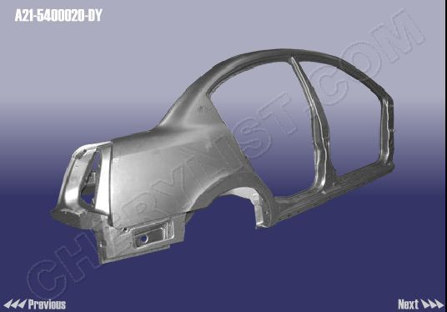PANEL ASSY - FR FENDER LH :: A21-8403750-DY

QTY = 100

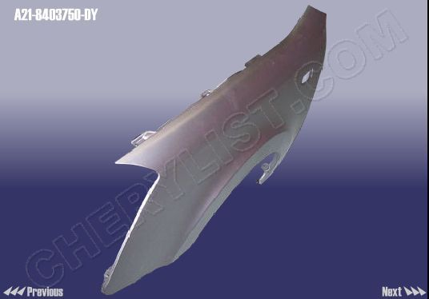

QTY = 100
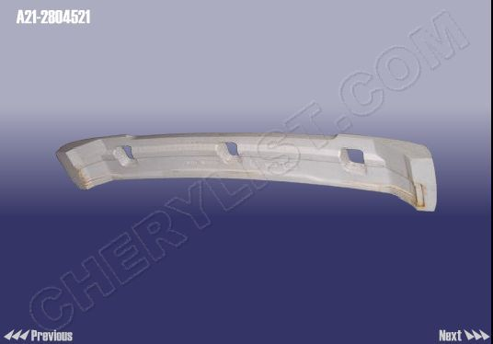

QTY = 100
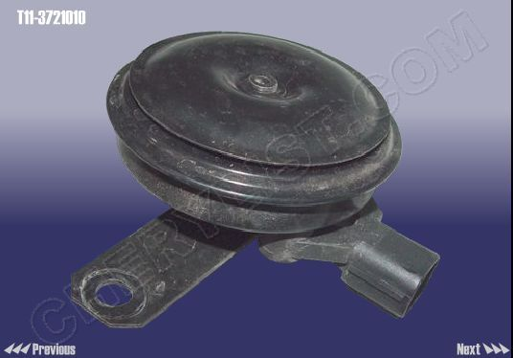

QTY = 100

LOW-TUNE HORN :: T11-3721020

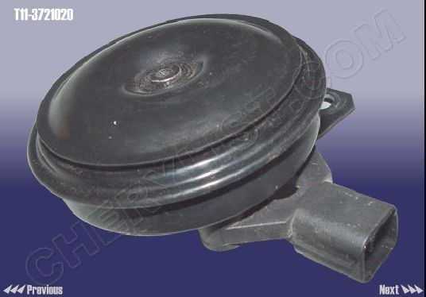

BATTERY FUSE BOX-POSITIVE :: A21-3723060

QTY = 2

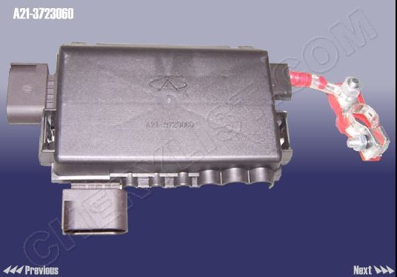

21 | A21-3735015 QTY = 200 | RELAY-20A
22 | A21-3735027 QTY = 200 | RELAY-30A
23 | A21-3600080 QTY = 200 | FAN RELAY

QTY = 100

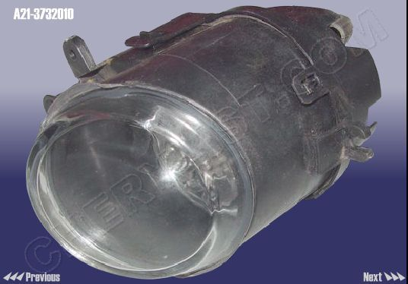

FLOWMETER - AIR :: A11-3614011

QTY = 50

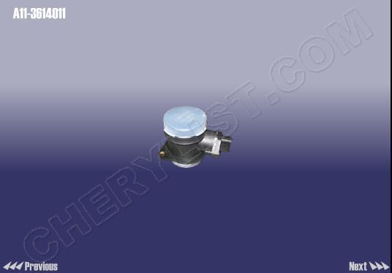

SENSOR - SHOCK :: B11-3611031

QTY = 20

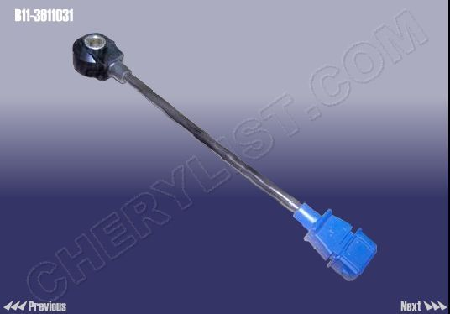

GASKET - VALVE CHAMBER COVER :: 481H-1003042

QTY = 20

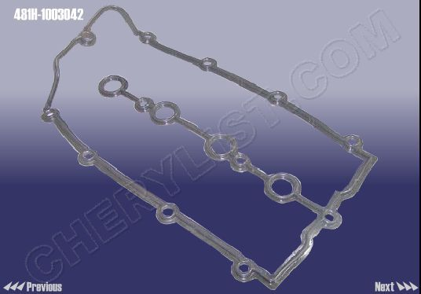

SENSOR-CAMSHAFT POSITION :: A11-3611011

QTY = 50

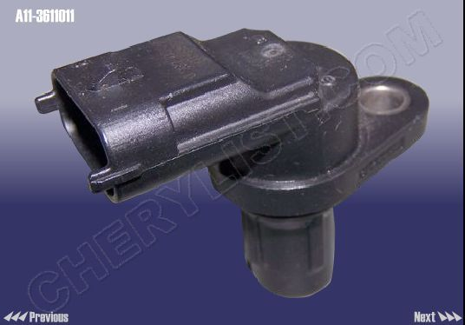

GENERATOR ASSY :: B11-3701110BB

QTY = 10

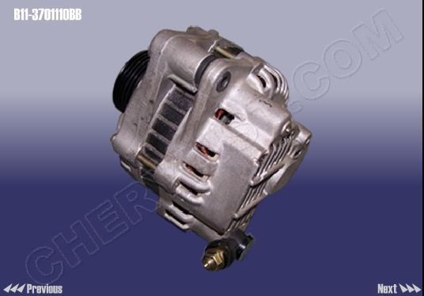

STARTER ASSY :: B11-3708110BA

QTY = 10

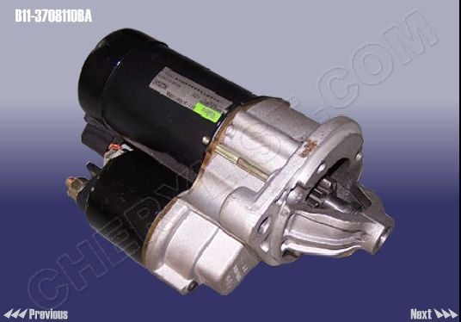

IGNITION COIL :: A11-3705110EA

QTY = 10

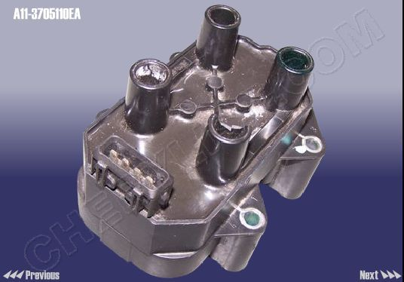

1 | A11-3707130GA QTY = 10 | CABLE-SPARK PLUG 1ST CYLINDER
2 | A11-3707140GA QTY = 10 | CABLE ASSY - SPARK PLUG NO.2
3 | A11-3707150GA QTY = 10 | CABLE-SPARK PLUG 3
4 | A11-3707160GA QTY = 10 | CABLE-SPARK PLUG 4

QTY = 10

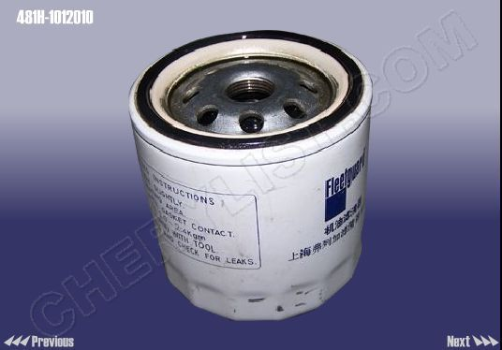

DOOR ASSY- FR DOOR LH (ELECTROPHORESIS) :: A21-6101010-DY

DOOR ASSY-RR LH :: A21-6201010-DY

QTY = 10

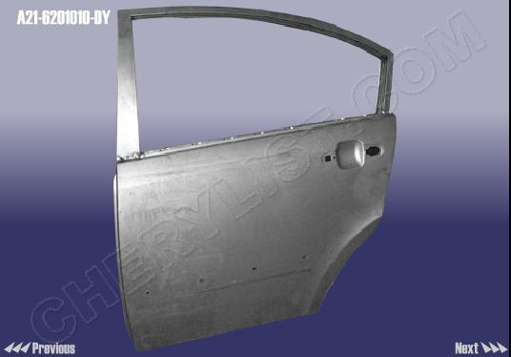

QTY = 10

DOOR ASSY-FR RH :: A21-6101020-DY

QTY = 10

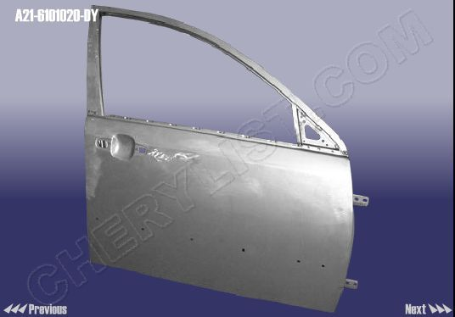

QTY = 10

DOOR ASSY-RR RH :: A21-6201020-DY

QTY = 10
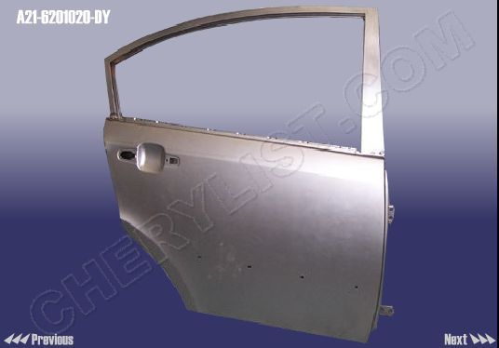

QTY = 10
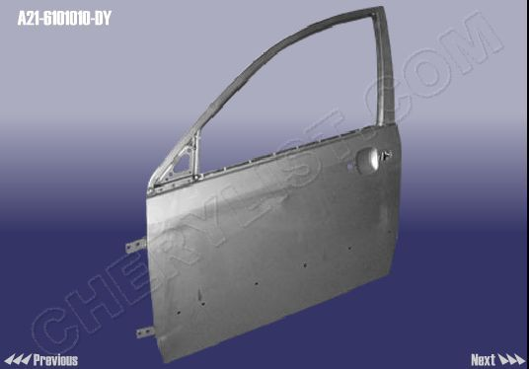

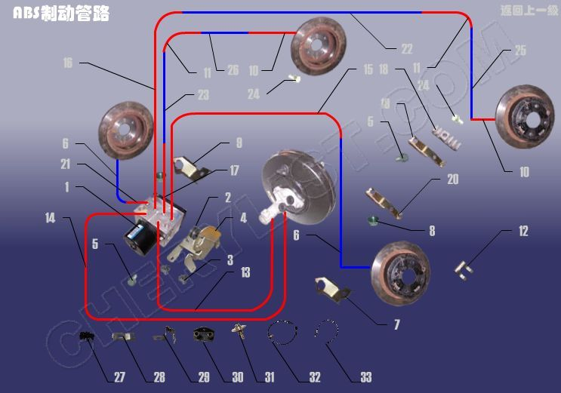
6 | A21-3506010 A21 - 3506010 QTY = 10
10 | A21-3506070 A21 - 3506070 QTY = 10
11 | A21-3506150 A21 - 3506150 QTY = 10
16 | A21-3506050 A21 - 3506050 QTY = 10
17 | A21-3506060 A21 - 3506060 QTY = 10
22 | A21-3506090 A21 - 3506090 QTY = 10
23 | A21-3506100 A21 - 3506100 QTY = 10
25 | A21-3506110 A21 - 3506110 QTY = 10
26 | A21-3506120 A21 - 3506120 QTY = 10

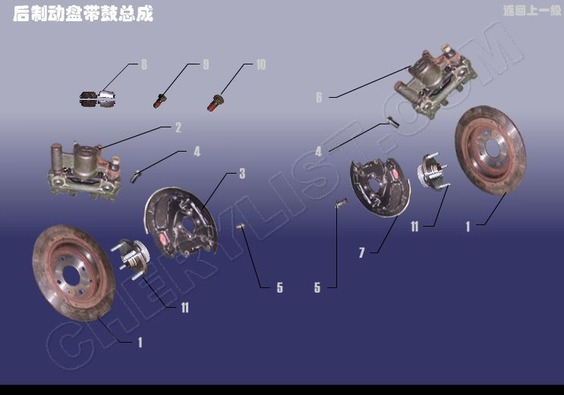

1 1 | A21-3502075 A21 - 3502075 QTY = 200 | BRAKE DISK-RR أقراص الفرامل بين الموارد العادية
11 11 | A21-3301210 A21 - 3301210 QTY = 200 | BEARING UNIT - RR HUB وإذ تضعان حدة -- مركز الموارد العادية

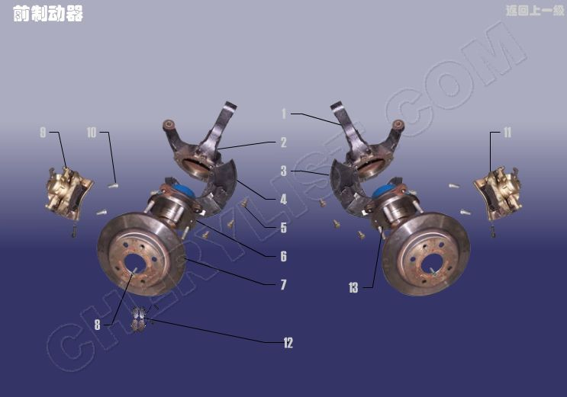
7 7 | A21-3501075 A21 - 3501075 QTY = 200
8 8 | Q2540616 Q2540616 QTY = 200
13 13 | A21-3001030 A21 - 3001030 QTY = 200
\

LOCK CYLINDER
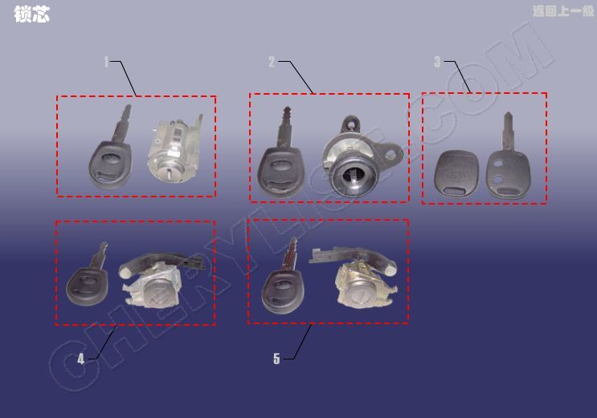

1 | A21-8CB3704017 | LOCK CORE ASSY - IGNITION(WICH KEY) QTY = 20
2 | A21-8CB6305190 | LOCK CYLINDER ASSY-COMPARTMENT PANEL(WITH KEY) QTY = 20
3 | A21-8CB6105410 | BLANK KEY-REMOTE QTY = 20
4 | A21-8CB6105310 | LOCK CYLINDER - FR DOOR LH WITH KEY QTY = 20
5 | A21-8CB6105320 | CORE LOCK-FR RH WITH KEY QTY = 20
6 | A21-8CB6105330SP | BLANK KEY-REMOTE QTY = 20
7 | A21SX-CTS | LOCK ASSY QTY = 20

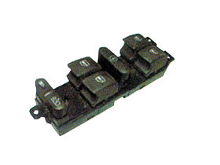
WINDOW REGULATOR SWITCH
A5 QTY = 50

1 | A21-2906013 QTY = 100 | RUBBER SUPPORTING
2 | A21-2906013AB QTY = 100 | BUSH - RUBBER

1 | A21-2909070 QTY = 100 | RUBBER SLEEVE ASSY-RR
2 | A21-BJ2909070 QTY = 100 | RUBBER SLEEVE ASSY-RR

1 | A21-2901110 QTY = 100 | BUFFER-FR
2 | A21-BJ2901110 QTY = 100 | BUFFER-FR
 | A21-2905010 QTY = 100 | FRONT ABSORBER ASSY
2 | A21-BJ2905010 QTY = 100 | FRONT ABSORBER ASSY

CROSSMEMBER WELDING ASSY-ENGINE SUPPORT :: A21-2801010 QTY = 10

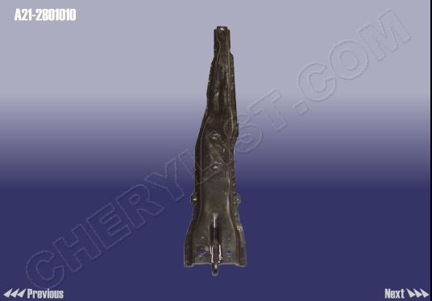

QTY = 50

WASHER - RUBBER :: A21-2906025
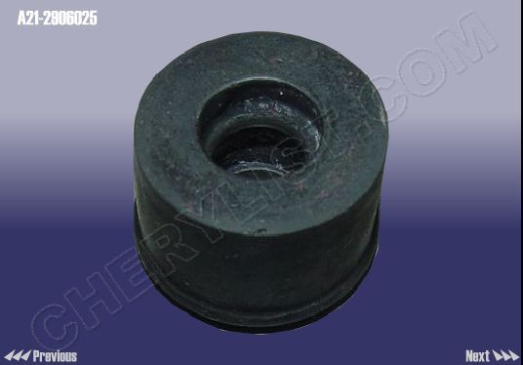

SUB FRAME ASSY :: A21-2810010 QTY = 10

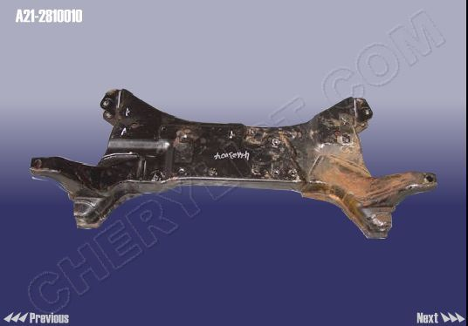

22 | A11-3301019BB QTY = 100 | END CAP-RR BEARING

BALL PIN :: A21-2909060 QTY = 200

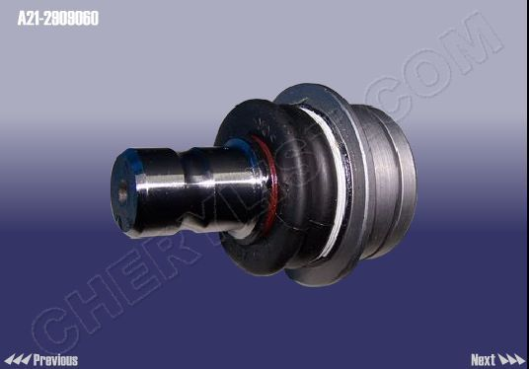

METAL SLEEVE :: A21-2906027 QTY = 100

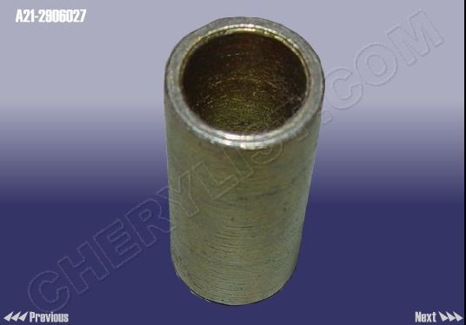

BRAKE DISK-FR :: A21-3501075
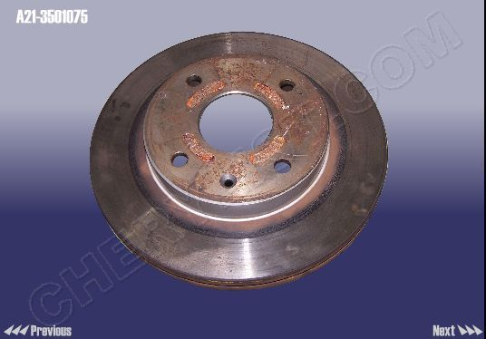

WHEEL BEARING-FR :: A21-3001030
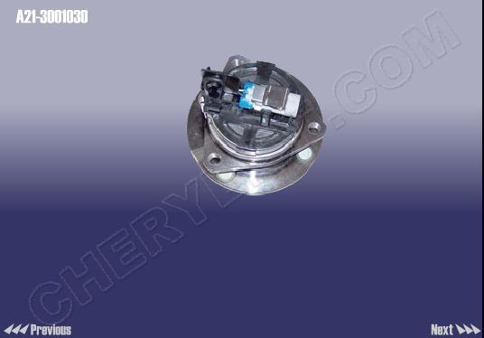

BRAKE PAD ASSY-RR WHEEL(PAIR) :: A21-3501090
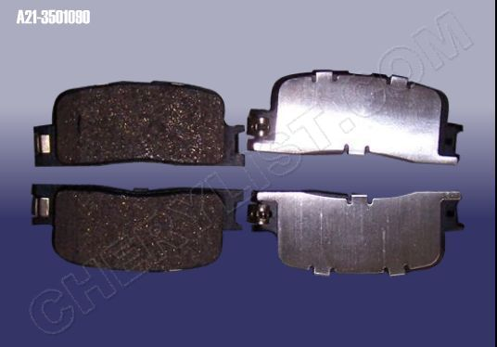

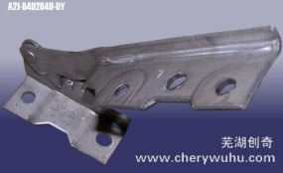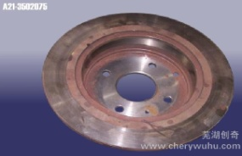

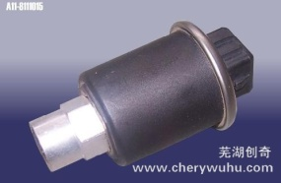
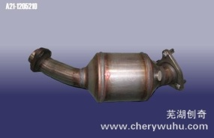

  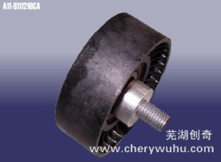
  idler pulley assy
  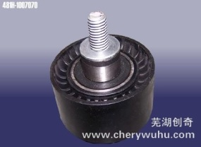
  idler pulley-tim…

  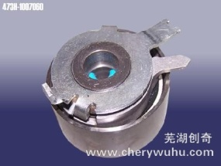
  tensioner assy
  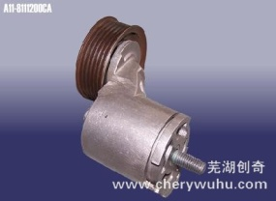
  tensioner

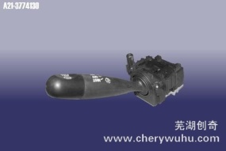

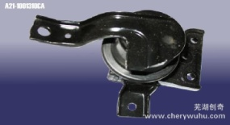
right suspension…
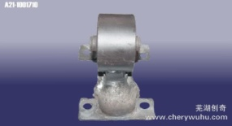
rear suspension …

BRAKE HOSE ASSY вё :: A21-3506070

BRAKE HOSE ASSY вЄ :: A21-3506150

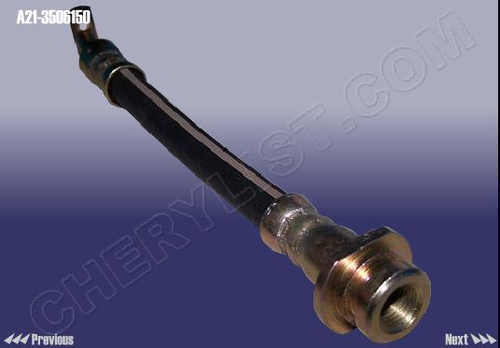SENSOR-RR ABS LH :: A21-3550131
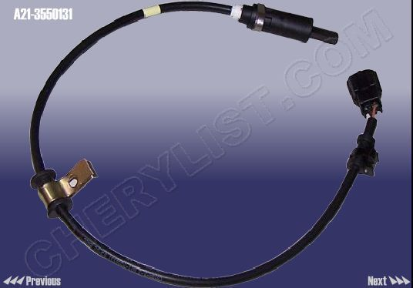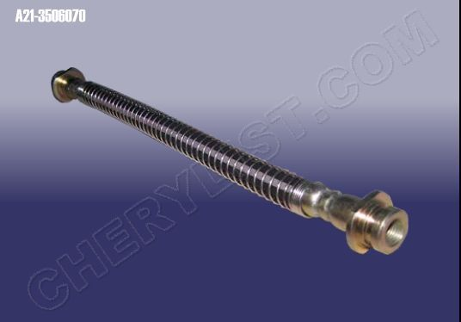139 items

SENSOR-RR ABS RH :: A21-3550132
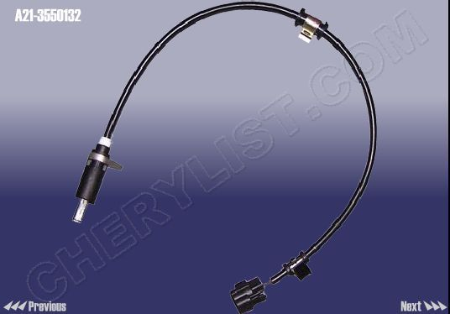

BRAKE DISK-FR :: A21-3501075

Skoda Part

.

