Fuel Pump

Type requested:

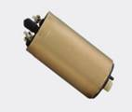 | MD-EP38 | AIRTEX:E8247 | NISSAN:17024-73Y00, 17042-Q5601

Important:
- Fuel pump for DIESEL engine

