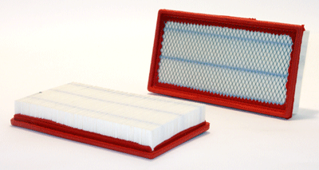
A1

Part Number: 46117
UPC Number: 765809461178
Principal Application: GM Cars & Trucks (92-05)
All Applications
Style: Air Filter Panel
Service: Air
Length: 11.563
Width: 6.050
Height: 1.660
CFM: 320

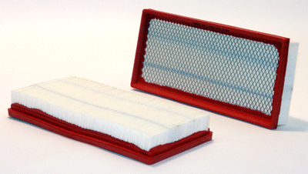
A2

Part Number: 46174
UPC Number: 765809461741
Principal Application: Ford Family of Trucks (87-98)
All Applications
Style: Air Filter Panel
Service: Air
Length: 12.864
Width: 5.856
Height: 1.713
CFM: 320
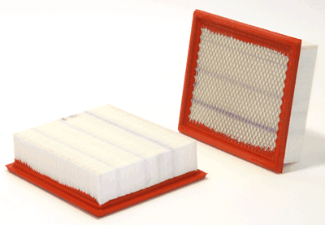
A3

Part Number: 46253
UPC Number: 765809462533
Principal Application: Ford Cars & Trucks (97-09), Mazda Trucks (99-09)
All Applications
Style: Air Filter Panel
Service: Air
Length: 8.791
Width: 7.575
Height: 2.295
CFM: 350

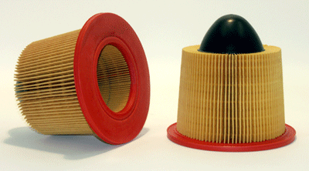
A4

Part Number: 46418
UPC Number: 765809464186
Principal Application: Ford Cars & Trucks (95-09)
All Applications
Style: Air Filter
Service: Air
Height: 7.811
Outer Diameter Top: 5.133
Outer Diameter Bottom: 8.134
Inner Diameter Top: Closed
Inner Diameter Bottom: 4.260
Ends: Plastic
CFM: 500

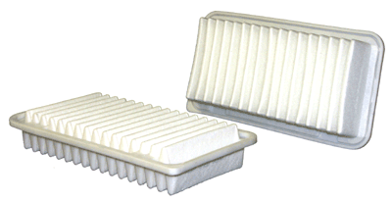
A5

Part Number: 46834
UPC Number: 765809468344
Principal Application: Toyota Matrix, Corolla, Pontiac Vibe (03-08), Scion tC (05-09)
All Applications
Style: Air Filter Panel
Service: Air
Media: Batt/Fiber
Length: 11.375
Width: 5.905
Height: 2.040

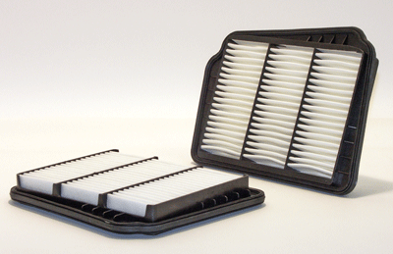
A6

Part Number: 42826
UPC Number: 765809428263
Principal Application: Chev Optra (04-07), Suzuki Forenza (04-08), Suzuki Reno (05-08)
All Applications
Style: Air Filter Panel
Service: Air
Media: Batt/Fiber
Length: 11.810
Width: 8.661
Height: 1.417

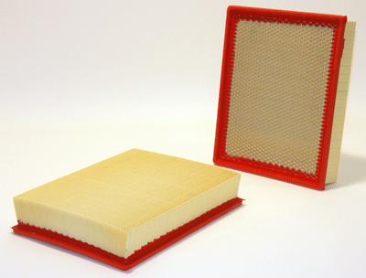
A7

Part Number: 42487
UPC Number: 765809424876
Principal Application: Chev/GM Trucks + SUVs (99-09) (Standard Version)
All Applications
Style: Air Filter Panel
Service: Air
Length: 12.250
Width: 9.720
Height: 2.365
CFM: 320
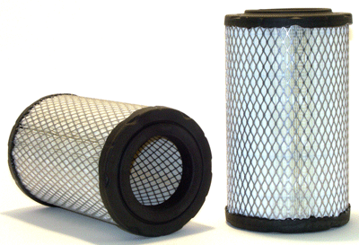
A8

Part Number: 46440
UPC Number: 765809464407
Principal Application: Chevy, GMC Pickups (Standard)(96-02)
All Applications
Style: Radial Seal Outer Air
Service: Air
Height: 11.122
Outer Diameter: 6.488
Inner Diameter Top: Closed
Inner Diameter Bottom: 3.580
Ends: Plastic
CFM: 250

