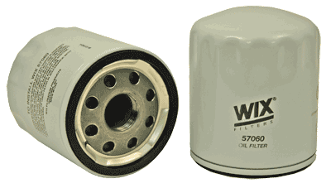
L1

Part Number: 57060
UPC Number: 765809570603
Principal Application: Various GM, Saturn, Saab (07-09)
All Applications
Style: Spin-On Lube Filter
Service: Lube
Type: Full Flow
Media: Paper
Height: 3.430
Outer Diameter Top: 2.970
Outer Diameter Bottom: Closed
Thread Size: 22X1.5 MM
By-Pass Valve Setting-PSI: 15
Anti-Drain Back Valve: Yes
Beta Ratio: 2/75=10/25
Max Flow Rate: 10-12 GPM
Nominal Micron Rating: 21
Gasket Diameters
Number O.D. I.D. Thk.
Attached 2.750 2.410 0

L2
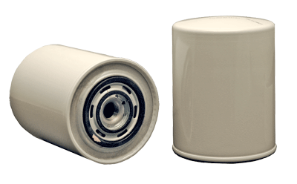

Part Number: 51431
UPC Number: 765809514317
Principal Application: Iveco, Fiat-Allis, Hesston, Hitachi
All Applications
Style: Spin-On Lube Filter
Service: Lube
Type: Full Flow/By-Pass
Media: Paper
Height: 5.638
Outer Diameter Top: 4.240
Outer Diameter Bottom: Closed
Thread Size: 3/4-16
By-Pass Valve Setting-PSI: 36
Anti-Drain Back Valve: Yes
Burst Pressure-PSI: 400
Max Flow Rate: 7-9 GPM
Nominal Micron Rating: 29
Gasket Diameters
Number O.D. I.D. Thk.
Attached 2.809 2.435 0.080

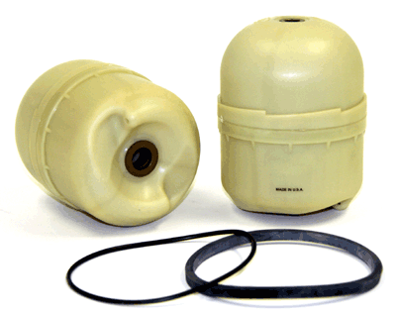
L3

Part Number: 57117
UPC Number: 765809571174
Principal Application: Mack, Renault Trucks - Centrifugal Element
All Applications
Style: Cartridge Lube Metal Canister Filter
Service: Lube
Type: By-Pass
Height: 4.962
Outer Diameter Top: 3.880
Outer Diameter Bottom: Closed
Inner Diameter Top: 0.396
Inner Diameter Bottom: 0.494
Beta Ratio: 2/8=5/9
Burst Pressure-PSI: 44
Max Flow Rate: 1-2 GPM
Nominal Micron Rating: 5
Gasket Diameters
Number O.D. I.D. Thk.
Packed 4.286 4.058 0.114
Packed 4.142 3.760 0.240

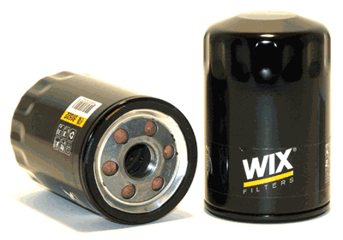
L4

Part Number: 51522
UPC Number: 765809515222
Principal Application: AMC (82-86), GM, Saturn (93-09), Jeep (81-86), Isuzu (03-09), Saab (06-09)
All Applications
Style: Spin-On Lube Filter
Service: Lube
Type: Full Flow
Media: Paper
Height: 4.526
Outer Diameter Top: 2.921
Outer Diameter Bottom: Closed
Thread Size: 13/16-16
By-Pass Valve Setting-PSI: None
Anti-Drain Back Valve: Yes
Burst Pressure-PSI: 290
Max Flow Rate: 9-11 GPM
Nominal Micron Rating: 15

Gasket Diameters
Number O.D. I.D. Thk.
Attached 2.734 2.430 0.226

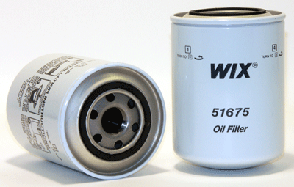
L5

Part Number: 51675
UPC Number: 765809516755
Principal Application: Mitsubishi Trucks
All Applications
Style: Spin-On Lube Filter
Service: Lube
Type: Full Flow/By-Pass
Media: Paper
Height: 5.981
Outer Diameter Top: 4.282
Outer Diameter Bottom: Closed
Thread Size: 26X1.5 MM
By-Pass Valve Setting-PSI: 13-16
Gasket Diameters
Number O.D. I.D. Thk.
Attached 2.834 2.462 0.200

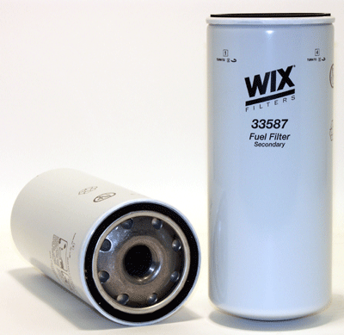
L6

Part Number: 33587
UPC Number: 765809335875
Principal Application: Mack 12L E-Tech Engine (Secondary)
All Applications
Style: Spin-On Fuel Filter
Service: Fuel
Height: 10.365
Outer Diameter Top: 4.282
Outer Diameter Bottom: Closed
Thread Size: 30X1.5 MM
By-Pass Valve Setting-PSI: NONE
Max Flow Rate: 12-15
Nominal Micron Rating: 3

Gasket Diameters
Number O.D. I.D. Thk.
Attached 3.967 3.587 0.340

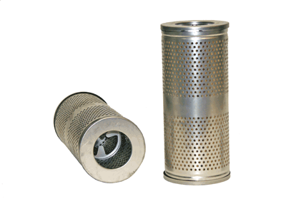
L7

Part Number: 51163
UPC Number: 765809511637
Principal Application: Caterpillar Equipment (If High Efficency version required, use 51167 - if fire retardant version required, use 57720)
All Applications
Style: Cartridge Lube Metal Canister Filter
Service: Transmission
Type: Full Flow
Media: Paper
Height: 9.250
Outer Diameter: 4.000
Inner Diameter: 2.300
Beta Ratio: 2/20=10/24
Nominal Micron Rating: 23
Gasket Diameters
Number O.D. I.D. Thk.
15163 ⁸ 5.012 4.734 0.139
Housing Gasket Not Packaged with Filter .....Order Separately.

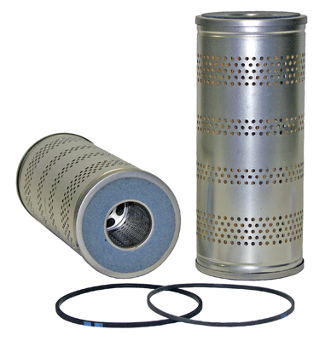
L8

Part Number: 51161
UPC Number: 765809511613
Principal Application: Autocar, Bay City Shovel, Caterpillar, Gardner-Denver, Koehring, Komatsu
All Applications
Style: Cartridge Lube Metal Canister Filter
Service: Lube
Type: Full Flow
Media: Paper
Height: 9.277
Outer Diameter: 3.968
Inner Diameter: 1.635
Beta Ratio: 2/20=17/33
Max Flow Rate: 18 GPM
Nominal Micron Rating: 25
Gasket Diameters
Number O.D. I.D. Thk.
15449 4.815 4.585 0.125
15286 4.790 4.630 0.125
15108 ⁸ 4.458 4.250 0.125
15460 ⁸ 4.810 4.580 0.125

Housing Gasket Not Packaged with Filter .....Order Separately.
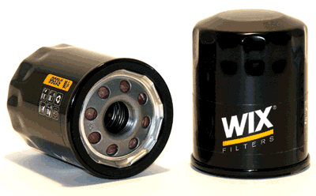
L9

Part Number: 51356
UPC Number: 765809513563
Principal Application: Acura (02-09), Chrysler Imports (92-06), Ford Probe (93-97), Honda (01-09), Infiniti/Nissan (96-09), Mazda (71-00), Mercury Villager (99-00), Mitsubishi (90-09), Saturn (04-07), Outboard Marine Engines, Various HD Equip.
All Applications
Style: Spin-On Lube Filter
Service: Lube
Type: Full Flow
Media: Paper
Height: 3.402
Outer Diameter Top: 2.685
Outer Diameter Bottom: Closed
Thread Size: 20X1.5 MM
By-Pass Valve Setting-PSI: 8-11
Anti-Drain Back Valve: Yes
Beta Ratio: 2/20=6/19
Burst Pressure-PSI: 363
Max Flow Rate: 9-11 GPM
Nominal Micron Rating: 19
Gasket Diameters
Number O.D. I.D. Thk.
Attached 2.475 2.173 0.233

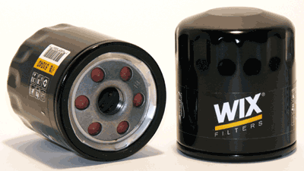
L10

Part Number: 51040
UPC Number: 765809510401
Principal Application: Daewoo (99-02), GM Cars/Trucks (76-09), Saab (94-98)
All Applications
Style: Spin-On Lube Filter
Service: Lube
Type: Full Flow
Media: Paper
Height: 3.404
Outer Diameter Top: 2.921
Outer Diameter Bottom: Closed
Thread Size: 18X1.5 MM
By-Pass Valve Setting-PSI: None
Anti-Drain Back Valve: Yes
Beta Ratio: 2/20=15/31
Burst Pressure-PSI: 325
Max Flow Rate: 7-9 GPM
Nominal Micron Rating: 19
Gasket Diameters
Number O.D. I.D. Thk.
Attached 2.734 2.430 0.226

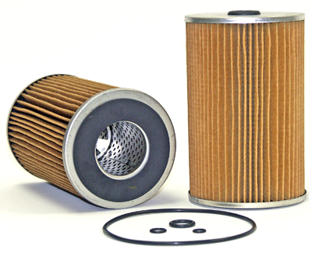
L11

Part Number: 51282
UPC Number: 765809512825
Principal Application: Isuzu Diesel Trucks (83-86) QD130 & C330 and Various Heavy Duty Equipment
All Applications
Style: Cartridge Lube Metal Canister Filter
Service: Lube
Type: Full Flow
Media: Paper
Height: 6.500
Outer Diameter: 4.100
Inner Diameter Top: 0.570
Inner Diameter Bottom: 1.828
Ends: Metal
Gasket Diameters
Number O.D. I.D. Thk.
Packed (4)

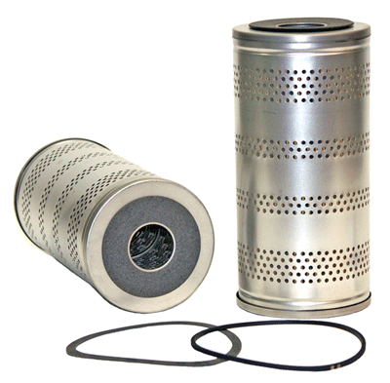
L12

Part Number: 51133
UPC Number: 765809511330
Principal Application: Adams, Allis-Chalmers, Case, Chevrolet Trucks (66-74), Detroit Diesel, Diamond T, Euclid, GMC, Gray Marine, Hercules, Hough, Joy, Letourneau-Westinghouse, Marion, M/F, Unit Crane, Worthington Compressors
All Applications
Style: Cartridge Lube Metal Canister Filter
Service: Lube
Type: Full Flow
Media: Paper
Height: 9.000
Outer Diameter: 4.312
Inner Diameter: 1.450
Nominal Micron Rating: 25
Gasket Diameters
Number O.D. I.D. Thk.
15119 5.140 4.590 0.062
15127 5.103 4.787 0.125
15333 ⁸ 1.090 0.765 0.055
15402 ⁸ 6.252 5.852 0.200

Housing Gasket Not Packaged with Filter .....Order Separately.

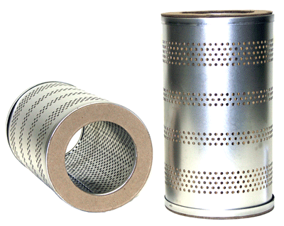
L13

Part Number: 51168
UPC Number: 765809511682
Principal Application: Caterpillar, Clark, Hyster, LeRoi, Lorain, P&H, Other
All Applications
Style: Cartridge Lube Metal Canister Filter
Service: Lube/Transmission
Type: Full Flow
Media: Paper
Height: 8.937
Outer Diameter: 5.094
Inner Diameter: 3.375
Nominal Micron Rating: 25
Gasket Diameters
Number O.D. I.D. Thk.
15193 ⁸ 5.674 5.468 0.125

Housing Gasket Not Packaged with Filter .....Order Separately.

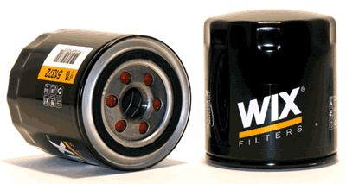
L14

Part Number: 51372
UPC Number: 765809513723
Principal Application: Ford/Lincoln/Mercury (91-09), Mazda (00-09), Cadillac STS-V, XLR-V (06-09)
All Applications
Style: Spin-On Lube Filter
Service: Lube
Type: Full Flow
Media: Paper
Height: 4.167
Outer Diameter Top: 3.660
Outer Diameter Bottom: Closed
Thread Size: 22X1.5 MM
By-Pass Valve Setting-PSI: 16
Anti-Drain Back Valve: Yes
Beta Ratio: 2/20=12/25
Burst Pressure-PSI: 275
Max Flow Rate: 11-13 GPM
Nominal Micron Rating: 19
Gasket Diameters
Number O.D. I.D. Thk.
Attached 2.834 2.462 0.200

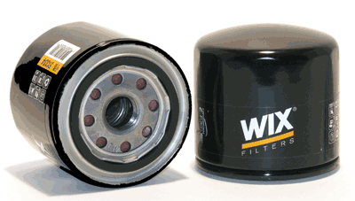
L15

Part Number: 51334
UPC Number: 765809513341
Principal Application: Acura (88-05), Chevrolet (85-88), Dodge (91-96), Ford (88-96), Honda (72-09), Hyundai (89-09), Isuzu (85-04), Kia (01-09), Mercury (87-91), Mitsubishi (89-98), Subaru (87-09) Atlas-Copco, Case, John Deere, Kobelco, Komatsu, Kubota, Onan, Toro & Yanmar Diesel, Other
All Applications
Style: Spin-On Lube Filter
Service: Lube
Type: Full Flow
Media: Paper
Height: 3.194
Outer Diameter Top: 3.252
Outer Diameter Bottom: Closed
Thread Size: 20X1.5 MM
By-Pass Valve Setting-PSI: 8-11
Anti-Drain Back Valve: Yes
Beta Ratio: 2/20=22/40
Burst Pressure-PSI: 280
Max Flow Rate: 9-11 GPM
Nominal Micron Rating: 19
Gasket Diameters
Number O.D. I.D. Thk.
Attached 2.475 2.173 0.233

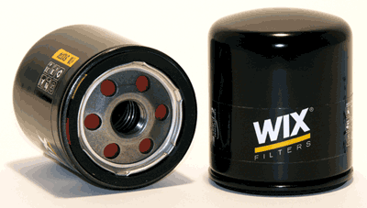
L16

Part Number: 51374
UPC Number: 765809513747
Principal Application: BMW (65-91), Lancia (76-77) and M.G. (75-80), Various HD Equipment
All Applications
Style: Spin-On Lube Filter
Service: Lube
Type: Full Flow
Media: Paper
Height: 3.529
Outer Diameter Top: 2.966
Outer Diameter Bottom: Closed
Thread Size: 3/4-16
By-Pass Valve Setting-PSI: 8-11
Anti-Drain Back Valve: Yes
Burst Pressure-PSI: 385
Max Flow Rate: 7-9 GPM
Nominal Micron Rating: 25
Gasket Diameters
Number O.D. I.D. Thk.
Attached 2.740 2.370 0.275

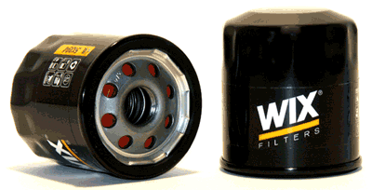
L17

Part Number: 51394
UPC Number: 765809513945
Principal Application: GM (85-09), Daihatsu (88-92), Infiniti (91-96), Kawasaki Mules, Nissan (91-95), Toyota (80-09), Scion (04-09), Atlas-Copco, Briggs&Stratton, Cub Cadet, Generac, John Deere, Kubota, New Holland
All Applications
Style: Spin-On Lube Filter
Service: Lube
Type: Full Flow
Media: Paper
Height: 2.977
Outer Diameter Top: 2.685
Outer Diameter Bottom: Closed
Thread Size: 3/4-16
By-Pass Valve Setting-PSI: 8-11
Anti-Drain Back Valve: Yes
Burst Pressure-PSI: 400
Max Flow Rate: 7-9 GPM
Nominal Micron Rating: 19
Gasket Diameters
Number O.D. I.D. Thk.
Attached 2.475 2.173 0.233

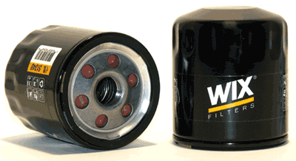
L18

Part Number: 51348
UPC Number: 765809513488
Principal Application: Various Chrysler/Jeep (82-09), Various GM, Saturn (85-07), Lexus (90-09), Saab (67-09), Suzuki (86-02), Toyota (88-09), Yugo (86-89), Harley-Davidson, Various Lawn&Garden, Farm Equip.
All Applications
Style: Spin-On Lube Filter
Service: Lube
Type: Full Flow
Media: Paper
Height: 3.404
Outer Diameter Top: 2.921
Outer Diameter Bottom: Closed
Thread Size: 3/4-16
By-Pass Valve Setting-PSI: 8-11
Anti-Drain Back Valve: Yes
Beta Ratio: 2/20=21/37
Burst Pressure-PSI: 275
Max Flow Rate: 7-9 GPM
Nominal Micron Rating: 19
Gasket Diameters
Number O.D. I.D. Thk.
Attached 2.734 2.430 0.226

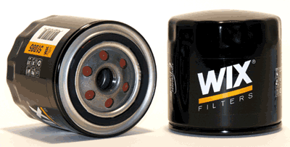
L19

Part Number: 51085
UPC Number: 765809510852
Principal Application: Chrysler/Dodge/Jeep Vehicles (91-08), Mitsubishi Eclipse (95-99); Caterpillar 3 Series Excavators, 9 Series Loaders, Kubota
All Applications
Style: Spin-On Lube Filter
Service: Lube
Type: Full Flow
Media: Paper
Height: 3.790
Outer Diameter Top: 3.660
Outer Diameter Bottom: Closed
Thread Size: 3/4-16
By-Pass Valve Setting-PSI: 8-11
Anti-Drain Back Valve: Yes
Beta Ratio: 2/20=15/28
Burst Pressure-PSI: 290
Max Flow Rate: 7-9 GPM
Nominal Micron Rating: 20
Gasket Diameters
Number O.D. I.D. Thk.
Attached 2.834 2.462 0.200

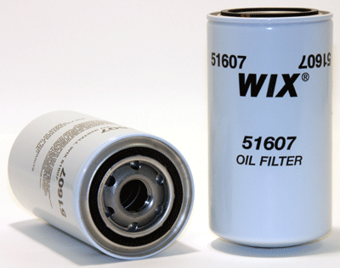
L20

Part Number: 51607
UPC Number: 765809516076
Principal Application: Cummins 5.9L "B" Series Eng, Dodge PU w/Diesel Eng. (89-02), Various HD Equip. (For High Efficiency Fluted Version Use 57620XE).
All Applications
Style: Spin-On Lube Filter
Service: Lube
Type: Full Flow
Media: Paper
Height: 6.987
Outer Diameter Top: 3.670
Outer Diameter Bottom: Closed
Thread Size: 1-16
By-Pass Valve Setting-PSI: None
Beta Ratio: 2/20=17/27
Burst Pressure-PSI: 350
Max Flow Rate: 12-16 GPM
Nominal Micron Rating: 17
Gasket Diameters
Number O.D. I.D. Thk.
Attached 2.834 2.462 0.255

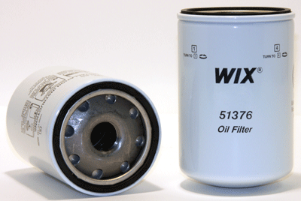
L21

Part Number: 51376
UPC Number: 765809513761
Principal Application: Mitsubishi FK & FM Model Trucks
All Applications
Style: Spin-On Lube Filter
Service: Lube
Type: Full Flow
Media: Paper
Height: 6.570
Outer Diameter Top: 4.282
Outer Diameter Bottom: Closed
Thread Size: 1 1/8-16
By-Pass Valve Setting-PSI: None
Burst Pressure-PSI: 420
Max Flow Rate: 18-20 GPM
Nominal Micron Rating: 28
Gasket Diameters
Number O.D. I.D. Thk.
Attached 3.967 3.587 0.340

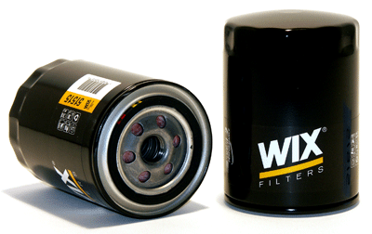
L22

Part Number: 51515
UPC Number: 765809515154
Principal Application: Chrysler Family of Cars/Trucks (57-70), Ford Family of Cars/Trucks (57-00), Mazda Trucks (94-00), Toyota Landcruiser (71-96) - (Two Quart version is 51773)
All Applications
Style: Spin-On Lube Filter
Service: Lube
Type: Full Flow
Media: Paper
Height: 5.178
Outer Diameter: 3.660
Thread Size: 3/4-16
By-Pass Valve Setting-PSI: 8-11
Anti-Drain Back Valve: Yes
Beta Ratio: 2/20=13/23
Burst Pressure-PSI: 290
Max Flow Rate: 7-9 GPM
Nominal Micron Rating: 19
Gasket Diameters
Number O.D. I.D. Thk.
Attached 2.834 2.462 0.200

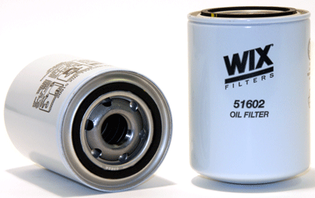
L23

Part Number: 51602
UPC Number: 765809516021
Principal Application: Agco, Case, Consolidated/Cummins 3.9L Engine, I-R, Komatsu, Other
All Applications
Style: Spin-On Lube Filter
Service: Lube
Type: Full Flow
Media: Paper
Height: 5.214
Outer Diameter Top: 3.663
Outer Diameter Bottom: Closed
Thread Size: 1-16
By-Pass Valve Setting-PSI: None
Beta Ratio: 2/20=11/25
Burst Pressure-PSI: 375
Max Flow Rate: 12-16 GPM
Nominal Micron Rating: 17
Gasket Diameters
Number O.D. I.D. Thk.
Attached 2.834 2.462 0.255

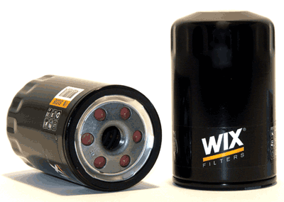
L24

Part Number: 51036
UPC Number: 765809510364
Principal Application: GM Cars + Trucks (80-05), Mercruiser, Volvo-Penta
All Applications
Style: Spin-On Lube Filter
Service: Lube
Type: Full Flow
Media: Paper
Height: 4.828
Outer Diameter Top: 2.921
Outer Diameter Bottom: Closed
Thread Size: 18X1.5 MM
By-Pass Valve Setting-PSI: None
Anti-Drain Back Valve: Yes
Beta Ratio: 2/20=12/26
Burst Pressure-PSI: 325
Max Flow Rate: 7-9 GPM
Nominal Micron Rating: 19
Gasket Diameters
Number O.D. I.D. Thk.
Attached 2.734 2.430 0.226

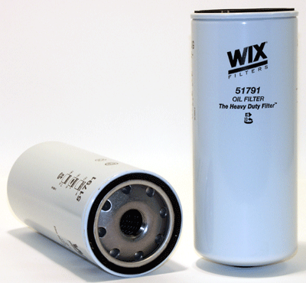
L25

Part Number: 51791
UPC Number: 765809517912
Principal Application: Cat, Mack, Volvo (For High Efficiency 100% Glass Media use 51791XE - For Performance between 51791 + 51791XE, use 57791 uses cellulose/glass blend) - For Extended Drain Version Use 51791XD)
All Applications
Style: Spin-On Lube Filter
Service: Lube
Type: Full Flow
Media: Paper
Height: 10.365
Outer Diameter Top: 4.282
Outer Diameter Bottom: Closed
Thread Size: 1 1/8-16
By-Pass Valve Setting-PSI: None
Beta Ratio: 2/20=11/25
Burst Pressure-PSI: 330
Max Flow Rate: 18-20 GPM
Nominal Micron Rating: 20

Gasket Diameters
Number O.D. I.D. Thk.
Attached 3.967 3.587 0.340

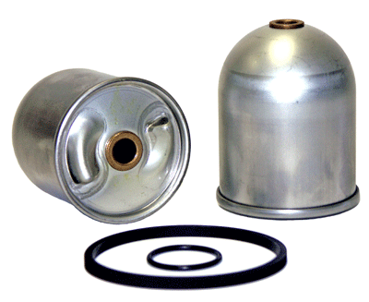
L26

Part Number: 51417
UPC Number: 765809514171
Principal Application: Mack Trucks w/ Centri-Max Centrifugal By-Pass Lube System
All Applications
Style: Cartridge Lube Metal Canister Filter
Service: Lube
Type: By-Pass
Height: 4.500
Outer Diameter Top: 3.830
Outer Diameter Bottom: 3.600
Inner Diameter Top: 0.556
Inner Diameter Bottom: 0.633
Gasket Diameters
Number O.D. I.D. Thk.
Packed 4.546 4.156 0.195
Packed 1.762 1.484 0.139

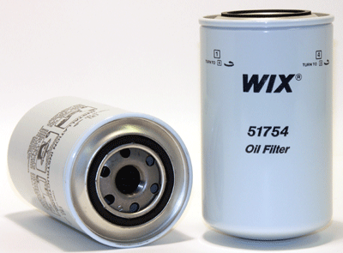
L27

Part Number: 51754
UPC Number: 765809517547
Principal Application: Ford Trucks 7.8L Diesel Eng. (87-93)
All Applications
Style: Spin-On Lube Filter
Service: Lube
Type: Full Flow
Media: Paper
Height: 7.332
Outer Diameter Top: 4.282
Outer Diameter Bottom: Closed
Thread Size: 1-12
By-Pass Valve Setting-PSI: 18-22
Burst Pressure-PSI: 435
Max Flow Rate: 12-16 GPM
Nominal Micron Rating: 16
Gasket Diameters
Number O.D. I.D. Thk.
Attached 2.834 2.462 0.200

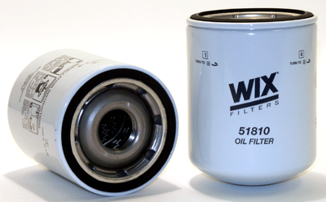
L28

Part Number: 51810
UPC Number: 765809518100
Principal Application: Equipment using Detroit Diesel 3-53, 4-53 Engines, Hino Trucks
All Applications
Style: Spin-On Lube Filter
Service: Lube
Type: Full Flow
Media: Paper
Height: 6.219
Outer Diameter Top: 4.658
Outer Diameter Bottom: Closed
Thread Size: 1 1/2-12
By-Pass Valve Setting-PSI: None
Beta Ratio: 2/20=21/36
Burst Pressure-PSI: 335
Max Flow Rate: 28-30 GPM
Nominal Micron Rating: 30
Gasket Diameters
Number O.D. I.D. Thk.
Attached 4.320 3.820 0.365

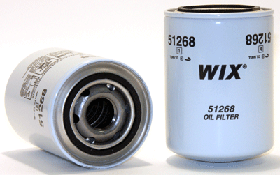
L29

Part Number: 51268
UPC Number: 765809512689
Principal Application: Caterpillar 3208 Engine, IHC Trucks, Allison Trans., Volvo Trucks
All Applications
Style: Spin-On Lube Filter
Service: Lube
Type: Full Flow
Media: Paper
Height: 5.218
Outer Diameter Top: 3.691
Outer Diameter Bottom: Closed
Thread Size: 1 1/8-16
By-Pass Valve Setting-PSI: None
Beta Ratio: 2/20=7/28
Burst Pressure-PSI: 560
Max Flow Rate: 18-20 GPM
Nominal Micron Rating: 25
Gasket Diameters
Number O.D. I.D. Thk.
Attached 2.729 2.415 0.255

