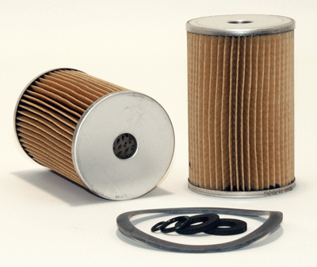
C1

Part Number: 33260
UPC Number: 765809332607
Principal Application: Isuzu, Hino, Hitachi, Komatsu, White (10 Micron)
All Applications
Style: Cartridge Fuel Metal Canister Filter
Service: Fuel
Media: Paper
Height: 4.133
Outer Diameter: 2.693
Inner Diameter: 0.625
Nominal Micron Rating: 10

Gasket Diameters
Number O.D. I.D. Thk.
Packed (4)

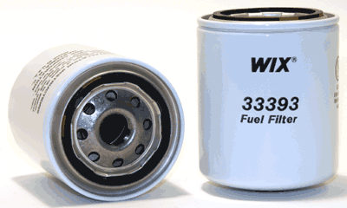
C2

Part Number: 33393
UPC Number: 765809333932
Principal Application: Hino, Isuzu, Mitsubishi, Nissan, Toyota Diesel Trucks (Secondary) (10 Micron)
All Applications
Style: Spin-On Fuel Filter
Service: Fuel
Height: 4.069
Outer Diameter Top: 3.234
Outer Diameter Bottom: Closed
Thread Size: 3/4-16
Burst Pressure-PSI: 290
Max Flow Rate: 8-10 GPM
Nominal Micron Rating: 10
Gasket Diameters
Number O.D. I.D. Thk.
Attached 2.487 1.987 0.140

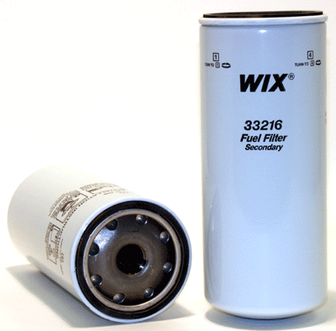
C3

Part Number: 33216
UPC Number: 765809332164
Principal Application: Mack Trucks - Secondary (6 Micron)
All Applications
Style: Spin-On Fuel Filter
Service: Fuel
Media: Paper
Height: 10.365
Outer Diameter Top: 4.282
Outer Diameter Bottom: Closed
Thread Size: 1 1/16-16
Burst Pressure-PSI: 375
Nominal Micron Rating: 6
Gasket Diameters
Number O.D. I.D. Thk.
Attached 3.967 3.587 0.340

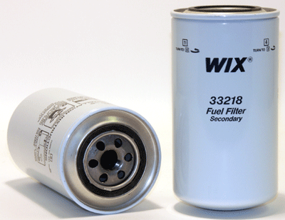
C4

Part Number: 33218
UPC Number: 765809332188
Principal Application: Mack, Iveco Trucks - Secondary (6 Micron)
All Applications
Style: Spin-On Fuel Filter
Service: Fuel
Media: Paper
Height: 8.053
Outer Diameter Top: 4.282
Outer Diameter Bottom: Closed
Thread Size: 7/8-16
Burst Pressure-PSI: 350
Nominal Micron Rating: 6
Gasket Diameters
Number O.D. I.D. Thk.
Attached 2.834 2.462 0.200

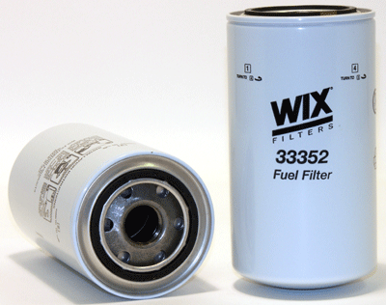
C5

Part Number: 33352
UPC Number: 765809333529
Principal Application: Caterpillar, Komatsu, Nissan, Other (6 Micron) - (2 Micron version is 33528)
All Applications
Style: Spin-On Fuel Filter
Service: Fuel
Media: Paper
Height: 6.987
Outer Diameter Top: 3.663
Outer Diameter Bottom: Closed
Thread Size: 1-14
Beta Ratio: 2/20=23/40
Burst Pressure-PSI: 310
Max Flow Rate: 12-15 GPM
Nominal Micron Rating: 6
Gasket Diameters
Number O.D. I.D. Thk.
Attached 2.729 2.415 0.255

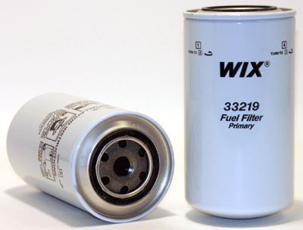
C6

Part Number: 33219
UPC Number: 765809332195
Principal Application: Mack Trucks - Primary (35 Micron)
All Applications
Style: Spin-On Fuel Filter
Service: Fuel
Media: Paper
Height: 8.113
Outer Diameter Top: 4.282
Outer Diameter Bottom: Closed
Thread Size: 13/16-18
Burst Pressure-PSI: 455
Nominal Micron Rating: 35
Gasket Diameters
Number O.D. I.D. Thk.
Attached 2.834 2.462 0.200

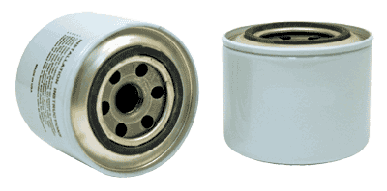
C7

Part Number: 33399
UPC Number: 765809333994
Principal Application: Atlas-Copco Generators, Caterpillar Excavators, Hyundai Excavators, John Deere Tractors, Kato Equipment, Komatsu Equipment, Mitsubishi Fuso Trucks, Takeuchi Equipment, Yanmar (10 Micron)
All Applications
Style: Spin-On Fuel Filter
Service: Fuel
Height: 3.146
Outer Diameter Top: 3.672
Outer Diameter Bottom: Closed
Thread Size: 20X1.5 MM
Burst Pressure-PSI: 240
Nominal Micron Rating: 10
Gasket Diameters
Number O.D. I.D. Thk.
Attached 2.538 2.224 0.200

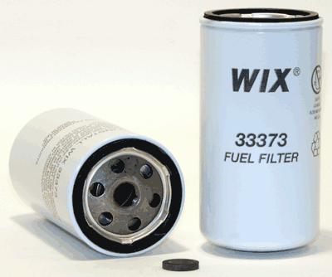
C8

Part Number: 33373
UPC Number: 765809333734
Principal Application: Deutz, IHC Equipment, Iveco Equipment (10 Micron)
All Applications
Style: Spin-On Fuel Filter
Service: Fuel
Media: Paper
Height: 5.811
Outer Diameter Top: 2.985
Outer Diameter Bottom: Closed
Thread Size: 16X1.5 MM
Burst Pressure-PSI: 360
Max Flow Rate: 6-8 GPM
Nominal Micron Rating: 10
Gasket Diameters
Number O.D. I.D. Thk.
Attached 2.740 2.370 0.275

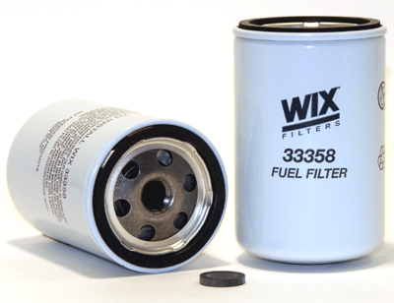
C9

Part Number: 33358
UPC Number: 765809333581
Principal Application: Case, Cummins, Deutz, Volvo (10 Micron) If drain is needed use 33472
All Applications
Style: Spin-On Fuel Filter
Service: Fuel
Media: Paper
Height: 4.709
Outer Diameter Top: 3.015
Outer Diameter Bottom: Closed
Thread Size: 16X1.5 MM
Beta Ratio: 2/20=3/20
Burst Pressure-PSI: 300
Max Flow Rate: 6-8 GPM
Nominal Micron Rating: 10

Gasket Diameters
Number O.D. I.D. Thk.
Attached 2.740 2.370 0.275
Packed 0.871 0.595 0.143

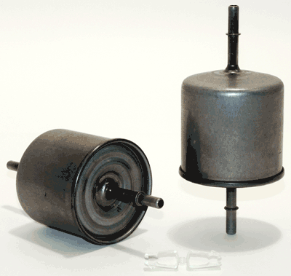
C10

Part Number: 33296
UPC Number: 765809332966
Principal Application: Ford Trucks + Vans (90-05) (08-09), Mazda Trucks (91-99) (08-09)
All Applications
Style: Fuel (Complete In-Line) Filter
Service: Fuel
Height: 6.696
Outer Diameter Top: 3.080
Outer Diameter Bottom: Closed
Max Flow Rate: 1 GPM
Nominal Micron Rating: 12
Gasket Diameters
Number O.D. I.D. Thk.
None

C11
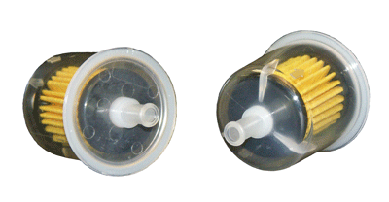

Part Number: 33002
UPC Number: 765809330023
Principal Application: Plastic Universal In-Line fuel filter w/ 5/16" Inlet and Oulet (Metal Version is 33032 w/Hoses and Clamps) - use only w/ gasoline (not diesel) - for diesel fuel, use 33972 All Applications
Style: Fuel (Complete In-Line) Filter
Service: Fuel
Height: 3.920
Outer Diameter Top: 1.770
Outer Diameter Bottom: Closed
Nominal Micron Rating: 20
Gasket Diameters
Number O.D. I.D. Thk.
None

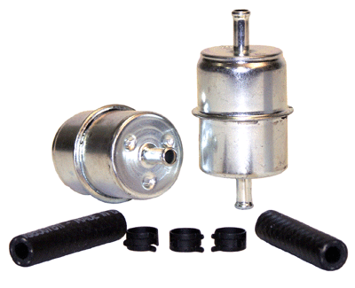
C12

Part Number: 33032
UPC Number: 765809330320
Principal Application: ABG Construction Equipment, Ford Festiva (88-91), Various Early Model Import and Domestic (Universal 5/16 in. In-Line w/Hoses and Clamps) All Applications
Style: Fuel (Complete In-Line) Filter
Service: Fuel
Height: 3.862
Outer Diameter Top: 1.936
Outer Diameter Bottom: Closed
Ends: Metal
Burst Pressure-PSI: 60
Nominal Micron Rating: 20
Gasket Diameters
Number O.D. I.D. Thk.
None

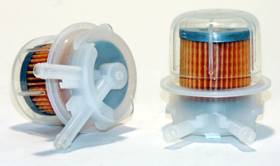
C13

Part Number: 33275
UPC Number: 765809332751
Principal Application: Chevrolet Nova (85-88), Toyota Corolla (88-89)
All Applications
Style: Fuel (Complete In-Line) Filter
Service: Fuel
Height: 2.250
Outer Diameter Top: 2.200
Outer Diameter Bottom: Closed
Gasket Diameters
Number O.D. I.D. Thk.
None

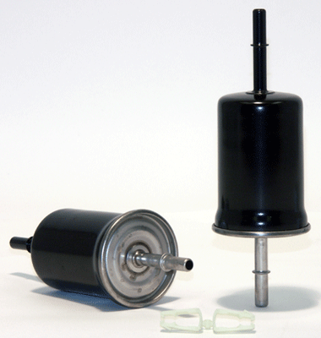
C14

Part Number: 33595
UPC Number: 765809335950
Principal Application: Ford, Lincoln, Mercury (98-09), Jaguar S-Type (01-08) - two clips packed with the filter - if shorter clips needed, order part # WCK11
All Applications
Style: Fuel (Complete In-Line) Filter
Service: Fuel
Media: Paper
Height: 7.150
Outer Diameter Top: 2.300
Outer Diameter Bottom: Closed
Nominal Micron Rating: 10
Gasket Diameters
Number O.D. I.D. Thk.
None

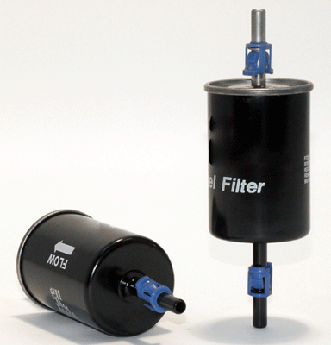
C15

Part Number: 33199
UPC Number: 765809331990
Principal Application: Buick Reatta, Riviera (90-92), Cadillac Eldorado, Seville (90-92), Olds Toronado (90-92) Corsa
All Applications
Style: Fuel (Complete In-Line) Filter
Service: Fuel
Height: 6.732
Outer Diameter: 2.176
Nominal Micron Rating: 10
Gasket Diameters
Number O.D. I.D. Thk.
None

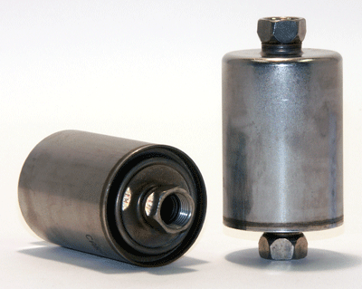

C16

Part Number: 33481
UPC Number: 765809334816
Principal Application: GM Models (83-08), Jaguar (97-09), Land Rover (99-04)
All Applications
Style: Fuel (Complete In-Line) Filter
Service: Fuel
Height: 4.290
Outer Diameter Top: 2.170
Outer Diameter Bottom: Closed
Burst Pressure-PSI: 300
Max Flow Rate: 1 - 2 GPM
Nominal Micron Rating: 4
Gasket Diameters
Number O.D. I.D. Thk.
None

