Headlight Switch

Part Nr. 311 941 531 B

Application:

Beetle 08/67 to 07/70
Karmann Ghia 08/78 to 07/70
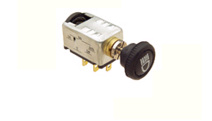
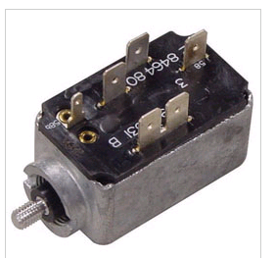
Type 3 08/67 to 07/70

