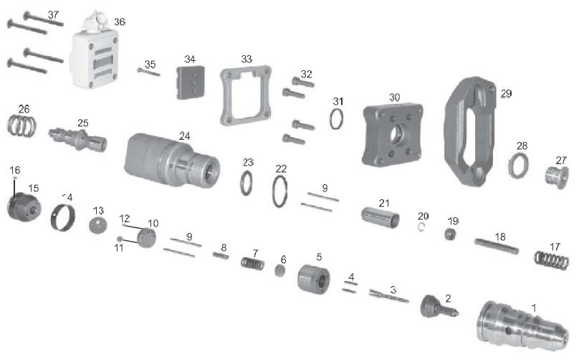

Hello.
We need spare part for fuel injector used on Cat 3126B engine. In quantity from 50 pieces. Whether there are they at you for following models of engines?
Cat 3126
Serial number CRP00282
Engine model 3126
Arrangement number 199-6082
Fuel injector part number: 2225966(important)
Reman fuel injector part number: 10r0781(important)
We need following positions: 2, 3, 4, 5, 6, 7, 8, 9, 10, 11, 12, 13, 14, 15, 16, 17, 18, 19, 20, 21, 22, 23, 31, 34

proftop@rambler.ru
Tel\Fax:+7 495 662 91 18
+7 905 7204254

