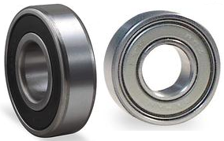
6201- ZZ Radial Ball Bearing 12mm
ZZ - Shield with snap ring on both sides of bearing
 | 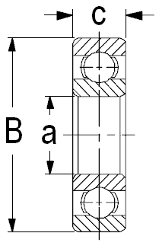
  Bearing Number | Boundary dimensions(mm)
   | a | B | C
  6201ZZ | 12 | 32 | 10

