engine cowling 3302-8402012-10 weight near 11.5 kgs
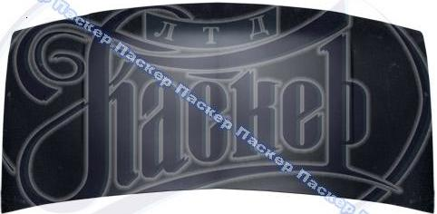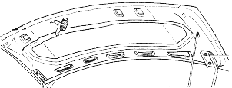
engine cowling 3302-8402012-20 weight near 11.6 kgs
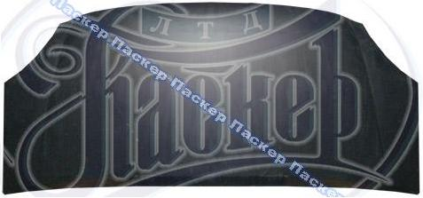
front left wing 3302-8403013-20 weight near 2.8 kgs
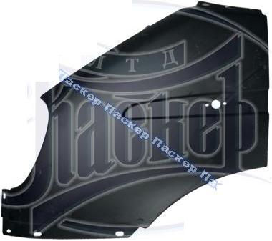
front right wing 3302-8403013-20 weight near 2.8 kgs
